Uji Linearitas
Parental attachment dan self-esteem
Model Summary and Parameter Estimates
Dependent Variable: Parentattach
Equation | Model Summary |  |  |  |  | Parameter Estimates
Equation | R Square | F | df1 | df2 | Sig. | Constant | b1
Linear | .099 | 13.864 | 1 | 126 | .000 | 38.393 | .320
The independent variable is selfesteem.

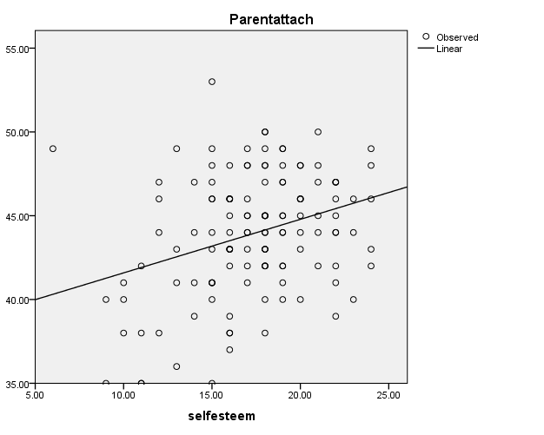

Parental attachment dan loneliness

Model Summary and Parameter Estimates
Dependent Variable: Parentalattachment
Equation | Model Summary |  |  |  |  | Parameter Estimates
Equation | R Square | F | df1 | df2 | Sig. | Constant | b1
Linear | .250 | 42.029 | 1 | 126 | .000 | 61.191 | -.969
The independent variable is loneliness.

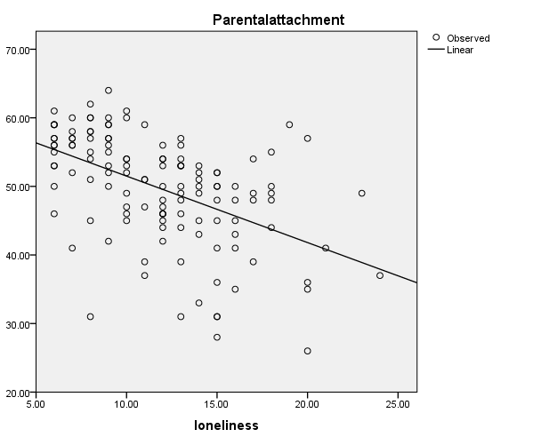

Self-esteem dan loneliness

Model Summary and Parameter Estimates
Dependent Variable: selfesteem
Equation | Model Summary |  |  |  |  | Parameter Estimates
Equation | R Square | F | df1 | df2 | Sig. | Constant | b1
Linear | .269 | 46.453 | 1 | 126 | .000 | 22.670 | -.453
The independent variable is loneliness.

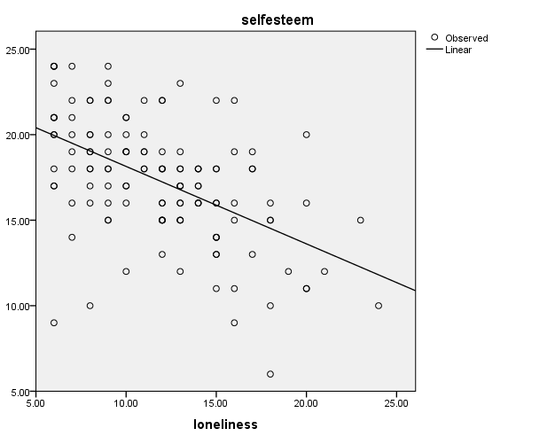

Analisis Konfirmasi Faktor (Estimator Robust Maximum Likelihood) dan Realibilitas
- Kesepian
Analisis Reabilitas
Frequentist Scale Reliability Statistics
Estimate |  | Cronbach's α
Point estimate |  | 0.845
95% CI lower bound |  | 0.799
95% CI upper bound |  | 0.882

Confirmatory Factor Analysis

Model fit
Chi-square test
Model |  | Χ² |  | df |  | p
Baseline model |  | 285.167 |  | 15
Factor model |  | 8.160 |  | 8 |  | 0.418

Additional fit measures
Fit indices
Index |  | Value
Comparative Fit Index (CFI) |  | 0.999
Tucker-Lewis Index (TLI) |  | 0.999
Bentler-Bonett Non-normed Fit Index (NNFI) |  | 0.999
Bentler-Bonett Normed Fit Index (NFI) |  | 0.971
Parsimony Normed Fit Index (PNFI) |  | 0.518
Bollen's Relative Fit Index (RFI) |  | 0.946
Bollen's Incremental Fit Index (IFI) |  | 0.999
Relative Noncentrality Index (RNI) |  | 0.999

Information criteria
 |  | Value
Log-likelihood |  | -879.061
Number of free parameters |  | 19.000
Akaike (AIC) |  | 1796.121
Bayesian (BIC) |  | 1850.310
Sample-size adjusted Bayesian (SSABIC) |  | 1790.221

Other fit measures
Metric |  | Value
Root mean square error of approximation (RMSEA) |  | 0.012
RMSEA 90% CI lower bound |  | 0.000
RMSEA 90% CI upper bound |  | 0.105
RMSEA p-value |  | 0.635
Standardized root mean square residual (SRMR) |  | 0.025
Hoelter's critical N (α = .05) |  | 244.262
Hoelter's critical N (α = .01) |  | 316.154
Goodness of fit index (GFI) |  | 0.995
McDonald fit index (MFI) |  | 0.999
Expected cross validation index (ECVI) |  | 0.361

Kaiser-Meyer-Olkin (KMO) test
Indicator |  | MSA
F2 |  | 0.849
F5 |  | 0.886
F6 |  | 0.902
S1 |  | 0.860
S3 |  | 0.882
S4 |  | 0.859
Overall |  | 0.870

R-Squared
 |  | R²
F2 |  | 0.671
F5 |  | 0.290
F6 |  | 0.429
S1 |  | 0.540
S3 |  | 0.527
S4 |  | 0.563

Parameter estimates
Factor loadings
 |  |  |  |  |  |  |  |  |  |  |  |  |  | 95% Confidence Interval
Factor |  | Indicator |  | Symbol |  | Estimate |  | Std. Error |  | z-value |  | p |  | Lower |  | Upper
Factor 1 |  | F2 |  | λ11 |  | 0.832 |  | 0.075 |  | 11.087 |  | < .001 |  | 0.685 |  | 0.979
 |  | F5 |  | λ12 |  | 0.488 |  | 0.100 |  | 4.900 |  | < .001 |  | 0.293 |  | 0.683
 |  | F6 |  | λ13 |  | 0.577 |  | 0.074 |  | 7.812 |  | < .001 |  | 0.432 |  | 0.722
Factor 2 |  | S1 |  | λ21 |  | 0.636 |  | 0.085 |  | 7.467 |  | < .001 |  | 0.469 |  | 0.803
 |  | S3 |  | λ22 |  | 0.685 |  | 0.079 |  | 8.631 |  | < .001 |  | 0.530 |  | 0.841
 |  | S4 |  | λ23 |  | 0.645 |  | 0.069 |  | 9.317 |  | < .001 |  | 0.509 |  | 0.780

Factor variances
 |  |  |  |  |  |  |  |  |  | 95% Confidence Interval
Factor |  | Estimate |  | Std. Error |  | z-value |  | p |  | Lower |  | Upper
Factor 1 |  | 1.000 |  | 0.000 |  |  |  |  |  | 1.000 |  | 1.000
Factor 2 |  | 1.000 |  | 0.000 |  |  |  |  |  | 1.000 |  | 1.000

Factor Covariances
 |  |  |  |  |  |  |  |  |  |  |  |  |  | 95% Confidence Interval
 |  |  |  |  |  | Estimate |  | Std. Error |  | z-value |  | p |  | Lower |  | Upper
Factor 1 |  | ↔ |  | Factor 2 |  | 0.942 |  | 0.059 |  | 16.097 |  | < .001 |  | 0.828 |  | 1.057

Residual variances
 |  |  |  |  |  |  |  |  |  | 95% Confidence Interval
Indicator |  | Estimate |  | Std. Error |  | z-value |  | p |  | Lower |  | Upper
F2 |  | 0.339 |  | 0.086 |  | 3.937 |  | < .001 |  | 0.170 |  | 0.508
F5 |  | 0.582 |  | 0.114 |  | 5.118 |  | < .001 |  | 0.359 |  | 0.805
F6 |  | 0.444 |  | 0.063 |  | 7.061 |  | < .001 |  | 0.321 |  | 0.567
S1 |  | 0.345 |  | 0.069 |  | 5.022 |  | < .001 |  | 0.210 |  | 0.479
S3 |  | 0.421 |  | 0.080 |  | 5.283 |  | < .001 |  | 0.265 |  | 0.577
S4 |  | 0.322 |  | 0.063 |  | 5.098 |  | < .001 |  | 0.198 |  | 0.446

Implied covariance matrix
F2 |  | F5 |  | F6 |  | S1 |  | S3 |  | S4
1.031
0.406 |  | 0.820
0.480 |  | 0.282 |  | 0.777
0.498 |  | 0.292 |  | 0.346 |  | 0.749
0.537 |  | 0.315 |  | 0.373 |  | 0.436 |  | 0.891
0.505 |  | 0.296 |  | 0.351 |  | 0.410 |  | 0.442 |  | 0.738

Residual covariance matrix
F2 |  | F5 |  | F6 |  | S1 |  | S3 |  | S4
< .001
0.039 |  | < .001
< .001 |  | < .001 |  | < .001
< .001 |  | < .001 |  | 0.008 |  | < .001
0.033 |  | 0.005 |  | 0.041 |  | < .001 |  | < .001
< .001 |  | < .001 |  | 0.006 |  | 0.043 |  | < .001 |  | < .001

Modification Indices
Cross-loadings
 |  |  |  |  |  | Mod. Ind. |  | EPC
Factor 1 |  | → |  | S3 |  | 5.233 |  | 1.495

Residual covariances
 |  |  |  |  |  | Mod. Ind. |  | EPC
S1 |  | ↔ |  | S4 |  | 5.233 |  | 0.106

Plots

Model plot
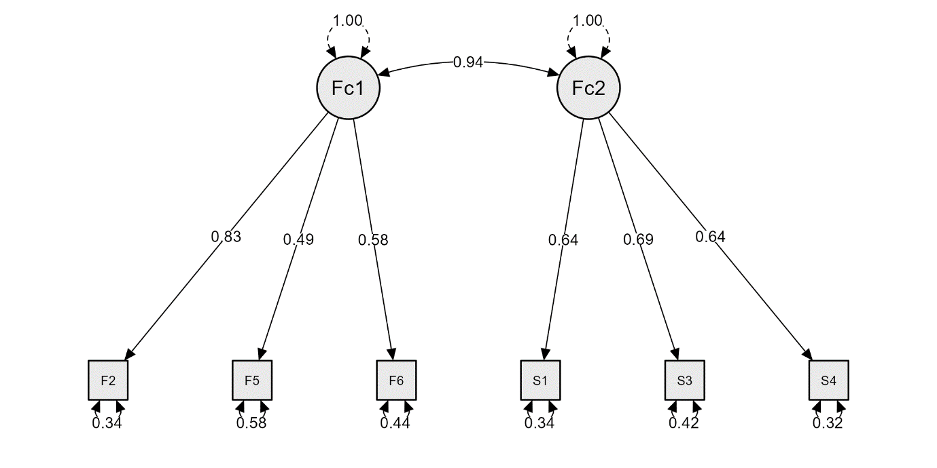

- Parental Attachment
Analisis Realibilitas
Frequentist Scale Reliability Statistics
Estimate |  | Cronbach's α
Point estimate |  | 0.853
95% CI lower bound |  | 0.812
95% CI upper bound |  | 0.887

Confirmatory Factor Analysis

Model fit
Chi-square test
Model |  | Χ² |  | df |  | p
Baseline model |  | 749.486 |  | 120
Factor model |  | 120.044 |  | 101 |  | 0.095

Additional fit measures
Fit indices
Index |  | Value
Comparative Fit Index (CFI) |  | 0.970
Tucker-Lewis Index (TLI) |  | 0.964
Bentler-Bonett Non-normed Fit Index (NNFI) |  | 0.964
Bentler-Bonett Normed Fit Index (NFI) |  | 0.840
Parsimony Normed Fit Index (PNFI) |  | 0.707
Bollen's Relative Fit Index (RFI) |  | 0.810
Bollen's Incremental Fit Index (IFI) |  | 0.971
Relative Noncentrality Index (RNI) |  | 0.970

Information criteria
 |  | Value
Log-likelihood |  | -2181.636
Number of free parameters |  | 51.000
Akaike (AIC) |  | 4465.272
Bayesian (BIC) |  | 4610.725
Sample-size adjusted Bayesian (SSABIC) |  | 4449.435

Other fit measures
Metric |  | Value
Root mean square error of approximation (RMSEA) |  | 0.038
RMSEA 90% CI lower bound |  | 0.000
RMSEA 90% CI upper bound |  | 0.063
RMSEA p-value |  | 0.761
Standardized root mean square residual (SRMR) |  | 0.061
Hoelter's critical N (α = .05) |  | 134.773
Hoelter's critical N (α = .01) |  | 147.048
Goodness of fit index (GFI) |  | 0.995
McDonald fit index (MFI) |  | 0.928
Expected cross validation index (ECVI) |  | 1.735

R-Squared
 |  | R²
T2 |  | 0.387
T3 |  | 0.258
T9 |  | 0.237
T12 |  | 0.357
T22 |  | 0.627
C7 |  | 0.397
C14 |  | 0.020
C15 |  | 0.674
C16 |  | 0.354
C19 |  | 0.445
C25 |  | 0.395
A10 |  | 0.478
A11 |  | 0.426
A8 |  | 0.171
A17 |  | 0.657
A18 |  | 0.406

Parameter estimates
Factor loadings
 |  |  |  |  |  |  |  |  |  |  |  |  |  | 95% Confidence Interval
Factor |  | Indicator |  | Symbol |  | Estimate |  | Std. Error |  | z-value |  | p |  | Lower |  | Upper
Factor 1 Trust |  | T2 |  | λ11 |  | 0.350 |  | 0.066 |  | 5.326 |  | < .001 |  | 0.221 |  | 0.479
 |  | T3 |  | λ12 |  | 0.334 |  | 0.074 |  | 4.528 |  | < .001 |  | 0.190 |  | 0.479
 |  | T9 |  | λ13 |  | 0.432 |  | 0.075 |  | 5.737 |  | < .001 |  | 0.285 |  | 0.580
 |  | T12 |  | λ14 |  | 0.465 |  | 0.062 |  | 7.546 |  | < .001 |  | 0.344 |  | 0.586
 |  | T22 |  | λ15 |  | 0.467 |  | 0.056 |  | 8.318 |  | < .001 |  | 0.357 |  | 0.577
Factor 2 communication |  | C7 |  | λ21 |  | 0.605 |  | 0.083 |  | 7.317 |  | < .001 |  | 0.443 |  | 0.767
 |  | C14 |  | λ22 |  | 0.128 |  | 0.100 |  | 1.283 |  | 0.199 |  | -0.067 |  | 0.323
 |  | C15 |  | λ23 |  | 0.673 |  | 0.070 |  | 9.580 |  | < .001 |  | 0.535 |  | 0.810
 |  | C16 |  | λ24 |  | 0.537 |  | 0.081 |  | 6.595 |  | < .001 |  | 0.378 |  | 0.697
 |  | C19 |  | λ25 |  | 0.553 |  | 0.074 |  | 7.507 |  | < .001 |  | 0.409 |  | 0.698
 |  | C25 |  | λ26 |  | 0.580 |  | 0.077 |  | 7.511 |  | < .001 |  | 0.429 |  | 0.731
Factor 3 allienation |  | A10 |  | λ31 |  | 0.553 |  | 0.090 |  | 6.124 |  | < .001 |  | 0.376 |  | 0.731
 |  | A11 |  | λ32 |  | 0.570 |  | 0.078 |  | 7.294 |  | < .001 |  | 0.417 |  | 0.724
 |  | A8 |  | λ33 |  | 0.400 |  | 0.094 |  | 4.253 |  | < .001 |  | 0.216 |  | 0.585
 |  | A17 |  | λ34 |  | 0.705 |  | 0.064 |  | 11.091 |  | < .001 |  | 0.581 |  | 0.830
 |  | A18 |  | λ35 |  | 0.592 |  | 0.064 |  | 9.261 |  | < .001 |  | 0.467 |  | 0.718

Factor variances
 |  |  |  |  |  |  |  |  |  | 95% Confidence Interval
Factor |  | Estimate |  | Std. Error |  | z-value |  | p |  | Lower |  | Upper
Factor 1 Trust |  | 1.000 |  | 0.000 |  |  |  |  |  | 1.000 |  | 1.000
Factor 2 communication |  | 1.000 |  | 0.000 |  |  |  |  |  | 1.000 |  | 1.000
Factor 3 allienation |  | 1.000 |  | 0.000 |  |  |  |  |  | 1.000 |  | 1.000

Factor Covariances
 |  |  |  |  |  |  |  |  |  |  |  |  |  | 95% Confidence Interval
 |  |  |  |  |  | Estimate |  | Std. Error |  | z-value |  | p |  | Lower |  | Upper
Factor 1 Trust |  | ↔ |  | Factor 2 communication |  | 0.807 |  | 0.068 |  | 11.843 |  | < .001 |  | 0.673 |  | 0.941
Factor 1 Trust |  | ↔ |  | Factor 3 allienation |  | -0.854 |  | 0.069 |  | -12.459 |  | < .001 |  | -0.988 |  | -0.720
Factor 2 communication |  | ↔ |  | Factor 3 allienation |  | -0.702 |  | 0.097 |  | -7.274 |  | < .001 |  | -0.892 |  | -0.513

Residual variances
 |  |  |  |  |  |  |  |  |  | 95% Confidence Interval
Indicator |  | Estimate |  | Std. Error |  | z-value |  | p |  | Lower |  | Upper
T2 |  | 0.194 |  | 0.040 |  | 4.895 |  | < .001 |  | 0.116 |  | 0.272
T3 |  | 0.322 |  | 0.075 |  | 4.311 |  | < .001 |  | 0.175 |  | 0.468
T9 |  | 0.601 |  | 0.112 |  | 5.343 |  | < .001 |  | 0.380 |  | 0.821
T12 |  | 0.389 |  | 0.081 |  | 4.820 |  | < .001 |  | 0.231 |  | 0.547
T22 |  | 0.130 |  | 0.028 |  | 4.630 |  | < .001 |  | 0.075 |  | 0.185
C7 |  | 0.554 |  | 0.092 |  | 6.027 |  | < .001 |  | 0.374 |  | 0.735
C14 |  | 0.806 |  | 0.082 |  | 9.835 |  | < .001 |  | 0.645 |  | 0.966
C15 |  | 0.218 |  | 0.044 |  | 4.995 |  | < .001 |  | 0.133 |  | 0.304
C16 |  | 0.528 |  | 0.079 |  | 6.719 |  | < .001 |  | 0.374 |  | 0.681
C19 |  | 0.382 |  | 0.093 |  | 4.086 |  | < .001 |  | 0.199 |  | 0.565
C25 |  | 0.515 |  | 0.075 |  | 6.841 |  | < .001 |  | 0.367 |  | 0.662
A10 |  | 0.334 |  | 0.070 |  | 4.802 |  | < .001 |  | 0.198 |  | 0.470
A11 |  | 0.438 |  | 0.062 |  | 7.025 |  | < .001 |  | 0.316 |  | 0.560
A8 |  | 0.779 |  | 0.081 |  | 9.603 |  | < .001 |  | 0.620 |  | 0.938
A17 |  | 0.260 |  | 0.055 |  | 4.731 |  | < .001 |  | 0.152 |  | 0.367
A18 |  | 0.514 |  | 0.105 |  | 4.879 |  | < .001 |  | 0.308 |  | 0.721

Implied covariance matrix
T2 |  | T3 |  | T9 |  | T12 |  | T22 |  | C7 |  | C14 |  | C15 |  | C16 |  | C19 |  | C25 |  | A10 |  | A11 |  | A8 |  | A17 |  | A18
0.317
0.117 |  | 0.434
0.151 |  | 0.145 |  | 0.788
0.163 |  | 0.156 |  | 0.201 |  | 0.605
0.164 |  | 0.156 |  | 0.202 |  | 0.217 |  | 0.348
0.171 |  | 0.163 |  | 0.211 |  | 0.227 |  | 0.228 |  | 0.920
0.036 |  | 0.034 |  | 0.045 |  | 0.048 |  | 0.048 |  | 0.077 |  | 0.822
0.190 |  | 0.182 |  | 0.235 |  | 0.252 |  | 0.254 |  | 0.407 |  | 0.086 |  | 0.671
0.152 |  | 0.145 |  | 0.187 |  | 0.202 |  | 0.203 |  | 0.325 |  | 0.069 |  | 0.361 |  | 0.816
0.156 |  | 0.149 |  | 0.193 |  | 0.208 |  | 0.209 |  | 0.334 |  | 0.071 |  | 0.372 |  | 0.297 |  | 0.687
0.164 |  | 0.157 |  | 0.202 |  | 0.218 |  | 0.219 |  | 0.351 |  | 0.074 |  | 0.390 |  | 0.312 |  | 0.321 |  | 0.851
-0.166 |  | -0.158 |  | -0.204 |  | -0.220 |  | -0.221 |  | -0.235 |  | -0.050 |  | -0.261 |  | -0.209 |  | -0.215 |  | -0.225 |  | 0.640
-0.171 |  | -0.163 |  | -0.211 |  | -0.226 |  | -0.228 |  | -0.242 |  | -0.051 |  | -0.269 |  | -0.215 |  | -0.222 |  | -0.232 |  | 0.316 |  | 0.763
-0.120 |  | -0.114 |  | -0.148 |  | -0.159 |  | -0.160 |  | -0.170 |  | -0.036 |  | -0.189 |  | -0.151 |  | -0.156 |  | -0.163 |  | 0.222 |  | 0.228 |  | 0.939
-0.211 |  | -0.201 |  | -0.261 |  | -0.280 |  | -0.281 |  | -0.300 |  | -0.063 |  | -0.333 |  | -0.266 |  | -0.274 |  | -0.287 |  | 0.390 |  | 0.402 |  | 0.282 |  | 0.757
-0.177 |  | -0.169 |  | -0.219 |  | -0.235 |  | -0.236 |  | -0.252 |  | -0.053 |  | -0.280 |  | -0.223 |  | -0.230 |  | -0.241 |  | 0.328 |  | 0.338 |  | 0.237 |  | 0.418 |  | 0.865

Residual covariance matrix
T2 |  | T3 |  | T9 |  | T12 |  | T22 |  | C7 |  | C14 |  | C15 |  | C16 |  | C19 |  | C25 |  | A10 |  | A11 |  | A8 |  | A17 |  | A18
< .001
< .001 |  | < .001
0.010 |  | 0.047 |  | < .001
0.025 |  | < .001 |  | < .001 |  | < .001
0.005 |  | < .001 |  | < .001 |  | 0.002 |  | < .001
0.003 |  | < .001 |  | < .001 |  | 0.137 |  | < .001 |  | < .001
< .001 |  | 0.041 |  | < .001 |  | 0.029 |  | 0.007 |  | 0.044 |  | < .001
0.011 |  | < .001 |  | < .001 |  | 0.054 |  | 0.002 |  | 0.008 |  | < .001 |  | < .001
< .001 |  | < .001 |  | 0.020 |  | < .001 |  | < .001 |  | 0.018 |  | < .001 |  | < .001 |  | < .001
< .001 |  | 0.015 |  | < .001 |  | 0.048 |  | < .001 |  | < .001 |  | 0.008 |  | 0.010 |  | 0.029 |  | < .001
< .001 |  | 0.038 |  | < .001 |  | 0.013 |  | < .001 |  | < .001 |  | < .001 |  | < .001 |  | 0.027 |  | < .001 |  | < .001
0.011 |  | < .001 |  | < .001 |  | 0.038 |  | 0.003 |  | 0.073 |  | < .001 |  | 0.010 |  | 0.031 |  | 0.026 |  | 0.041 |  | < .001
0.007 |  | 0.037 |  | < .001 |  | 0.040 |  | 0.025 |  | < .001 |  | < .001 |  | 0.028 |  | < .001 |  | < .001 |  | < .001 |  | < .001 |  | < .001
< .001 |  | < .001 |  | < .001 |  | < .001 |  | < .001 |  | < .001 |  | < .001 |  | < .001 |  | < .001 |  | < .001 |  | < .001 |  | < .001 |  | 0.006 |  | < .001
0.016 |  | < .001 |  | 0.010 |  | 0.058 |  | < .001 |  | 0.066 |  | < .001 |  | 0.060 |  | 0.050 |  | 0.005 |  | < .001 |  | 0.043 |  | 0.034 |  | < .001 |  | < .001
0.023 |  | < .001 |  | < .001 |  | 0.004 |  | < .001 |  | < .001 |  | < .001 |  | 0.031 |  | < .001 |  | < .001 |  | < .001 |  | < .001 |  | < .001 |  | < .001 |  | < .001 |  | < .001

Modification Indices
Cross-loadings
 |  |  |  |  |  | Mod. Ind. |  | EPC
Factor 2 communication |  | → |  | A8 |  | 14.551 |  | -0.552
Factor 1 Trust |  | → |  | A8 |  | 11.042 |  | -0.811
Factor 3 allienation |  | → |  | C14 |  | 5.967 |  | -0.349
Factor 2 communication |  | → |  | T12 |  | 5.506 |  | 0.351
Factor 2 communication |  | → |  | A17 |  | 5.181 |  | 0.270

Residual covariances
 |  |  |  |  |  | Mod. Ind. |  | EPC
T12 |  | ↔ |  | C7 |  | 8.146 |  | 0.129
A10 |  | ↔ |  | A17 |  | 6.640 |  | 0.105
C16 |  | ↔ |  | A8 |  | 6.181 |  | -0.149
A8 |  | ↔ |  | A17 |  | 5.210 |  | -0.116
C25 |  | ↔ |  | A18 |  | 4.784 |  | -0.110
C15 |  | ↔ |  | A18 |  | 4.554 |  | 0.080

Plots

Model plot
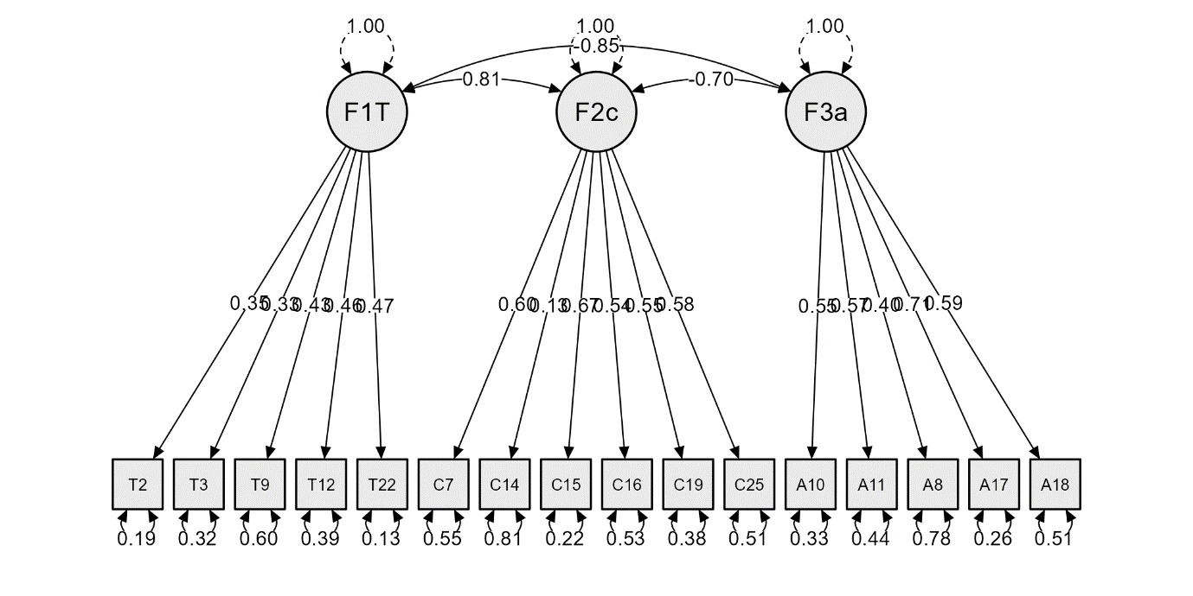

# Factors
Factor1 =~ lambda_1_1*T2 + lambda_1_2*T3 + lambda_1_3*T9 + lambda_1_4*T12 + lambda_1_5*T22
Factor2 =~ lambda_2_1*C7 + lambda_2_2*C14 + lambda_2_3*C15 + lambda_2_4*C16 + lambda_2_5*C19 + lambda_2_6*C25
Factor3 =~ lambda_3_1*A10 + lambda_3_2*A11 + lambda_3_3*A8 + lambda_3_4*A17 + lambda_3_5*A18

- Self-Esteem
Analisis Reabilitas
Frequentist Scale Reliability Statistics
Estimate |  | Cronbach's α
Point estimate |  | 0.821
95% CI lower bound |  | 0.768
95% CI upper bound |  | 0.864

Confirmatory Factor Analysis

Model fit
Chi-square test
Model |  | Χ² |  | df |  | p
Baseline model |  | 210.592 |  | 15
Factor model |  | 10.448 |  | 8 |  | 0.235

Additional fit measures
Fit indices
Index |  | Value
Comparative Fit Index (CFI) |  | 0.987
Tucker-Lewis Index (TLI) |  | 0.977
Bentler-Bonett Non-normed Fit Index (NNFI) |  | 0.977
Bentler-Bonett Normed Fit Index (NFI) |  | 0.950
Parsimony Normed Fit Index (PNFI) |  | 0.507
Bollen's Relative Fit Index (RFI) |  | 0.907
Bollen's Incremental Fit Index (IFI) |  | 0.988
Relative Noncentrality Index (RNI) |  | 0.987

Information criteria
 |  | Value
Log-likelihood |  | -849.857
Number of free parameters |  | 19.000
Akaike (AIC) |  | 1737.714
Bayesian (BIC) |  | 1791.902
Sample-size adjusted Bayesian (SSABIC) |  | 1731.814

Other fit measures
Metric |  | Value
Root mean square error of approximation (RMSEA) |  | 0.049
RMSEA 90% CI lower bound |  | 0.000
RMSEA 90% CI upper bound |  | 0.121
RMSEA p-value |  | 0.446
Standardized root mean square residual (SRMR) |  | 0.032
Hoelter's critical N (α = .05) |  | 190.975
Hoelter's critical N (α = .01) |  | 247.119
Goodness of fit index (GFI) |  | 0.997
McDonald fit index (MFI) |  | 0.990
Expected cross validation index (ECVI) |  | 0.379

R-Squared
 |  | R²
SC3 |  | 0.419
SC4 |  | 0.418
SC6 |  | 0.383
SC8 |  | 0.454
SL1 |  | 0.540
SL5 |  | 0.361

Parameter estimates
Factor loadings
 |  |  |  |  |  |  |  |  |  |  |  |  |  | 95% Confidence Interval
Factor |  | Indicator |  | Symbol |  | Estimate |  | Std. Error |  | z-value |  | p |  | Lower |  | Upper
Factor 1 |  | SC3 |  | λ11 |  | 0.483 |  | 0.069 |  | 7.011 |  | < .001 |  | 0.348 |  | 0.618
 |  | SC4 |  | λ12 |  | 0.603 |  | 0.081 |  | 7.406 |  | < .001 |  | 0.444 |  | 0.763
 |  | SC6 |  | λ13 |  | 0.474 |  | 0.067 |  | 7.015 |  | < .001 |  | 0.341 |  | 0.606
 |  | SC8 |  | λ14 |  | 0.527 |  | 0.071 |  | 7.426 |  | < .001 |  | 0.388 |  | 0.666
Factor 2 |  | SL1 |  | λ21 |  | 0.633 |  | 0.075 |  | 8.407 |  | < .001 |  | 0.486 |  | 0.781
 |  | SL5 |  | λ22 |  | 0.562 |  | 0.080 |  | 6.992 |  | < .001 |  | 0.404 |  | 0.719

Factor variances
 |  |  |  |  |  |  |  |  |  | 95% Confidence Interval
Factor |  | Estimate |  | Std. Error |  | z-value |  | p |  | Lower |  | Upper
Factor 1 |  | 1.000 |  | 0.000 |  |  |  |  |  | 1.000 |  | 1.000
Factor 2 |  | 1.000 |  | 0.000 |  |  |  |  |  | 1.000 |  | 1.000

Factor Covariances
 |  |  |  |  |  |  |  |  |  |  |  |  |  | 95% Confidence Interval
 |  |  |  |  |  | Estimate |  | Std. Error |  | z-value |  | p |  | Lower |  | Upper
Factor 1 |  | ↔ |  | Factor 2 |  | 0.936 |  | 0.082 |  | 11.352 |  | < .001 |  | 0.775 |  | 1.098

Residual variances
 |  |  |  |  |  |  |  |  |  | 95% Confidence Interval
Indicator |  | Estimate |  | Std. Error |  | z-value |  | p |  | Lower |  | Upper
SC3 |  | 0.324 |  | 0.047 |  | 6.948 |  | < .001 |  | 0.232 |  | 0.415
SC4 |  | 0.507 |  | 0.093 |  | 5.458 |  | < .001 |  | 0.325 |  | 0.689
SC6 |  | 0.361 |  | 0.054 |  | 6.692 |  | < .001 |  | 0.255 |  | 0.467
SC8 |  | 0.333 |  | 0.084 |  | 3.980 |  | < .001 |  | 0.169 |  | 0.498
SL1 |  | 0.341 |  | 0.076 |  | 4.501 |  | < .001 |  | 0.193 |  | 0.490
SL5 |  | 0.559 |  | 0.078 |  | 7.133 |  | < .001 |  | 0.406 |  | 0.713

Implied covariance matrix
SC3 |  | SC4 |  | SC6 |  | SC8 |  | SL1 |  | SL5
0.557
0.291 |  | 0.871
0.229 |  | 0.286 |  | 0.585
0.254 |  | 0.318 |  | 0.250 |  | 0.611
0.286 |  | 0.358 |  | 0.281 |  | 0.312 |  | 0.742
0.254 |  | 0.317 |  | 0.249 |  | 0.277 |  | 0.356 |  | 0.875

Residual covariance matrix
SC3 |  | SC4 |  | SC6 |  | SC8 |  | SL1 |  | SL5
< .001
0.020 |  | < .001
0.009 |  | 0.033 |  | < .001
0.016 |  | < .001 |  | < .001 |  | < .001
< .001 |  | < .001 |  | 0.016 |  | 0.030 |  | < .001
< .001 |  | 0.042 |  | < .001 |  | 0.030 |  | < .001 |  | < .001

Plots

Model plot
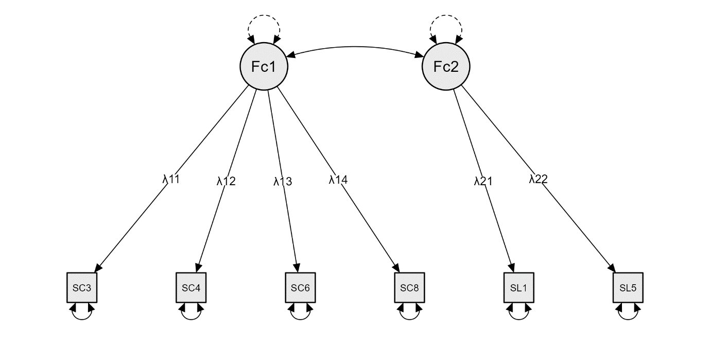

# Factors
Factor1 =~ lambda_1_1*SC3 + lambda_1_2*SC4 + lambda_1_3*SC6 + lambda_1_4*SC8
Factor2 =~ lambda_2_1*SL1 + lambda_2_2*SL5

