The Visitor Perception for Vegetation and The Existence of City Park, Tebing City, Sumatera Utara, Indonesia
Hafizah Arinah ¹, Orang Kaya Hasnanda Syahputra ², Suri Fadhilla², Wahyu Andayani³, Ratna Sari⁴, Jajang Setiawan⁵
¹ Faculty of Forestry, Universitas Sumatera Utara, Medan, Indonesia
² Faculty of Forestry, Gadjah Mada University, Jl. Agro No.1 Bulaksumur, Yogyakarta, Indonesia
³Agriculture and forest faculty, Universitas Satya Terra Bhinneka, Medan, Indonesia
⁴ Research Center for Biomass and Bioproducts, National Research and Innovation Agency, Cibinong, 16911, Indonesia
* Corresponding Author: Hafizaharinah@usu.ac.id
082168853793
Artikel diterima : ………….. (Tanggal tulisan diajukan). Revisi diterima : .................... 20xx.
ABSTRACT
One type of green open space crucial to creating a delightful, comfortable, and healthy urban environment for city dwellers is Tebing Tinggi City Park. This study aims to examine how tourists see the presence of City Park Tebing Tinggi City and its greenery. To conduct research, two steps must be completed: creating a study questionnaire and interviewing park visitors in Tebing Tinggi City Park. The generated data will be tallied, graphically represented, and subjected to qualitative analysis through descriptions. The socio-demographic traits and perceptions of the respondents were investigated using descriptive analysis. According to the observation findings, visitors' perceptions of Tebing Tinggi City Park are also adequate or good. These impressions encompass the park's easy accessibility, active functions and activities, comfort and impression quality, and social capacity for teamwork. Then, we discovered that most people had a positive opinion of vegetation, with 70% of respondents thinking that it has more positive effects on animals, shade, and air quality than negative ones.

Key words: city parks; vegetation; visitor perception; urban area.
INTRODUCTION
Tebing Tinggi City, located approximately 80 kilometers away from Medan, is one of the cities in North Sumatra. The geographical coordinates of Tebing Tinggi City are 30°9̡3̔ – 30°4̡50̕ North Latitude (N) and 99°4̍1̔ – 99°0̍0̕ East Longitude (BT). Tebing Tinggi has five (five) sub-districts, according to information from the North Sumatra Information and Communication Agency. Tebing Tinggi City has a total size of 38,438 km2. One of the green open areas in Tebing Tinggi is the municipal park, which is situated in the city center. The park's presence has helped Tebing Tinggi's pollution levels decline and has developed into a community recreation area. Because City Parks have a lot of trees planted in them, which serve as the animals' homes or habitats in Tebing Tinggi City Park, they also help to reduce urban pollution. (Sumatra Utara Badan Informasi dan Komunikasi, 2019).
Urban physical growth, meant to enhance human existence, has created its own set of issues due to poor planning. Infrastructural development and population increase to support urban economic activity result in environmental harm, including air and water pollution, loss of green open space, and impairment of water absorption processes. (KLHK Balitabang, 2014).
While the urban environment is growing economically, it is deteriorating environmentally. In Indonesia, cities are becoming more physically, mostly influenced by the quantity of infrastructure and amenities already in place. Green open spaces are so ignored, to the point where the lovely aspect of nature is lost. Green spaces are frequently abused or transformed into commercial, residential, industrial, and other municipal infrastructure and facilities. This is a concerning problem. Temperature fluctuations, declining groundwater levels, and land level variations are the three conditions that are most obviously altering due to air pollution. The deteriorating state disrupts the urban ecosystem (Sundari, 2010).
Prior studies on Tebing Tinggi's green space, including examining land use changes and development, have revealed that the city lacks green space (Lubis et al., 2021; Daulay et al., 2020). To create ideas for creating City Parks or green open spaces in the Tebing Tinggi City Park, research is being done on how visitors perceive the vegetation and the park's presence. This study aims to examine how visitors view the presence of Tebing Tinggi, a municipal park, and the vegetation.
MATERIALS AND METHODS
Participant Recruitment and Study Area
The study was Tebing Tinggi City Parkonducted in Tebing Tinggi City Park, North Sumatra, between October and November 2023. Its geographical coordinates are 30°9̍3̕ – 30°4̡50̕ North Latitude (N) and 99°4̍1̕ – 99°0̍0̕ East Longitude (BT). The requirements for visitors who are 12 years of age or older, as well as the methodology of incidental sampling and visitor determination. Approximately ten minutes were needed to finish the survey.
Data Collection Procedures
In this study, a closed-ended questionnaire was created, and 100 visitors to Tebing Tinggi City Park were interviewed using an incidental sampling technique to determine the respondents. A standardized questionnaire was used to gather data through in-person interviews. The respondents' demographic profile, including their gender, age, civil status, level of education, employment, and monthly income, was requested in the first section of the questionnaire. The respondents' opinions regarding vegetation and the existence of Tebing Tinggi City Park were questioned in the second section, which had the options for strongly agree, agree, disagree, and strongly disagree..
Questionnaire and Data Analysis
Descriptive statistics were employed in the study to examine respondents' demographic traits, views on vegetation, and the presence of City Parks. We inquired about accessibility, function, and activities in the first phase of a survey created by Tauhena (2019), which covered comfort facilities frequently discussed in City Parks. Data on participant demographics, such as age, gender, occupation, degree of education, and place of residence, were collected in the first section. Our study was based on the second part of a Drillet et al. (2020) survey listing 10 ecological disservices and 15 ecosystem services frequently connected to green urban environments. Participants were asked to score each statement on a five-point Likert scale ranging from strongly disagree to strongly agree. We presented the idea of City Park vegetation and included numerous contextualized examples at the start of the survey's second section. It was anticipated that by giving participants these examples, they would have a deeper comprehension of the study's subject, to which we included references in the statements. The statements related to the environmental services and disservices were addressed in Table 1 and included in the print-out questionnaire.

Table 1. The stateements related to the environmental services and disservices
No. | Statement | Ecosystem services type
Ecosistem services statements:
S1ª | It improves air quality | Regulating
S2ª | It provides me with shade | Regulating
S3ª | It supports wildlife that I enjoy | Cultural
S4ª | It is pleasing for me to look at | Cultural
S5ª | It encourages me to spend time outdoors | Cultural
S6ª | It provides opportunities for me to learn more about nature | Cultural
S7ª | It possesses spiritual or religious value | Cultural
S8ª | It provides me with a good place to socialize | Cultural
S9ª | It provides me with inspiration for art, creativity, and photography | Cultural
S10ª | It makes me feel better (e.g., it improves my longevity, relieves my feelings of stress, allows me to relax, etc.) | Cultural
S11ª | It reduces surrounding noise levels | Regulating
S12ª | It stores carbon
S13ª | It controls the effects of heavy rainfall and flooding | Regulating
S14ª | It provides food or useful materials | Provision
S15ª | It increases my interaction with wildlife | Regulating
Ecosystem disservices statements:
D1^{b} | It encourages the presence of general pests (e.g.,mosquitoes, rats, etc.) | NA^{c}
D2^{b} | It looks messy | NA^{c}
D3^{b} | It is a safety hazard to people and personal property | NA^{c}
D4^{b} | It is strong-smelling | NA^{c}
D5^{b} | It poses a crime risk | NA^{c}
D6^{b} | It makes me feel uneasy
D7^{b} | poses a risk of spreading mosquito-borne diseases (e. g., dengue) | NA^{c}
D8^{b} | It is damaging to sidewalks | NA^{c}
D9^{b} | It promotes wildlife i don't like
D10^{b} | It increases my interaction with wildlife which i don't like | NA^{c}
Notes: ªServices
^{b}Disservices
^{c}Not available
Results and Discussion
Socio-demographic Characteristics of Respondents
The descriptive analysis revealed that 60% of respondents were female and 40% were male. Over half of them were unmarried (84%), had completed high school (69%), and 80% did not yet have a job since they were primarily students (58%) and undergraduates (24%). Seventy percent of them are between the ages of twelve and twenty. The respondents' socio-demographic profile is shown in Table 2.
Table 2. Socio-demograpic profile of (n=100)
Socio-demographic variable | frequency | Percent (100%)
Gender
Male | 40 | 40
Female | 60 | 60
Total | 100 | 100%
Civil status
Single | 84 | 84
Married | 16 | 16
Total | 100 | 100%
Educational attainment
Primary | 1 | 1
Elementary | 23 | 23
High school | 69 | 69
undergraduate | 7 | 7
Master degree | 0 | 0
Doctorate | 0 | 0
Total | 100 | 100%
Occupation
Housewife | 0 | 0
Student | 58 | 58
Undergraduate student | 24 | 24
Private employe | 2 | 2
Civil servant | 1 | 1
Other | 15 | 15
Total | 100 | 100%
Income
< 2,5 Milion Rupiahs | 13 | 13
2,5 – 5 Milion Rupiahs | 3 | 3
5 – 7,5 Milion Rupiahs | 4 | 4
Not yet earning | 80 | 80
Total | 100 | 100%
Age group
12-20 | 70 | 70
21-30 | 22 | 22
31-40 | 6 | 6
41-50 | 2 | 2
Total | 100 | 100%
Visitor Perceptions of Tebing Tinggi City Park
The study's findings indicate that most people think the Tebing Tinggi City Park's amenities are comfortable, relationships are accessible, activities work well, and opportunities for social engagement are in good shape. According to (table 1), the neighborhood accepts that Tebing Tinggi Park's amenities security, cleanliness, coolness, seats, park lighting, and the park itself are pleasant and in good shape. The state of the amenities available to facilitate activities in Tebing Tinggi Park is correlated with the comfort of the facilities. This demonstrates that Tebing Tinggi Park is maintained and cared for. According to Gearin and Kahle (2006), people will feel more at ease doing activities in public open spaces if they are clean, as they are less likely to visit dirty public open spaces. People's comfort in public open spaces is further aided by the presence of amenities such park seats, lighting, garbage cans, and restrooms (Suhasman et al., 2017).
The public believes that there is a generally positive association between City Parks and accessibility. Table 2 illustrates this point by demonstrating that the City Park is free of impediments, has ample parking for guests, and is reasonably close to my residence. According to Project for Public Space (2004), relationships and accessibility specifically, how simple it is to physically and visually enter and observe public open spaces are crucial to their effectiveness. One of the things that determines whether or not people visit the park is how easy it is to get there and how far it takes to get there (Ilmiajayanti and Dewi, 2015).Most people also concur that Tebing Tinggi City Park is a joyful place to visit at any time of day and that its existence is crucial to the community (Table 3).
The social contacts of the general public or within a community provide evidence of the Tebing Tinggi City Park area's high social comfort factor. The majority of respondents concur that this City Park is a warm, pleasant, well-kept space that celebrates ethnicity, according to (table 4).
Comfort Facilities
The public firmly agrees that municipal parks have comfortable facilities, which is consistent with their assessment of the facilities' comfort level. Numerous indicators point to this, including the following: (1) Tebing Tinggi City Park is safe to visit; (2) It is kept clean; (3) The vegetation (trees and plants) offers shade and coolness during visits; (4) There are enough seats available for visitors to the Tebing Tinggi City Park; (5) The park lights work effectively; and (6) The Tebing Tinggi City Park is quite attractive. The table below (table 2) displays data gathered from observations and guests' opinions regarding the comfort levels of Tebing Tinggi City Park facilities.
Table 3. Visitors perceptions of the comfort of Tebing Tinggi City Park facilities
No | Variable | Perception |  | Information
No | Variable | Questionnaire |  | Information
1 | Security | The number of choices that strongly agree is 18%, the number of choices that agree is 60%, the number of neutral choices is 20%, the number of choices that disagree and strongly disagree is 1% | 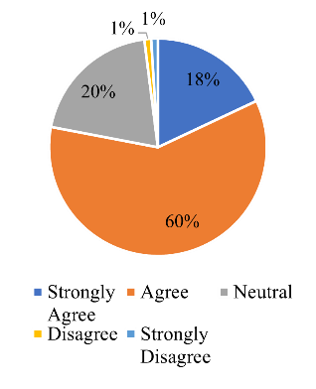 | The dominant visitor perception agrees that City Parks are safe to visit.
2 | Cleanliness | The number of choices that strongly agree is 10%, the number of choices that agree is 58%, the number of neutral choices is 30%, the number of choices that disagree and strongly disagree is 1% | 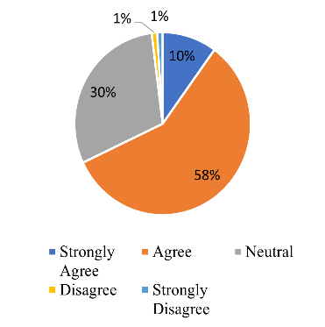 | The dominant visitor perception agrees that Tebing Tinggi City Park is clean
3 | Vegetation | The number of strongly agree choices was 17%, the number of agree choices was 52%, the number of neutral choices was 28%, the number of disagree choices was 1%, and the number of strongly disagree was 2% | 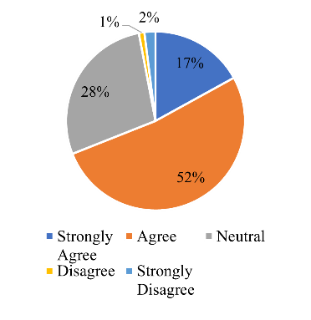 | The dominant visitor perception agrees that the vegetation is calming and soothing.
4 | Seat | The number of strongly agreed choices was 10%, the number of agree choices was 52%, the number of neutral choices was 32%, the number of disagree choices was 4%, and the number of strongly disagree was 2%. | 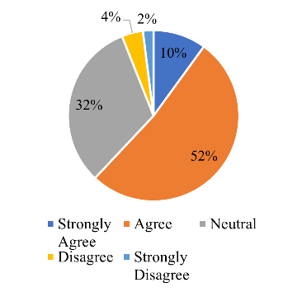 | The dominant visitor perception agrees that there is enough seating available for visitors.
5 | Garden lamp | The number of strongly agreed choices was 15%, the number of agree choices was 48%, the number of neutral choices was 32%, the number of disagree choices was 3%, and the number of strongly disagree was 2%. | 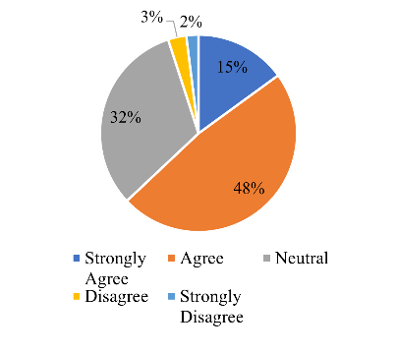 | The dominant visitor perception agrees that the park lights function well.
6 | Attractiveness | The number of strongly agreed choices was 12%, the number of agree choices was 42%, the number of neutral choices was 35%, the number of disagree choices was 8%, and the number of strongly disagree was 3%. | 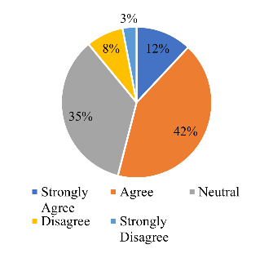 | The dominant visitor perception agrees that City Parks are quite interesting.

Relationship Accessibility
The public believes that City Parks have generally good accessibility relations, which is the same value as the public's perception of accessibility. This is evident from some factors, including: (1) The City Park is excellent and free of barriers; (2) There is ample parking for cars visiting the park; and (3) The distance is reasonably priced and close to your home. Table 4 below displays data gathered from observations and guests' opinions regarding City Parkthe accessibility of Tebing Tinggi City Park links.
Table 4. Visitors' perceptions of the accessibility of Tebing Tinggi City Park connections
No | Variable | Perception |  | Information
No | Variable | Questionnaire |  | Information
1 | Obstacle | The number of strongly agree choices is 10%, the number of agree choices is 52%, the number of neutral choices is 32%, the number of disagree choices is 4% and the number of strongly disagree is 2% | 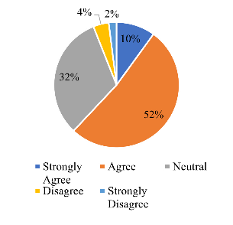 | The dominant visitor perception agrees that City Parks are safe to visit.
2 | Parking lot | The number of strongly agreed choices was 15%, the number of agree choices was 48%, the number of neutral choices was 32%, the number of disagree choices was 3% and the number of strongly disagree was 2%. | 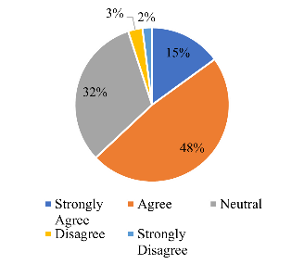 | The dominant visitor perception agrees that the Tebing Tinggi City Park is clean.
3 | Mileage | The number of strongly agreed choices was 12%, the number of agree choices was 42%, the number of neutral choices was 35%, the number of disagree choices was 8%, and the number of strongly disagree was 3%. | 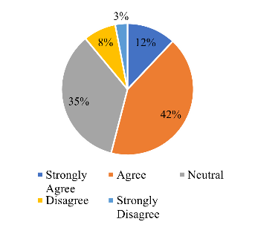 | The dominant visitor perception agrees that the vegetation is calming and soothing.

Activity and Activity Functions
Public opinion on accessibility is similar to public opinion on the value of municipal parks' features and offerings. Several evidence point to this, including the following: (1) the delight that comes from visiting the Tebing Tinggi City Park; (2) the park's open-access nature; and (3) the significance of the park's presence for the Tebing Tinggi. Table 5 below displays information gathered from observations and guests' opinions regarding the features and operations of the Tebing Tinggi City Park.
Table 5. Visitors' perceptions of the functions and activities of the Tebing Tinggi City Park
No | Variable | Perception |  | Information
No | Variable | Questionnaire |  | Information
1 | Happiness | The number of choices that strongly agree is 13%, the number of choices that agree is 56%, the number of neutral choices is 25%, the number of choices that disagree and strongly disagree is 3% | 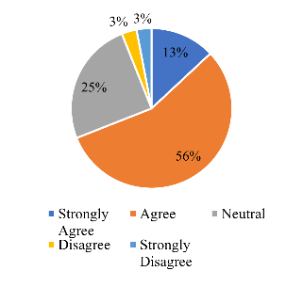 | The dominant perception of visitors agrees that visiting City Parks creates a feeling of pleasure.
2 | Flexibility to visit | The number of strongly agree choices is 24%, the number of agree choices is 58%, the number of neutral choices is 13%, the number of disagree choices is 3%, and the number of strongly disagree is 2% | 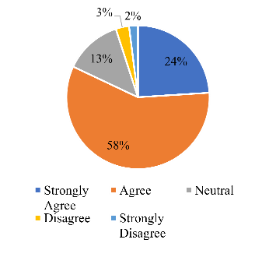 | The dominant visitor perception agrees that the Tebing Tinggi City Park can be visited at any time
3 | existence | The number of choices that strongly agree is 18%, the number of choices that agree is 60%, the number of neutral choices is 16%, the number of choices that disagree and strongly disagree is 3% | 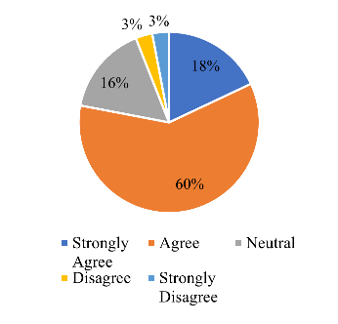 | The dominant perception of visitors agrees that the existence of the Tebing Tinggi City Park is important.
Social Interaction Ability
The public's perception of accessibility is the same point of view that the public agrees that the Tebing Tinggi City Park can create quite good social interaction. This can be seen from several indicators, namely: (1) Friendliness, (2) Friendliness, (3) Management, (4) Nationality. Data from observations and visitors' perceptions of the social interaction capabilities of Tebing Tinggi City Park can be seen in (Table 6) below.
Table 6. Visitors perceptions of the social interaction capabilities of Tebing Tinggi City Park
No | Variables | Perception |  | Information
No | Variables | Questionnaire |  | Information
1 | Friendliness | The number of strongly agree choices is 17%, the number of agree choices is 57%, the number of neutral choices is 23%, the number of disagree choices is 2% and the number of strongly disagree is 1% | 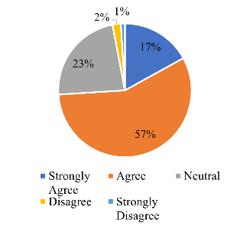 | The dominant visitor perception agrees that Tebing Tinggi City Park has friendly social interactions.
2 | Friendly | The number of strongly agree choices is 16%, the number of agree choices is 57%, the number of neutral choices is 23%, the number of disagree choices is 4%, and none strongly disagree. | 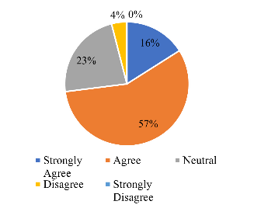 | The dominant visitor perception agrees that the Tebing Tinggi City Park is a friendly place.
3 | Management | The number of strongly agree choices is 11%, the number of agree choices is 60%, the number of neutral choices is 25%, the number of disagree choices is 4%, and none strongly disagree. | 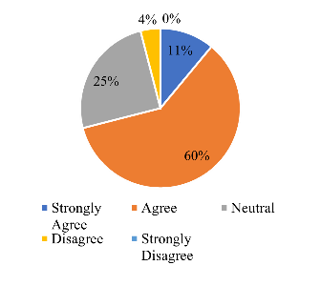 | The dominant perception of visitors is that Tebing Tinggi City Park management is good.
4 | Nationality | The number of strongly agree choices is 12%, the number of agree choices is 62%, the number of neutral choices is 23%, the number of disagree choices is 2% and the number of strongly disagree is 1% | 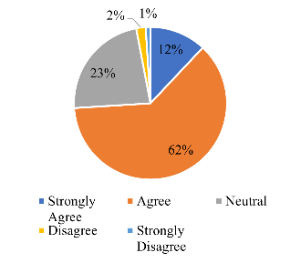 | The dominant perception of visitors agrees that Tebing Tinggi City Park can increase nationality
The visitor perception of vegetation in City Park Tebing Tinggi
The study also looked at how visitors felt about the plants in Tebing Tinggi City Park. The results indicate that most respondents agreed with the assertions about the ecosystem services that the vegetation in Tebing Tinggi City Park provides while disagreeing with the comments about the park's disadvantages. Just over 11% of the sample population disagreed with urban greenery's advantages, while 5% agreed with its drawbacks. Before and after applying the poststratification technique, there is a clear positive view of vegetation's ecological benefits. However, it is important to note that the degree of positivism somewhat declines with the application of data weighting. This implies that individuals belonging to marginalized groups who bear a greater burden following the weighting process display a less optimistic outlook.
This survey's conclusions are fairly consistent with those of earlier research. In a study done in Berlin and Cologne, Weber et al. (2014) discovered that the vegetation along the urban roadside was well-liked for city people. Plants and well-maintained greenery. However, were somewhat more favored. The results of a study by Camacho-Cervantes et al. (2014) in Morelia, west-central Mexico, showed that people are more interested in the advantages of trees and think that more should be planted in urban areas, even though they think that trees can cause harm. On the other hand, according to Drillet et al. (2020), about -thirds of Singaporeans think vegetation should be regarded as a necessary component of the urban environment since it offers ecosystem services. An additional study finding compared to Because it can prevent solar hazards and lessen urban pollution, vegetation in City Parks needs to be controlled (Russo et al., 2017).
In our study, the majority of respondents agreed that (D7, 7% agreement) It increases the risk of mosquito-borne diseases (like dengue) and (D1, 6% agreement) It fosters the presence of general pests (like rats, mosquitoes, and others). Disease vectors could be to blame for this, particularly for dengue fever, which is spread by mosquitoes that prefer to build their nests in particular kinds of flora (Agustina et al., 2019).
Nonetheless, participants were unsure in many of their answers regarding ecosystem disservices. More than 20% of voters chose to neither agree nor disagree with some assertions. The notion held by many participants that the sheer existence of vegetation does not imply benefits may be the cause of a large number of indifferent votes. People's perceptions might have been affected by additional circumstances as well. 22% of respondents said they were unsure, which may indicate that it depends on the type of vegetation (trees, shrubs, or grasses), the location, and the management technique. According to our research, people would rather live nearer to nature—but only in ways that satisfy their desire for control over the natural world. Future research should examine if people's perceptions vary based on the type of vegetation or how well-maintained it is; however, this is outside the purview of this study.
It should be noted that, despite their strong opinion of the ecosystem services that vegetation offers, participants may not have realized, when filling out the questionnaire, that certain vegetation-related concerns may directly impact them later on. Trees outside their residences may cause damage to walkways or cause leaves to fall, affecting how they view vegetation. Personal experiences have been known to cause these shifts in perspective; for example, environmental programs that are initially generally supported may subsequently be turned away by those who believe they would be clearly impacted (Scott et al., 2016).
Perception of City Park' 'Park's Vegetation Related to Ecosystem Services
Based on the information displayed in Fig. 1, replies to statements about ecosystem services were generally positive. The assertions regarding the ecosystem services given by vegetation were largely agreed upon (agree and strongly agree) by nearly two thirds of the participants.

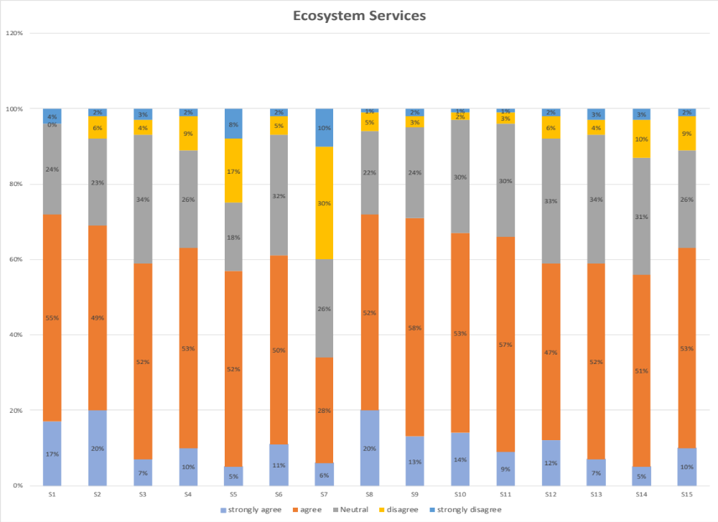
Fig. 1. Ecosystem services
Only the argument "It possesses spiritual or religious value" (S7) deviated from the norm regarding response patterns. Regarding visitor perception, 34% agreed that the vegetation in the City Park has a spiritual value, 40% disagreed, and 26% voted neutrally. 71% of participants said that the City Park's greenery is It gives them a nice area to socialize (S8), inspires them to create art and take pictures (S9), and enhances the quality of the air (S1). The agreement rate for the remaining statements was greater than 56%. Considering that S1 and S2 are associated with regulatory services, S3, S4, S5, and S10 pertain to the delivery of cultural services.
The group of individuals who disagreed with some of the statements made in the questionnaire (Fig. 1) is the more unexpected feature of the results. Except for S7 and S5 (spiritual value, spend time outdoors), the majority of participants did not disagree, with a mean of 11% throughout. Nevertheless, contrary to expectations, the decline in the number of participants who agreed with some claims was accompanied by a rise in the percentage of those who disagreed.
Perception of Vegetation Associated with Ecosystem Disservices
Now, see (Fig. 2) at the comments regarding ecological disservices. It was discovered that over two-thirds of the sample disagreed with the notion that vegetation causes environmental difficulties. When asked if it inspires them for art, creativity, and photography (S9), 71% of respondents agreed. This is congruent with the negative that people disagreed with the most, which was that it seems disorganized (D2). It poses a safety concern to persons and personal property, which was the second most disagreed with statement, with 74% of respondents agreeing. Regarding the remaining statements, the rejection percentage was close to 70% (strongly disagree and disagree).
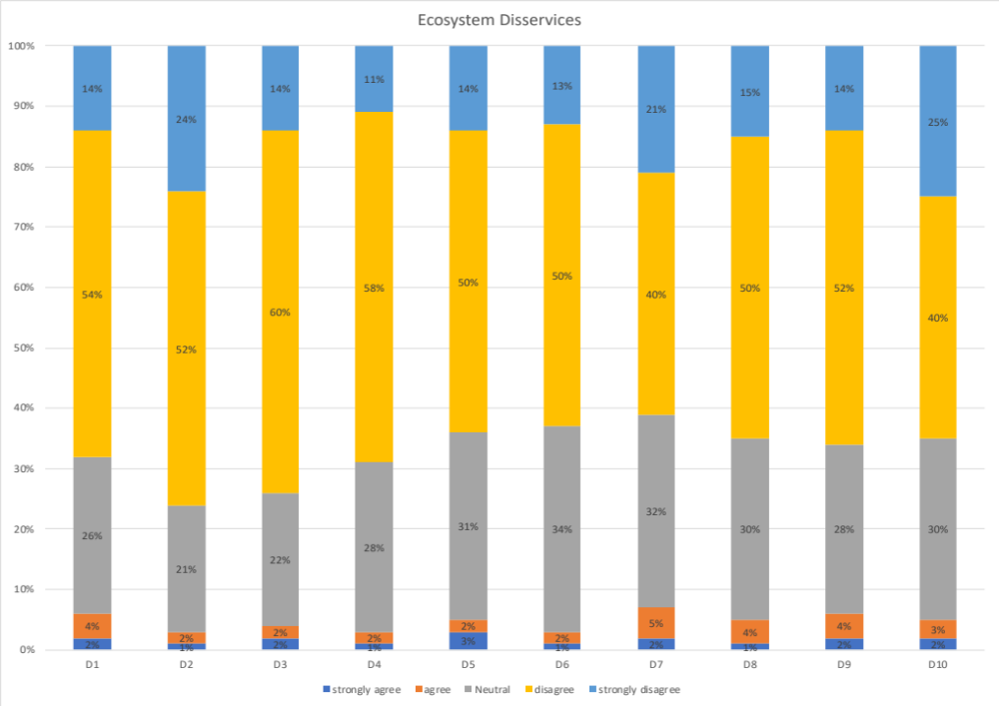
Fig. 2. Ecosystem disservices
Overall, a much smaller proportion of respondents concurred with the disservices than disagreed with the services is noteworthy. We also observed an overall increase in respondents who were unsure and chose to vote neither agree nor disapprove of this collection of statements. However, the percentage of respondents who thought that vegetation has negative consequences was significantly higher for two particular items.
CONCLUSIONS
The study's findings indicate that most individuals in are in favor of the existence of City ParksCity Park because the community assigned aspects of Tebing Tinggi City Park, like safety, cleanliness, and vegetation, a score higher than 60%, visitors' impressions and perceptions of the park are satisfied or good. In addition, the public's impressions of the benefits and drawbacks of the vegetation in Tebing Tinggi City Park are shown in the perception of the vegetation there. Views of vegetation in Tebing Tinggi City Park are overwhelmingly positive, and it is evident that people find the services they offer advantageous

ACKNOWLEDGMENTS

The authors are grateful to Universitas Sumatera Utara, Medan, Indonesia for funding this research through the Talenta Grant Scheme Fundamental Research No. 1507/UN5.2.1.15/KPM/2023, and also to the Ministry of Education and Culture, Republic of Indonesia.

REFERENCES
Agustina, E., Sari, W., and Ofreza, A. (2019). Preferensi Tanaman Tempat Aktivitas Aedes di Pekarangan Rumah Desa Kopelma Banda Aceh. Journal of Vector-borne Disease Studies 11(1): 59-66.
Camacho-Cervantes, M., Schondube, J. E., Castillo, A., and MacGregor-Fors, I., (2014). How do People Perceive Urban Trees? Assessing Likes and Dislikes in Relation to the Trees of a City. Urban Ecosyst 17(3): 761–773. https://doi.org/10.1007/s11252-014-0343-6.
Dahlan, E. 1992. Hutan Kota Untuk Pengelolaan dan Peningkatan Kualitas Lingkungan. Buku. APHI. Jakarta
Dahlan, E. 2006. Studi Kemampuan Tanaman dalam Menyerap Timbal Emisi dari Kendaraan Bermotor. Fakultas Pasca Sarjana. IPB. Bogor.
Daulay, Meilina, A., Purwoko, and Sirojuzilam. Analysis Of Green Open Space Development, Tebing Tinggi Kota Sub-District, Tebing Tinggi City. EPRA International Journal of Research and Development (IJRD) Volume: 5 | Issue: 11 | November 2020- Peer Reviewed Journal ISSN: 2455-7838 (Online).
Drillet, Z., Fung, T., Leong, R., Sachidhanandam, U., Edwards, P., and Richards, D., 2020. Urban Vegetation Types are not Perceived Equally in Providing Ecosystem Services and Disservices. Sustainability 12(5): 2076. https://doi.org/10.3390/su12052076.
Gearin, E., and Kahle, C. 2006. Teen and Adult Perceptions of Urban Green Spaces Los Angeles. Journal of Children, Youth and Environments 16(1): 2548.
Ibrahim, T., Martosenjoyo, T., and A M Radja. 2019. Persepsi Pengunjung Terhadap Kenyamanan Fasilitas Ruang Terbuka Publik Fort Rotterdam. Nature: National Academic Journal of Architecture.
Ilmiajayanti, F., and Dewi, D., I., K. 2015. Persepsi Pengguna Taman Tematik Kota Bandung Terhadap Aksesibilitas dan Pemanfaatannya. Ruang. 1(1): 21-30.
Lubis, D., Parlaungan, D., W., Nurwihastuti, M., and Sintong. 2021. Analysis of Land Use Changes for Green Open Space (Gos) in Tebingtinggi City. ICOSTA 2020 IOP Publishing. Journal of Physics: Conference Series 1811 (2021) 012024 doi:10.1088/1742-6596/1811/1/012024.
Lussetyowati. 2011. Analisa Penyediaan Ruang Terbuka Hijau Perkotaan Studi, Kasus Kota Martapura. Fakultas Teknik Universitas Sriwijaya. Martapur.
Marcus, C., C., and Francis C. 1998. People Places Design Guideline for Urban Space. New York: Van Nostrand Reinhold.
Miardini, A. 2006. Analisis Kesehatan Pohon di Kebun Raya Bogor. Departemen Konservasi Sumberdaya Hutan dan Ekowisata Fakultas Kehutanan Institut Pertanian Bogor. Bogor
Peraturan Menteri No. 5 Tahun 2008 Hal: 5-6 . Fungsi Ruang Terbuka Hijau Pada Kawasan Perkotaan.
Suhasman, Agussalim, N., Yusuf. 2017. Analisis Persepsi Masyarakat Terhadap Taman di Kota Makassar. Jurnal Inovasi dan Pelayanan Publik Makassar 1(2): 1-10.
Retrieved from https://www.pps.org on 02 Feb 2024
Russo, A., Escobedo, F., J., Cirella, G., T., and Zerbe, S. 2017. Edible Green Infrastructure: an Approach and Review of Provisioning Ecosystem Services and Disservices in Urban Environments. Agriculture, Ecosystems & Environment 242: 53–66.https://doi.org/10.1016/j.agee.2017.03.026.
Suhasman, Agussalim, and N. Yusuf. 2017. Analisis Persepsi Masyarakat Terhadap Taman di Kota Makassar. Jurnal Inovasi dan Pelayanan Publik Makassar 1(2): 1-10.
Scott, J., Kikken, M., Rose, M., and Colyer, P. 2016. Nimbyism and Nature: Whose Backyard is It Anyway?. In: Balanced Urban Development: Options and Strategies for Liveable Cities, 72 Springer International Publishing, pp. 29–43. https://doi.org/10.1007/ 978-3-319-28112-4_3.

