DATA PENDUKUNG PENELITIAN
Lampiran 1. Diagram pelaksanaan penelitian
Mulai

Penyediaan pupuk kompos
Penyediaan media tanam

Penyediaan semai

Persiapan lokasi penelitian

Pengisian polybag

Perlakuan pendahuluan media tanam

Penyapihan

Pemeliharaan

Pengamatan

Selesai

Lampiran 2. Bagan percobaan rancangan acak lengkap (RAL)
D4.1
D1.4
D2.4
D4.3
D2.1
D4.2
D1.5
D2.2
D4.4
D2.3
D4.5
D1.1
D1.3
D3.5
D3.3
D3.2
D2.5
D3.1
D3.4
D1.2

15 cm

15 cm

Keterangan:
D1, D2, D3, D4 : Jenis pemberian perlakuan
1, 2, 3, 4, 5 : Ulangan

Lampiran 3. Hasil analisis sidik ragam Pengaruh Pemberian Pupuk Kompos Terhadap Pertumbuhan Semai Paraserianthes falcataria Pada Media Tanam Bekas Tambang Emas
a. Persentase hidup
Sumber Keragaman | DB | JK | KT | F.Hitung | F.Tabel
Perlakuan | 3 | 2620 | 873,33 | 14,56* | 3,24
Galat | 16 | 960 | 60
Total | 19 | 3580
KK = 8,51
* = Signifikan
b. Pertambahan tinggi
Sumber Keragaman | DB | JK | KT | F.Hitung | F.Tabel
Perlakuan | 3 | 1120,54 | 373,51 | 28,26* | 3,24
Galat | 16 | 211,44 | 13,21
Total | 19 | 1331,98
KK = 18,83
* = Signifikan
c. Pertambahan diameter
Sumber Keragaman | DB | JK | KT | F.Hitung | F.Tabel
Perlakuan | 3 | 8,53 | 2,843 | 22,40* | 3,24
Galat | 16 | 2,03 | 0,127
Total | 19 | 10,56
KK = 17,54
* = Signifikan

d. Berat kering tanaman
Sumber Keragaman | DB | JK | KT | F.Hitung | F.Tabel
Perlakuan | 3 | 52,69 | 17,56 | 63,03* | 4,07
Galat | 8 | 2,23 | 0,28
Total | 11 | 54,92
KK = 13,20
* = Signifikan
e. Rasio tajuk akar
Sumber Keragaman | DB | JK | KT | F.Hitung | F.Tabel
Perlakuan | 3 | 22,34 | 7,45 | 42,40* | 4,07
Galat | 8 | 1,40 | 0,18
Total | 11 | 23,74
KK = 9,26
* = Signifikan

Lampiran 4. Hasil uji SPSS antar perlakuan Pengaruh Pemberian Pupuk Kompos Terhadap Pertumbuhan Semai Paraserianthes falcataria Pada Media Tanam Bekas Tambang Emas
a. Persentase hidup
Between-Subjects Factors
 |  | Value Label | N
perlakuan | D1 | D1 | 5
perlakuan | D2 | D2 | 5
perlakuan | D3 | D3 | 5
perlakuan | D4 | D4 | 5

Tests of Between-Subjects Effects
Dependent Variable: persenhidup
Source | Type III Sum of Squares | Df | Mean Square | F | Sig.
Corrected Model | 2620.000ª | 3 | 873.333 | 14.556 | .000
Intercept | 165620.000 | 1 | 165620.000 | 2760.333 | .000
Perlakuan | 2620.000 | 3 | 873.333 | 14.556 | .000
Error | 960.000 | 16 | 60.000
Total | 169200.000 | 20
Corrected Total | 3580.000 | 19
a. R Squared = .732 (Adjusted R Squared = .682)

Persenhidup
Duncan^{a,b}
Perlakuan | N | Subset
Perlakuan | N | 1 | 2
D1 | 5 | 72.0000
D2 | 5 |  | 92.0000
D3 | 5 |  | 100.0000
D4 | 5 |  | 100.0000
Sig. |  | 1.000 | .140
Means for groups in homogeneous subsets are displayed.
Based on observed means.
The error term is Mean Square(Error) = 60.000.
a. Uses Harmonic Mean Sample Size = 5.000.
b. Alpha = ,05.

b. Pertambahan tinggi
Between-Subjects Factors
 |  | Value Label | N
perlakuan | D1 | D1 | 5
perlakuan | D2 | D2 | 5
perlakuan | D3 | D3 | 5
perlakuan | D4 | D4 | 5

Tests of Between-Subjects Effects
Dependent Variable: tinggi
Source | Type III Sum of Squares | Df | Mean Square | F | Sig.
Corrected Model | 1120.543ª | 3 | 373.514 | 28.264 | .000
Intercept | 7456.750 | 1 | 7456.750 | 564.264 | .000
Perlakuan | 1120.543 | 3 | 373.514 | 28.264 | .000
Error | 211.440 | 16 | 13.215
Total | 8788.732 | 20
Corrected Total | 1331.983 | 19
a. R Squared = ,841 (Adjusted R Squared = ,811)

Tinggi
Duncan^{a,b}
Perlakuan | N | Subset
Perlakuan | N | 1 | 2 | 3
D1 | 5 | 7.7240
D2 | 5 |  | 17.7800
D3 | 5 |  |  | 24.9800
D4 | 5 |  |  | 26.7520
Sig. |  | 1.000 | 1.000 | .452
Means for groups in homogeneous subsets are displayed.
Based on observed means.
The error term is Mean Square(Error) = 13,215.
a. Uses Harmonic Mean Sample Size = 5,000.
b. Alpha = ,05.

c. Pertambahan diameter
Between-Subjects Factors
 |  | Value Label | N
perlakuan | D1 | D1 | 5
perlakuan | D2 | D2 | 5
perlakuan | D3 | D3 | 5
perlakuan | D4 | D4 | 5

Tests of Between-Subjects Effects
Dependent Variable: diameter
Source | Type III Sum of Squares | df | Mean Square | F | Sig.
Corrected Model | 8.528ª | 3 | 2.843 | 22.395 | .000
Intercept | 82.499 | 1 | 82.499 | 649.958 | .000
Perlakuan | 8.528 | 3 | 2.843 | 22.395 | .000
Error | 2.031 | 16 | .127
Total | 93.058 | 20
Corrected Total | 10.559 | 19
a. R Squared = .808 (Adjusted R Squared = .772)

Diameter
Duncan^{a,b}
Perlakuan | N | Subset
Perlakuan | N | 1 | 2 | 3
D1 | 5 | .9800
D2 | 5 |  | 2.0040
D3 | 5 |  | 2.4720 | 2.4720
D4 | 5 |  |  | 2.6680
Sig. |  | 1.000 | .054 | .397
Means for groups in homogeneous subsets are displayed.
Based on observed means.
The error term is Mean Square(Error) = .127.

a. Uses Harmonic Mean Sample Size = 5.000.
b. Alpha = ,05.

d. berat kering tanaman
Between-Subjects Factors
 |  | Value Label | N
Perlakuan | D1 | D1 | 3
Perlakuan | D2 | D2 | 3
Perlakuan | D3 | D3 | 3
Perlakuan | D4 | D4 | 3

Tests of Between-Subjects Effects
Dependent Variable: berat kering
Source | Type III Sum of Squares | df | Mean Square | F | Sig.
Corrected Model | 52.694ª | 3 | 17.565 | 63.034 | .000
Intercept | 191.800 | 1 | 191.800 | 688.319 | .000
Perlakuan | 52.694 | 3 | 17.565 | 63.034 | .000
Error | 2.229 | 8 | .279
Total | 246.723 | 12
Corrected Total | 54.923 | 11
a. R Squared = ,959 (Adjusted R Squared = ,944)

Berat Kering
Duncan^{a,b}
Perakuan | N | Subset
Perakuan | N | 1 | 2 | 3 | 4
D1 | 3 | 1.2953
D2 | 3 |  | 2.9537
D3 | 3 |  |  | 4.8343
D4 | 3 |  |  |  | 6.9083
Sig. |  | 1.000 | 1.000 | 1.000 | 1.000
Means for groups in homogeneous subsets are displayed.
Based on observed means.
The error term is Mean Square(Error) = ,279.

a. Uses Harmonic Mean Sample Size = 3,000.
b. Alpha = ,05.

e. Rasio tajuk akar
Between-Subjects Factors
 |  | Value Label | N
Perlakuan | D1 | D1 | 3
Perlakuan | D2 | D2 | 3
Perlakuan | D3 | D3 | 3
Perlakuan | D4 | D4 | 3

Tests of Between-Subjects Effects
Dependent Variable: rasio tajuk akar
Source | Type III Sum of Squares | df | Mean Square | F | Sig.
Corrected Model | 22.335ª | 3 | 7.445 | 42.398 | .000
Intercept | 245.979 | 1 | 245.979 | 1400.795 | .000
Perlakuan | 22.335 | 3 | 7.445 | 42.398 | .000
Error | 1.405 | 8 | .176
Total | 269.719 | 12
Corrected Total | 23.740 | 11
a. R Squared = ,941 (Adjusted R Squared = ,919)

Rasio tajuk akar
Duncan^{a,b}
Perlakuan | N | Subset
Perlakuan | N | 1 | 2 | 3
D1 | 3 | 2.5000
D2 | 3 |  | 4.0907
D3 | 3 |  |  | 5.5283
D4 | 3 |  |  | 5.9910
Sig. |  | 1.000 | 1.000 | .213
Means for groups in homogeneous subsets are displayed.
Based on observed means.
The error term is Mean Square(Error) = ,176.

a. Uses Harmonic Mean Sample Size = 3,000.
b. Alpha = ,05.

Lampiran 5. Dokumentasi penelitian

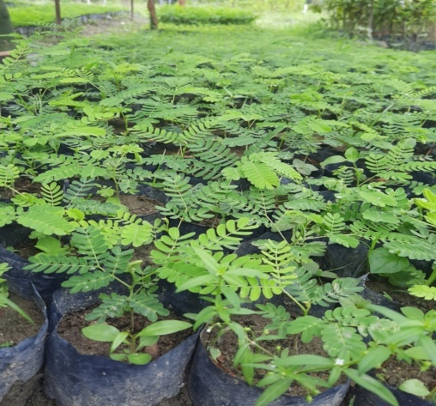
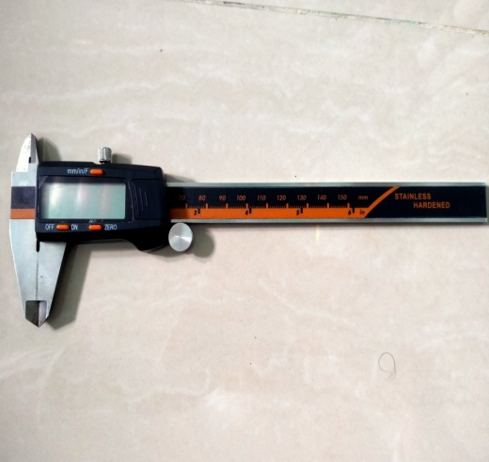
Caliper
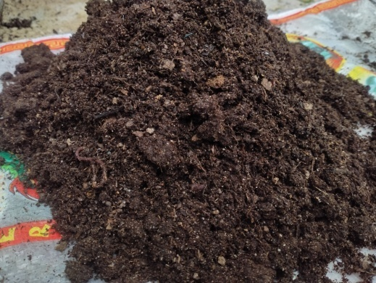
Pupuk kompos
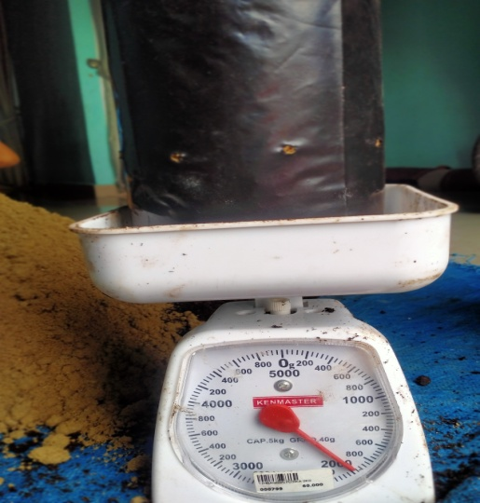
Penimbangan media tanam

Semai sengon
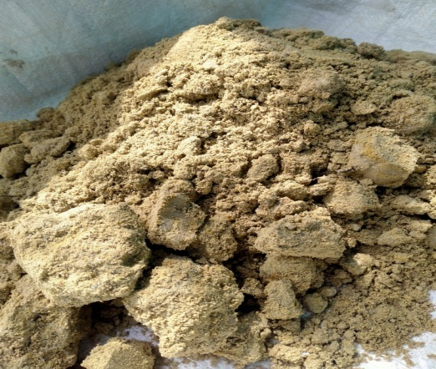
Tanah bekas tambang emas
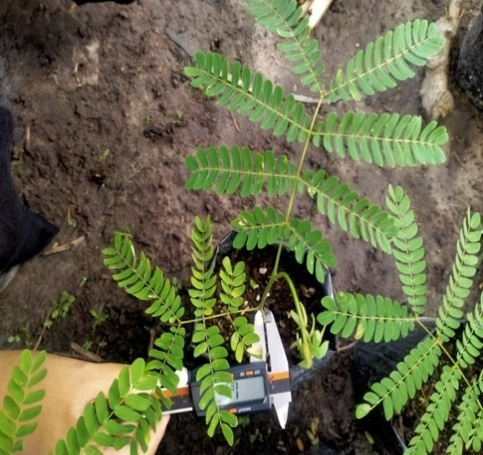
Pengukuran diameter
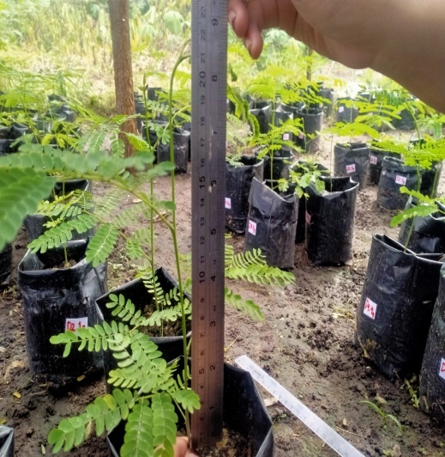
Pengukuran tinggi
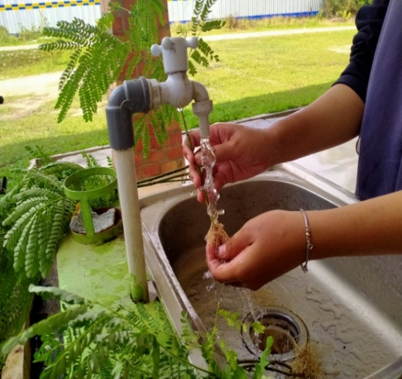
Proses pencucian semai
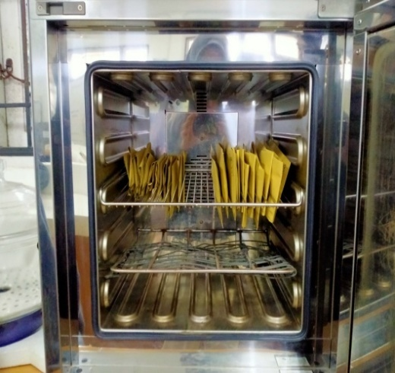
Pengovenan semai

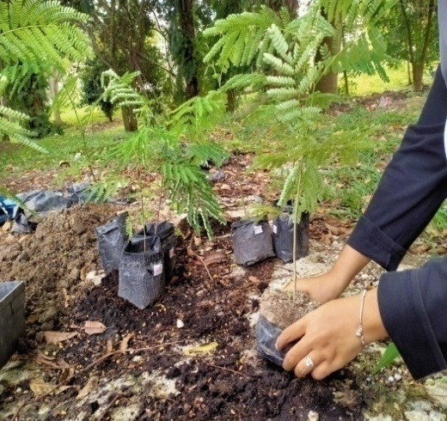
Pembongkaran semai untuk di oven
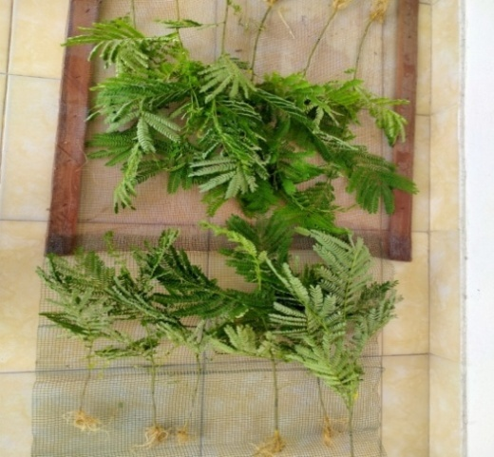
Proses kering anginkan semai
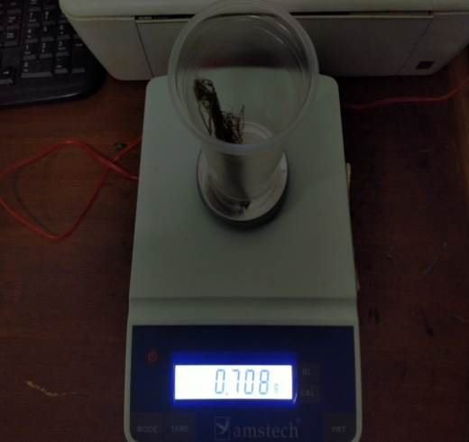
Pengukuran berat kering

