Hasil Uji Reliabilitas dan Validitas UWES-9

Reliability Statistics
Cronbach's Alpha | N of Items
.918 | 9

Item-Total Statistics
 | Scale Mean if Item Deleted | Scale Variance if Item Deleted | Corrected Item-Total Correlation | Cronbach's Alpha if Item Deleted
V1 | 42.38 | 30.962 | .674 | .912
V2 | 42.43 | 29.784 | .839 | .900
A1 | 42.27 | 31.434 | .681 | .911
A2 | 42.31 | 31.665 | .712 | .909
V3 | 42.42 | 29.933 | .805 | .903
A3 | 42.43 | 30.646 | .777 | .905
D1 | 42.04 | 33.549 | .700 | .913
D2 | 42.82 | 29.574 | .687 | .912
D3 | 42.62 | 30.137 | .636 | .916

Hasil Uji Reliabilitas dan Validitas I-TSES

Reliability Statistics
Cronbach's Alpha | N of Items
.968 | 24

Item-Total Statistics
 | Scale Mean if Item Deleted | Scale Variance if Item Deleted | Corrected Item-Total Correlation | Cronbach's Alpha if Item Deleted
SE1 | 185.48 | 548.939 | .558 | .969
SE2 | 185.11 | 545.383 | .766 | .966
SE3 | 184.93 | 549.032 | .782 | .966
SE4 | 184.81 | 549.669 | .793 | .966
SE5 | 184.79 | 556.655 | .753 | .966
SE6 | 184.98 | 553.056 | .758 | .966
SE7 | 185.03 | 554.605 | .678 | .967
SE8 | 185.08 | 556.300 | .638 | .967
IS1 | 185.01 | 554.900 | .756 | .966
IS2 | 184.97 | 553.518 | .788 | .966
IS3 | 184.91 | 553.017 | .799 | .966
IS4 | 185.06 | 552.421 | .766 | .966
IS5 | 185.05 | 553.673 | .774 | .966
IS6 | 185.29 | 541.630 | .823 | .965
IS7 | 185.04 | 552.599 | .646 | .967
IS8 | 185.02 | 547.924 | .702 | .966
CM1 | 185.12 | 546.622 | .802 | .966
CM2 | 184.83 | 551.653 | .802 | .966
CM3 | 184.76 | 556.156 | .804 | .966
CM4 | 184.95 | 545.310 | .825 | .965
CM5 | 184.72 | 558.265 | .792 | .966
CM6 | 184.94 | 546.371 | .751 | .966
CM7 | 184.98 | 549.993 | .731 | .966
CM8 | 185.27 | 544.137 | .605 | .968

Hasil Uji Reliabilitas dan Validitas TSI

Reliability Statistics
Cronbach's Alpha | N of Items
.942 | 20

Item-Total Statistics
 | Scale Mean if Item Deleted | Scale Variance if Item Deleted | Corrected Item-Total Correlation | Cronbach's Alpha if Item Deleted
PR1 | 22.06 | 194.891 | .686 | .938
SM1 | 21.83 | 193.457 | .706 | .938
PR2 | 22.05 | 192.398 | .767 | .937
W1 | 21.71 | 192.505 | .697 | .938
SM2 | 21.89 | 195.208 | .700 | .938
W2 | 22.16 | 194.511 | .747 | .937
SM3 | 21.90 | 196.328 | .710 | .938
PR3 | 21.71 | 188.870 | .736 | .937
W3 | 21.50 | 188.502 | .750 | .937
CR1 | 21.95 | 192.148 | .726 | .937
SM4_INV | 19.75 | 239.325 | -.785 | .959
W4 | 21.65 | 190.353 | .749 | .937
PCR1 | 22.00 | 192.888 | .774 | .937
CR2 | 21.89 | 193.837 | .759 | .937
CR3 | 22.01 | 193.794 | .796 | .936
CR4 | 21.89 | 192.112 | .793 | .936
PCR2 | 22.16 | 196.024 | .705 | .938
SM5 | 21.19 | 199.806 | .657 | .939
PCR3 | 21.84 | 193.174 | .737 | .937
CR5 | 21.86 | 193.961 | .659 | .939

Hasil Uji Reliabilitas dan Validitas MSPSS

Reliability Statistics
Cronbach's Alpha | N of Items
.926 | 12

Item-Total Statistics
 | Scale Mean if Item Deleted | Scale Variance if Item Deleted | Corrected Item-Total Correlation | Cronbach's Alpha if Item Deleted
K1 | 63.80 | 148.744 | .664 | .921
K2 | 63.85 | 147.382 | .653 | .921
K3 | 63.81 | 145.027 | .726 | .919
K4 | 63.92 | 145.367 | .724 | .919
T1 | 63.97 | 147.822 | .728 | .919
T2 | 64.48 | 144.492 | .621 | .923
T3 | 64.03 | 147.271 | .694 | .920
T4 | 64.88 | 143.321 | .559 | .927
OL1 | 64.45 | 137.831 | .768 | .916
OL2 | 64.36 | 137.056 | .778 | .916
OL3 | 64.29 | 139.663 | .725 | .918
OL4 | 64.23 | 142.024 | .689 | .920

Hasil Perhitungan G Power
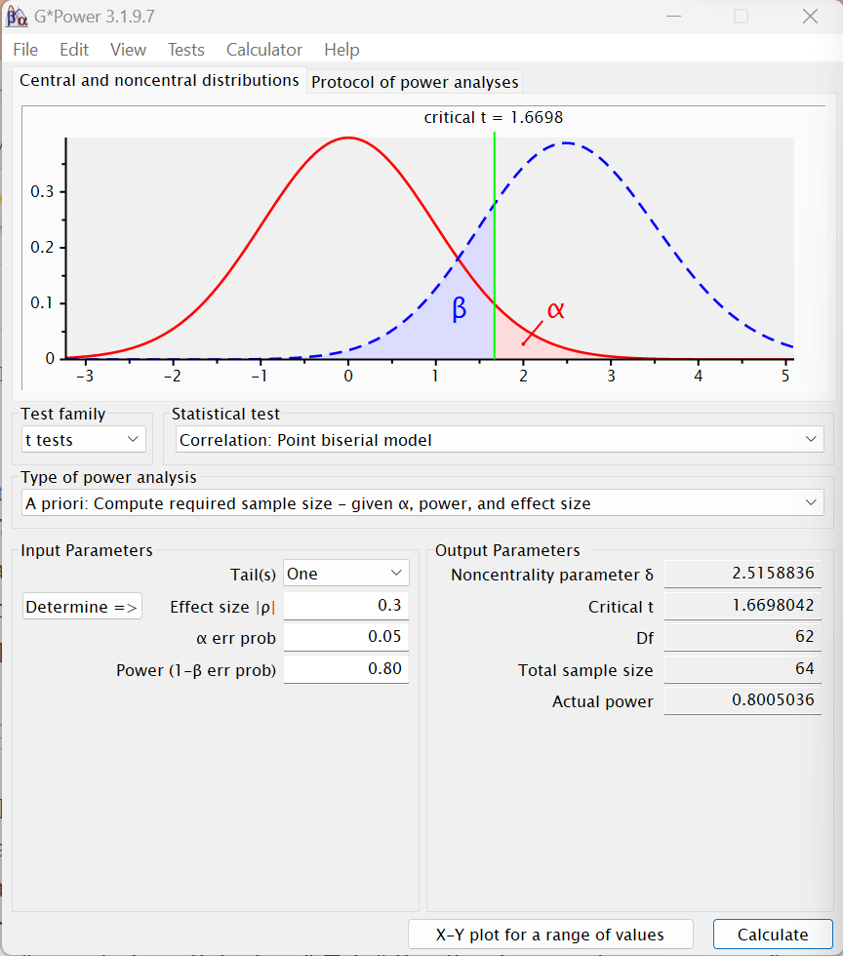

Output Spss Uji Normalitas
One-Sample Kolmogorov-Smirnov Test
 |  | Unstandardized Residual
N |  | 76
Normal Parameters^{a,b} | Mean | .0000000
Normal Parameters^{a,b} | Std. Deviation | 4.87284807
Most Extreme Differences | Absolute | .089
Most Extreme Differences | Positive | .077
Most Extreme Differences | Negative | -.089
Test Statistic |  | .089
Asymp. Sig. (2-tailed) |  | .200^{c,d}
a. Test distribution is Normal.
b. Calculated from data.
c. Lilliefors Significance Correction.
d. This is a lower bound of the true significance.
Coefficientsª
Model |  | Unstandardized Coefficients |  | Standardized Coefficients | t | Sig. | Collinearity Statistics
 |  | B | Std. Error | Beta | t | Sig. | Tolerance | VIF
1 | (Konstan) | 33.627 | 7.563 |  | 4.446 | .000
1 | Efikasi Guru | .068 | .040 | .213 | 1.704 | .093 | .806 | 1.240
1 | Stres Kerja | -.067 | .046 | -.171 | -1.438 | .155 | .887 | 1.127
1 | Dukungan Sosial | -.002 | .062 | -.003 | -.024 | .981 | .786 | 1.272
a. Dependent Variable: Keterikatan Kerja

Output Spss Uji Multikolinieritas

Output Spss Uji Heteroskedasitas

Coefficientsª
Model |  | Unstandardized Coefficients |  | Standardized Coefficients | t | Sig.
 |  | B | Std. Error | Beta | t | Sig.
1 | (Konstan) | 3.489 | 4.287 |  | .814 | .418
1 | Efikasi Guru | .001 | .022 | .006 | .048 | .962
1 | Stres Kerja | -.010 | .026 | -.049 | -.390 | .698
1 | Dukungan Sosial | .009 | .035 | .032 | .242 | .810
a. Dependent Variable: RES_2

Output Spss Uji Deskriptif SPSS
Descriptive Statistics
 | N | Minimum | Maximum | Mean | Std. Deviation
Keterikatan Kerja | 76 | 35 | 53 | 44.34 | 5.116
Efikasi Guru | 76 | 143 | 216 | 187.45 | 16.127
Stres Kerja | 76 | 6 | 50 | 27.67 | 13.151
Dukungan Sosial | 76 | 39 | 80 | 67.12 | 10.369
Valid N (listwise) | 76

Output Spss Uji Regresi Linier SPSS
Coefficientsª
Model |  | Unstandardized Coefficients |  | Standardized Coefficients | t | Sig.
 |  | B | Std. Error | Beta | t | Sig.
1 | (Konstan) | 33.584 | 7.309 |  | 4.595 | .000
1 | Efikasi Guru | .067 | .037 | .212 | 1.835 | .071
1 | Stres Kerja | -.066 | .045 | -.171 | -1.479 | .143
a. Dependent Variable: Keterikatan Kerja

Model Summary
Model | R | R Square | Adjusted R Square | Std. Error of the Estimate
1 | .305ª | .093 | .068 | 4.939
a. Predictors: (Konstan), Stres Kerja, Efikasi Guru

Lampiran 23 Output Spss Uji MRA SPSS
Coefficientsª
Model |  | Unstandardized Coefficients |  | Standardized Coefficients | t | Sig.
 |  | B | Std. Error | Beta | t | Sig.
1 | (Konstan) | 75.146 | 63.962 |  | 1.175 | .244
1 | Efikasi Guru | -.238 | .318 | -.751 | -.748 | .457
1 | Stres Kerja | .595 | .611 | 1.529 | .974 | .333
1 | Dukungan Sosial | -.554 | 1.015 | -1.123 | -.545 | .587
1 | Efikasi Guru X Dukungan Sosial | .004 | .005 | 2.066 | .821 | .414
1 | Stres Kerja X Dukungan Sosial | -.013 | .015 | -2.223 | -.869 | .388
1 | X1M_X2M | 2.588E-7 | .000 | .636 | .485 | .629
a. Dependent Variable: Keterikatan Kerja

Model Summary
Model | R | R Square | Adjusted R Square | Std. Error of the Estimate
1 | .373ª | .139 | .064 | 4.949
a. Predictors: (Konstan), X1M_X2M, Efikasi Guru, Dukungan Sosial, Stres Kerja, Efikasi Guru X Dukungan Sosial, Stres Kerja X Dukungan Sosial

