

IMPLEMENTATION OF HEALTH POLICY IN LAW NUMBER 36 OF 2009 REGARDING HEALTH SERVICES: A STUDY OF BPJS MATARAM CITY

Rahmat Hidayat¹, Nurillah Agustina², Suci Khairani³, Aprilia Eka Lestari⁴, Ismiatun⁵, Adhar⁶, Resi Nopalina⁷
^{1,2,3,4,5,6,7} Muhammadiyah University of Mataram
Corresponding Author : larahmad2000@gmail.com

Abstract: The purpose of the BPJS Kesehatan program study on the implementation of health service policies in Mataram City based on Law Number 36 of 2009 is to evaluate the quality of services and identify success factors and challenges that arise. And using the theory of Van meter and Van Horn to measure the implementation of HEALTH POLICY IN LAW NUMBER 36 OF 2009 REGARDING HEALTH SERVICES: A STUDY OF BPJS MATARAM CITY. Collecting comprehensive information about the success of the services provided, this study uses qualitative techniques such as document analysis, key staff interviews, and field observations. With a high participation rate of 99%, the results of the study show how well BPJS, local governments, and health facilities collaborate to provide equitable health services to all levels of society. However, problems with service capacity and efficiency remain, therefore collaboration and periodic evaluation are needed. The conclusion of this study emphasizes the importance of resource allocation and community participation as well as stakeholders to improve service delivery and advance larger goals, namely health equity and social welfare in Mataram City. Periodic evaluations need to be carried out to produce results from BPJS.
Keywords: Mataram, BPJS, health services, policy impleentation

Abstrak: Tujuan dari kajian program BPJS Kesehatan terhadap implementasi kebijakan pelayanan kesehatan di Kota Mataram berdasarkan Undang-Undang Nomor 36 Tahun 2009 adalah untuk mengevaluasi mutu pelayanan dan mengidentifikasi faktor-faktor keberhasilan serta tantangan yang muncul. Serta menggunakan teori Van meter dan Van Horn untuk mengukur implementasi KEBIJAKAN KESEHATAN DALAM UNDANG-UNDANG NOMOR 36 TAHUN 2009 TENTANG PELAYANAN KESEHATAN: STUDI BPJS KOTA MATARAM. Mengumpulkan informasi yang komprehensif tentang keberhasilan layanan yang diberikan, penelitian ini menggunakan teknik kualitatif seperti analisis dokumen, wawancara staf kunci, dan observasi lapangan. Dengan tingkat partisipasi yang tinggi yaitu 99%, hasil penelitian menunjukkan seberapa baik BPJS, pemerintah daerah, dan fasilitas kesehatan berkolaborasi untuk memberikan layanan kesehatan yang adil bagi semua lapisan masyarakat. Namun, masalah kapasitas dan efisiensi layanan masih ada, oleh karena itu diperlukan kolaborasi dan evaluasi berkala. Kesimpulan dari penelitian ini menekankan pentingnya alokasi sumber daya dan partisipasi masyarakat serta pemangku kepentingan untuk meningkatkan pemberian layanan dan memajukan tujuan yang lebih besar, yaitu pemerataan kesehatan dan kesejahteraan sosial di Kota Mataram. Evaluasi berkala perlu dilakukan untuk menghasilkan hasil dari BPJS.
Kata Kunci : Mataram, BPJS, pelayanan kesehatan, implementasi kebijakan

Pendahuluan
The One of the most important phases in the public policy cycle is the implementation stage, which plays a crucial role in determining the success of a policy. The success of a policy is highly dependent on how effectively and efficiently the policy is implemented in the field. Wahab (2005) emphasized that policy implementation is even more important than the policy concept itself, because implementation is a concrete step that connects policy ideas and objectives with the reality on the ground. In this context, Winarno (2002) stated that policy implementation is a process that involves cooperation between various individuals and organizations, each of which has a role and responsibility in ensuring that the policy can be implemented properly. Nugroho (2004) also added that implementation functions as a means to achieve the stated policy objectives. In general, experts agree that the success of a policy is highly dependent on the effectiveness of the implementation of the policy, because without good implementation, the objectives outlined in the policy are difficult to achieve (Suprapto & Malik, 2019).

One of the policies that researchers analyze is the process of implementing health service policies. In this case, the implementation of the policy is carried out by the Mataram BPJS branch located on Jl. Bung Karno, Cilinaya, Kec. Cakranegara, Mataram City, Nusa Tenggara Barat. 83231, Indonesia. As an institution responsible for organizing health insurance, the Social Security Administering Agency (BPJS) Health has the main task of ensuring fair and equitable access to health services for all Indonesian people, in accordance with the basic principles that have been established by the government. The Social Security Administering Agency (BPJS) Health is a legal entity that is directly responsible to the President of the Republic of Indonesia. The main task of BPJS Health is to coordinate the implementation of the national health insurance (JKN) program which aims to provide comprehensive access to health services for all Indonesian people. As an integral part of the national social security system, BPJS Health has a strategic role in ensuring the achievement of the main objectives of social security, namely equitable and sustainable social protection. In this case, BPJS Kesehatan not only functions as a health service provider, but also as an institution that manages and regulates various health insurance programs for all levels of Indonesian society. Therefore, BPJS Kesehatan can be seen as one of the key components in the government's efforts to realize more inclusive and comprehensive social welfare, in accordance with the mandate given by the National Social Security System Law (Mariyam, 2021). In an effort to implement the National Health Insurance (JKN), the government launched BPJS Kesehatan and BPJS Ketenagakerjaan on December 31, 2013. On January 1, 2014, PT Askes Indonesia was replaced by BPJS Kesehatan, then on July 1, 2014, BPJS Ketenagakerjaan began operating. Law Number 24 of 2011 established the two organizations, with BPJS Kesehatan tasked with providing health insurance for all Indonesian people and ensuring fair access to high-quality medical care in accordance with the ideals of social justice (Suryani & Suharyanto, 2020). Although BPJS Health services for the underprivileged and poor in Mataram City have been running well, a number of metrics used to assess service efficiency are still not optimal due to various internal and external constraints. Various indications show the success of this free BPJS Health service, with several indicators used to assess performance, including human adaptation, job performance, job satisfaction, service quality, social integration, and evaluation (Hidayat, 2023). According to Augustinus (2006), public policies often cause some decision makers to be unaware of or even fail to meet the needs, desires, or issues that actually need to be met. Their views on policies and how they view these policies are influenced by their personal and organizational interests, which then shape their attitudes towards these policies (Fajriansyah et al., 2022). Service quality must begin with good performance so that the community can get what they need and achieve a level of community satisfaction, as well as a positive perception of service quality. As parties who buy and consume services, the community who receive services becomes a benchmark for the quality of service provided by the local government or the company concerned. There are 5 (five) dimensions of Service Quality, namely physical evidence, attention, reliability, responsiveness and assurance of certainty. These five (five) dimensions affect the satisfaction of participants of the Social Security Administering Agency (BPJS) Health (Q.A. & Sujarwoto, 2024).
The Ministry of Health and Regional Governments launched the Public Safety Center (PSC) program which utilizes digital technology to improve health services. Natalisa (2021) emphasized that digital transformation requires digital skills, such as technological proficiency, communication, and cross-sector collaboration, so that they can be applied effectively in health services (Hidayat, 2023). The public demands the achievement of equal prime service quality without distinguishing between social or economic backgrounds as a result of technological advances and increasing knowledge of the value of services. Through a separate bureaucracy or service organization, this demand is fully focused on providers of administrative services, goods, and services (Hidayat, 2018). Law Number 44 of 2009 concerning Hospitals mandates that every hospital is required to provide safe, quality, and non-harmful health services to patients. This is in line with the basic principles of the health service system which emphasizes quality, patient safety, and avoidance of risks that can be detrimental. In order to ensure the achievement of effective and non-discriminatory services, certain standards are regulated by statutory provisions, as explained in Article 29 letter b and Article 40 paragraph 1 of the Law (Putra & Raymond, 2024).

Public Policy Implementation Model Based on Van Meter and Van Horn Theory
Van Meter and Van Horn's theory can explain the effectiveness of the program in the context of implementing BPJS Kesehatan health policies in Mataram City by highlighting a number of important elements. First, the standard of policy facilities shows that, as predicted by this theory, the utilization of facilities such as hospitals and health centers to reach all levels of society reflects the readiness of facilities to support policy objectives. Second, by working together with FKTP, hospitals, and local governments, BPJS maximizes resources and builds organizational synergy, an important component of policy implementation, according to Van Meter and Van Horn's theory. Third, the characteristics of BPJS implementing organizations, such as a clear organizational structure and effective division of labor, reflect the implementation of good management practices that support the smooth implementation of policies. This is very important to ensure that each element in the organization has well-defined responsibilities, thus facilitating coordination and efficient implementation of policies. In addition, coordination and synergy between the various parties involved, including between BPJS and other stakeholders such as local governments and the police, strengthen efficient inter-organizational communication. Good communication between stakeholders is essential to achieving overall health policy objectives. In accordance with the view that the dedication and motivation of implementers have a significant impact on policy outcomes, the proactive approach implemented by BPJS implementers has also been shown to increase the success of policy implementation. This shows that the active role and high commitment of policy implementers can accelerate the achievement of predetermined goals. Finally, the social, economic, and political climate in NTB which has strong political support from the local government is very important for the smooth running of the health insurance program and the creation of an atmosphere that supports the successful implementation of the policy. The success of BPJS Kesehatan in Mataram City, NTB, which achieved a participation rate of 99%, can be seen as concrete evidence of the effectiveness of implementing health policies regulated in Law Number 36 of 2009 concerning Health Services. This high participation rate reflects good synergy between BPJS Kesehatan, Primary Health Facilities (FKTP), Advanced Referral Health Facilities (FKRTL), and various other stakeholders, including local governments, law enforcement officers, prosecutors, the Social Service, and the Population and Civil Registration Service (Disdukcapil). This multi-party collaboration is a key factor in ensuring that every individual is registered as a participant in the National Health Insurance (JKN), as well as ensuring access to fair and quality health services for all levels of society. Furthermore, this success is in line with the ideals of the law that prioritize the principle of social justice in the implementation of health services. As a result of this achievement, Mataram City is now the best example of the implementation of national health policies that can be used as a reference for other regions in Indonesia, showing that collaboration between the government, related institutions, and the community can achieve significant results in creating an inclusive and sustainable health system.

Problem Formulation
The problem formulation in this study includes two main aspects, namely:
- How is the quality of services provided by BPJS Kesehatan Kota Mataram in meeting the health service standards expected by the community?

- What are the success factors that influence the implementation of BPJS Kesehatan services in Kota Mataram?

Theoretical Framework
According to Law Number 36 of 2009, BPJS Kesehatan in Mataram City is implementing health service policies in accordance with Van Meter and Van Horn's policy implementation theory, which highlights the significance of specific and quantifiable policy objectives, as well as the availability of required resources, including funds, equipment, and skilled personnel, to achieve effectiveness in implementation; the implementing organization's structure and capacity, as well as the implementer's attitude, including personal commitment and motivation, as well as interactions between organizations, are important factors in the implementation process; in this regard, multi-party collaboration between BPJS, local governments, health facilities, and other stakeholders is crucial to create cooperation in providing fair services. In order to increase service quality and accomplish the objective of health equity, community involvement is also required in the implementation and evaluation of health services, where regular evaluations are a crucial step. Furthermore, the dimensions of service quality—physical evidence, assurance, responsiveness, and reliability—will aid in evaluating how well health policy is being implemented in Mataram City through BPJS Kesehatan and identifying important variables that affect the difficulties and achievements encountered in delivering high-quality healthcare.

Research Methods
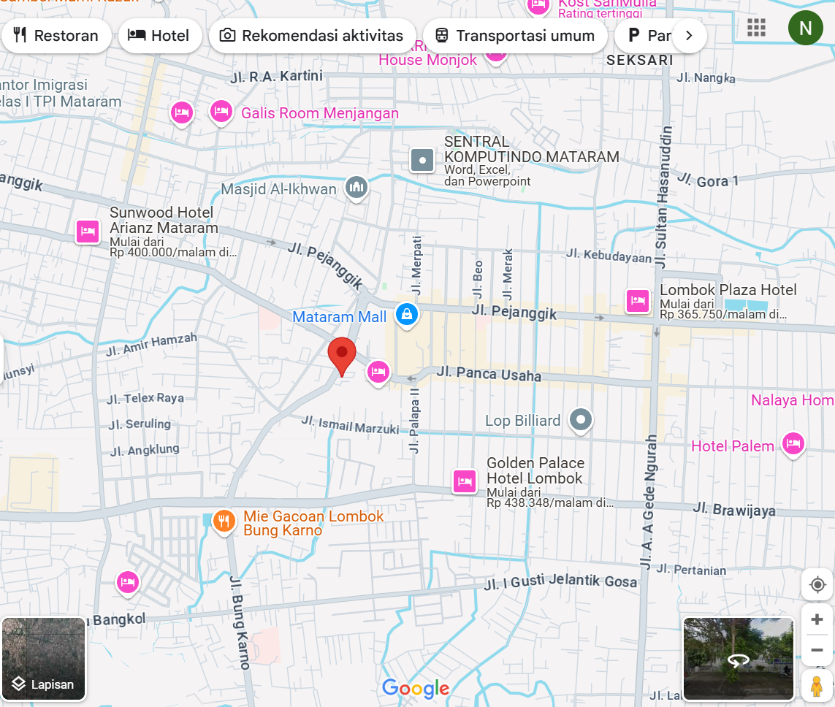
Figure 1. Research location
Source : https://idalamat.com/alamat/3536/bpjs-kesehatan-kantor-cabang-mataram (Kesehatan, 2024)

The author conducted a study located at Jl. Bung Karno, Cilinaya, Kec. Cakranegara, Mataram City, West Nusa Tenggara, on November 15, 2024, using field observation, interview, and documentation methods. Field observation aims to assess the condition of facilities, interactions between BPJS Kesehatan officers, and evaluate the quality of services provided. Interviews will be conducted with Mrs. Farida as the head of the financial planning and audit section and Mrs. Icha in the field of financial planning and audit of BPJS Kesehatan to obtain information regarding policies, procedures, and challenges in services. The data obtained will be supplemented with related documents, such as regulations.

A literature review will be used to explore Law No. 36 of 2009 concerning health services, which is the basis for BPJS Kesehatan policy. This study will examine the implementation of the policy and the factors that influence its effectiveness at the local level. The literature review will also cover variables such as policy characteristics, resources, and relationships between actors that influence policy implementation.

The data collected will be analyzed using a quantitative descriptive approach to describe the condition of BPJS services in Mataram City. This study refers to the theory of policy implementation by Van Meter and Van Horn, which highlights factors such as policy characteristics, resources, and interactions between actors in successful implementation. The results of the study will be compiled to provide a comprehensive picture of the implementation of BPJS Kesehatan policies in Mataram City in accordance with the provisions of Law No. 36 of 2009.

Results and Discussion
Law Number 36 of 2014 concerning Health Workers who are oriented towards community welfare
To achieve optimal health as an investment in human resource development, the role of health workers is very important in improving the quality of health services to the community. This principle is in line with Law Number 36 of 2014 concerning Health Workers, which is oriented towards public welfare, in accordance with the mandate of the 1945 Constitution of the Republic of Indonesia. Professional health workers are expected to provide affordable and equitable services, overcoming barriers to health access such as discrimination and limited resources. According to Article 28A and Article 28H paragraph (1) of the 1945 Constitution, everyone has the right to a prosperous life and decent health services. Article 34 paragraph (3) emphasizes the state's responsibility to provide adequate health service facilities, in order to guarantee the right to health for all citizens (Yudha Koswara I, 2018). Legal protection of patient rights in health services based on Law Number 36 of 2009 is regulated in Article 58 which determines; (1) Everyone has the right to claim compensation against a person, health worker, and/or health provider who causes losses due to errors or negligence in the health services they receive. (2) The claim for compensation as referred to in paragraph (1) does not apply to health workers who carry out life-saving actions or prevent disability of a person in an emergency (Rambet, 2020).

Based on the provisions of Article 58 of Law Number 36 of 2009, it can be understood that legal protection of patient rights in health services based on the Health Law is the protection of patient rights through civil lawsuits to claim compensation. In the framework of protecting patient rights, the law provides patients with the right to sue if there is service that does not comply with service standards, or is often called malpractice. The 1945 Constitution guarantees that everyone has the right to obtain health services, which aim to improve the health of individuals, groups, and society in general (Basith & Prameswari, 2020).

For this reason, health services must be defined as all types of services planned both individually and collectively in a system or organization, with the main objective of maintaining and improving health, preventing and curing diseases, and restoring the health conditions of individuals, families, groups, and/or communities. These services include a variety of medical and non-medical interventions designed to improve the quality of life and overall well-being of the community. In this context, health services focus not only on treating diseases, but also on proactive prevention and health maintenance efforts through various well-organized health programs and policies (Mustika & Yoki Pradikta, 2022).

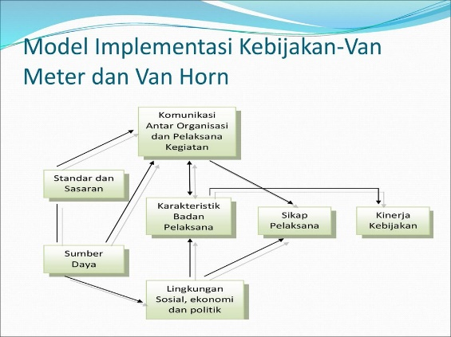
Figure 2. Van Meter and Van Horn policy implementation model
Source : https://slideplayer.info/slide/13107655/79/images/12/Model+Implementasi+Kebijakan-Van+Meter+dan+Van+Horn.jpg

The Policy Implementation Model developed by Van Meter and Van Horn in 1975 is an approach that aims to understand the policy implementation process in a more systematic and structured way. In this model, policy implementation is viewed as a series of processes influenced by the relationship between various variables, which contribute to the success or failure of a policy. This model emphasizes that political decisions taken at the policy-making stage drive policy implementation in a linear manner, but the performance of the implementation is greatly influenced by a number of key factors. Factors that influence policy implementation performance, according to this model, include: (1) Policy goals, criteria, and targets, which must be clear and measurable to ensure effective achievement; (2) Available resources, whether in the form of funds, equipment, or materials needed in implementing the policy; (3) Attributes of the implementing organization, which include the structure, capacity, and ability of the organization to manage and implement the policy; (4) The attitude of the implementer, which includes the commitment, motivation, and perceptions of the individuals involved in implementing the policy; and (5) Interaction between implementation efforts and related organizations, reflecting the importance of effective coordination and communication between the various actors involved in the policy implementation process By understanding these variables, the Van Meter and Van Horn model provides an important framework for analyzing and designing policies to improve the effectiveness of implementation in the field.

1. Standards and Facilities of BPJS Mataram City

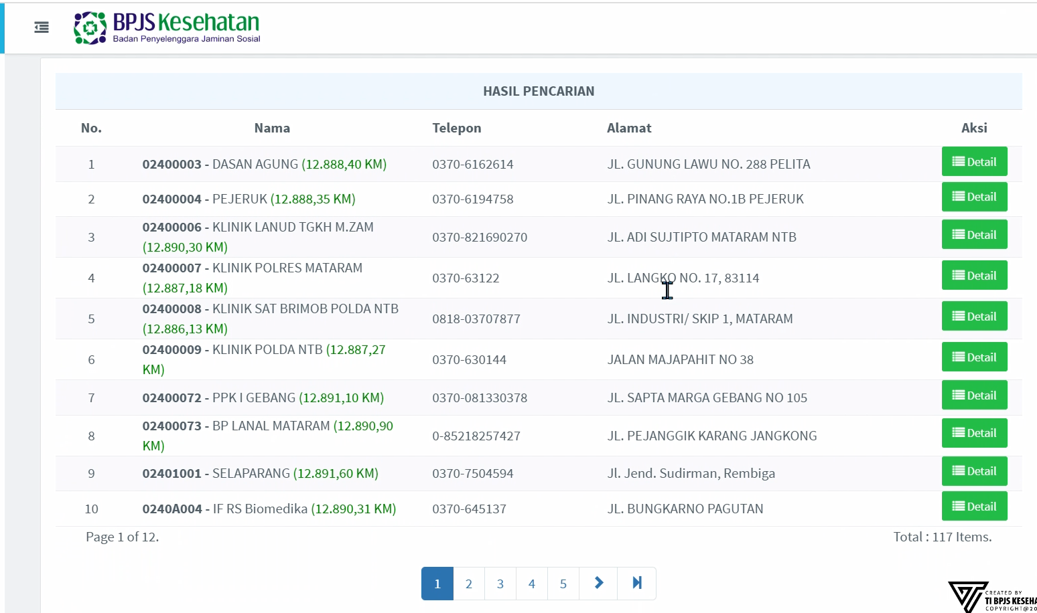
Figure 3. Standards and Facilities of BPJS Mataram City
Source : https://faskes.bpjs-kesehatan.go.id/aplicares/#/app/pnama/byname

Hospitals, clinics, health centers, and pharmacies are some of the various health facilities (Faskes) that collaborate with BPJS Kesehatan in organizing national health insurance (JKN) services. In order to join the BPJS Kesehatan network, each of these health facilities is required to meet a number of established standards. These standards include the availability of sufficient and skilled medical personnel, high-quality medical equipment, and adequate service capacity to handle the number of patients according to needs. In addition, Mataram City Health Services has adopted the direction of the Ministry of Health to develop a new approach to improve emergency services, especially the Integrated Emergency Response System (SPGDT). National Command Center (NCC), a 24-hour service that will facilitate access to emergency services and speed up the response to handling victims (Hidayat, 2023b).

The implementation of this standard aims to ensure that health facilities included in the JKN program can provide safe, quality, and timely services to participants. Mrs. Rita as an employee of BPJS Mataram City also claims that she has recently collaborated with the police. The collaboration between BPJS Kesehatan and the National Police aims to prevent misuse of health services, verify participant data, provide education to the public, and ensure fair access to health care. The National Police also plays a role in emergency response and supports the success of the JKN program nationally.

In order to facilitate access to services for participants, BPJS Kesehatan has developed various integrated applications and information systems. Among the systems provided are an electronic claim system that facilitates health facilities in the claim submission process, an online registration portal that allows participants to register and manage membership status online, and the BPJS Kesehatan mobile application (Mobile JKN) which makes it easy for participants to access various services, including information about health facilities, checking participant status, and checking service history. In addition, this information system is also used to monitor and manage the use of health services, as well as to manage participant data effectively, in order to ensure optimal and efficient services in the JKN program.

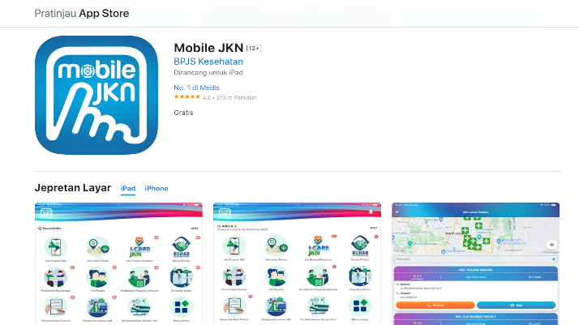
Figure 4. JKN Mobile Application
Source : https://apps.apple.com/id/app/mobile-jkn/id1237601115?l=id

All Indonesian residents registered in the BPJS Kesehatan National Health Insurance (JKN) program consist of three categories of participants with different financing mechanisms. First, Contribution Assistance Recipients (PBI), namely groups of people who are less fortunate, such as poor families, whose contributions are fully covered by the government. This program aims to ensure access to health services for those who are economically vulnerable. Especially for vulnerable groups (elderly, disabled): there are special chairs, priority services, prolanis programs for chronic diseases. Preventive promotive programs: healthy gymnastics at health centers. Covered medical devices: glasses, tanpen, krok for broken bones, according to medical indications. Second, Independent Non-Wage Recipient Participants (PBPU), which include individuals who work in the informal sector, entrepreneurs, or who are not registered with any business entity. These participants pay contributions independently, with a flexible choice of treatment classes according to their financial capabilities. Third, Business Entity Wage Recipient Participants (PPU), namely workers who are registered through the company or business entity where they work, where contributions are paid jointly by the employer and employee based on the wages received. These three categories, namely PBI, PBPU Mandiri, and PPBU, are an integral part of the health insurance system that aims to provide equitable and affordable health protection for all levels of Indonesian society. In addition, Mataram City Health Services have adopted the direction of the Ministry of Health to develop a new approach to improve emergency services, especially the Integrated Emergency Response System (SPGDT). National Command Center (NCC), a 24-hour service that will facilitate access to emergency services and accelerate the response to handling victims (Hidayat, 2023).

2. Resources

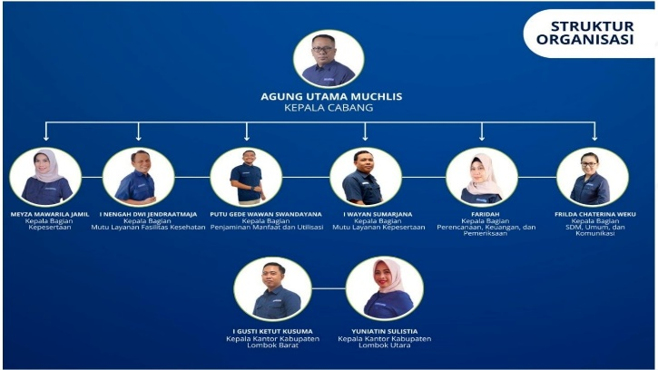
Figure 5. Mataram branch of BPJS organization
Source: Author's processed results

In the management of the National Health Insurance (JKN) BPJS Kesehatan, BPJS Kota Mataram also has various fields that coordinate with each other to ensure smooth health services, financial management, and proper membership. Based on the explanation of Mrs. Farida and Mrs. Icha, here is a brief explanation of the fields involved in BPJS Kota Mataram:

- Financial Collection and Planning Field (PKP)
This field is responsible for budget planning and management, as well as collection of contributions from independent participants and business entities, to ensure that funds are available efficiently for the BPJS Kota Mataram JKN program.

- HR and General Field (SDMUK)
This field manages human resources working in health facilities, ensures that medical and administrative personnel meet competency standards, and handles operations and administration that support smooth services at BPJS Kota Mataram.

- PMU (Primary Medical Services) Division
Focuses on managing hospital services and health facilities that collaborate with BPJS Kesehatan, including those in Mataram City, and ensuring the quality of services in accordance with the standards set by BPJS Kesehatan.

- Participation and Cooperation with Local Government Division
Manage participant data, registration, and data verification, and collaborate with the Mataram City regional government and business entities to register participants and ensure that beneficiaries, including PBI, are properly registered.

- Yanser Division (Frontline Services)
Responsible for direct services to participants, such as making BPJS cards, verifying data, and providing information and support related to access to health services for JKN participants at BPJS Mataram City.

Overall, all divisions at BPJS Mataram City work together to ensure the success of the JKN program and provide maximum benefits to the community in Mataram City.

3. Characteristics of implementing organizations

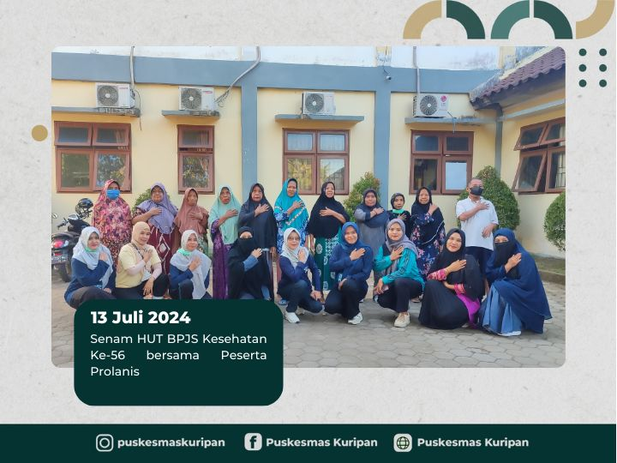
Figure 6. BPJS Anniversary Gymnastics with Prolanis
Source : https://puskesmassuranadi-dikes.lombokbaratkab.go.id/berita/senam-hut-bpjs-kesehatan-ke-56-bersama- peserta-prolanis/

BPJS Kesehatan in Mataram City has characteristics that reflect integrated services, are easily accessible, focus on health equity, and support cooperation with various health facilities and other related parties. Integrated services ensure that all aspects of JKN participant health services, from registration to access to health facilities, are managed in one interconnected system. This makes it easier for participants to get services without having to repeat procedures at each facility. Ease of access is reflected in various online registration channels, 24/7 services, and the reach of health facilities that are evenly distributed throughout Mataram City, from hospitals to private clinics and health centers. BPJS Mataram City also focuses on equalizing access to health by ensuring that vulnerable community groups, such as Contribution Assistance Recipients (PBI), receive services without being constrained by costs, and educating the public about the importance of health insurance through various socialization programs. In addition, BPJS Kesehatan in Mataram City collaborates closely with health facilities, local governments, and business entities to ensure optimal services, from managing participant data, registration, to providing health services. This collaboration not only reaches urban areas, but also ensures access to services in the outskirts and villages, with a regular monitoring and evaluation system to improve the quality of service. All of these characteristics work together to ensure that JKN participants in Mataram City receive appropriate, efficient, and equitable services.

4. Disposition/Attitude of the Implementers

The attitude of BPJS Kesehatan implementers in Mataram City reflects a commitment to provide professional, responsive, and participant-oriented services. BPJS implementers in Mataram City always strive to provide responsive services to participant needs, both in terms of claims, registration, and access to health services. They also show empathy and concern for participants, especially for vulnerable community groups, such as recipients of contribution assistance (PBI), the elderly, people with disabilities, and chronic disease sufferers (prolanis), by giving special attention and explaining procedures clearly. An attitude of openness and transparency is also an important part of their service, by ensuring that participants understand their rights and obligations as well as existing service procedures.

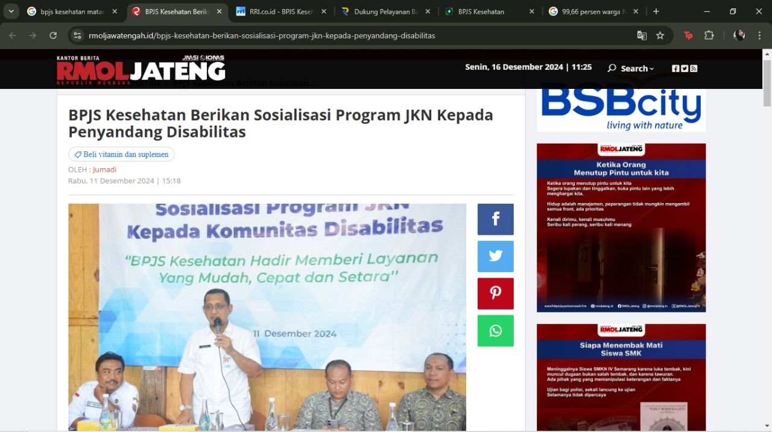
Figure 7. BPJS socialization for people with disabilities
Source : https://ntbsatu.com/2024/07/10/9966-persen-warga-ntb-sudah-terdaftar-bpjs.html#google_vignette

In addition, BPJS implementers in Mataram City have a strong commitment to maintaining service quality, by following applicable regulations and ensuring that participants receive services according to their needs. They also prioritize a cooperative and collaborative attitude, working together with various related parties, such as health facilities, local governments (including the prosecutor's office, police, social services, and Dukcapil), and business entities to ensure the smooth running of the JKN program. BPJS Kesehatan also prioritizes special services for vulnerable groups, such as the elderly, people with disabilities, and participants with chronic diseases through the Prolanis program.
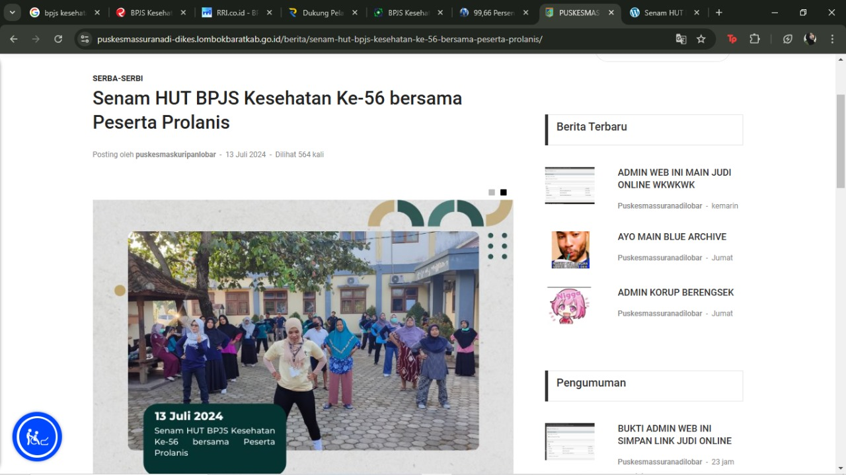
Figure 8. BPJS Anniversary Gymnastics with Prolanis
Source : https://puskesmassuranadi-dikes.lombokbaratkab.go.id/berita/senam-hut-bpjs-kesehatan-ke-56-bersama- peserta-prolanis/

Furthermore, BPJS Kesehatan in Mataram City regularly participates in health promotion and prevention initiatives. In order to preserve public health and prevent disease, these programs include healthy activity classes held in neighborhood health centers. The organization encourages locals to engage in activities that promote health because it places a high value on community involvement.
In addition to maintaining participant data and accurately processing claims, the BPJS implementers in Mataram City are also accountable for making sure that all services fulfill strict quality criteria. In order to pinpoint areas that require improvement, they consistently solicit input from participants and the community, cultivating an atmosphere of openness and responsiveness.
These constructive behaviors and attitudes greatly aid BPJS Kesehatan's main objectives, which are to offer fair, effective, and superior health care for every member of the community. BPJS Kesehatan seeks to lower the prevalence of avoidable diseases and promote a healthier populace by emphasizing preventative care and actively engaging the community. In addition to improving personal wellbeing, this all-encompassing strategy also benefits the community's general health.

5. Communication
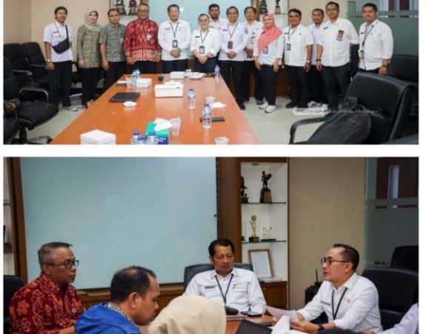
Figure 9. communication between stakeholders
Source : https://www.metrontb.com/kesehatan/81810984437/bpjs-kesehatan-cabang-mataram-gandeng-kejari-mataram-kawal-kepatuhan-badan-usaha-laksanakan-program-jkn

Communication between BPJS Kesehatan organizations in Mataram City is established through intense coordination between various related parties, both internal BPJS, health facilities, local governments, business entities, and the community. Within BPJS, communication between fields such as Financial Collection and Planning (PKP), Human Resources and General (SDMUK), and Primary Medical Services (PMU) is carried out routinely to ensure that all operational aspects are well integrated. With health facilities, BPJS Mataram City utilizes an electronic claim system to facilitate the claim process and ensure timely and procedural services. BPJS also collaborates with local governments, social services, and Dukcapil in recording participant data, especially for the PBI program, and ensuring successful participant registration. In addition, BPJS communicates with business entities to ensure that PPU participants are properly registered, and educates the public through various information channels, including the Mobile JKN application and complaint services. This collaboration creates an efficient, transparent, and responsive system, which ultimately ensures equitable and quality health services for the people of Mataram City (Fatrullibramsah & Dunan, 2022).

6. Policy Performance

Figure 10. BPJS Health Membership in 2023
Source: Author's processed results

The Social Security Administering Agency (BPJS) Health reported that as of September 1, 2023, there were 262,865,343 National Health Insurance (JKN) participants, according to the findings of the author's analysis above. While 90% of NTB has enrolled as a BPJS participant, this number represents around 94.64 percent of Indonesia's total population. David Bangun, the director of BPJS Health Participation, stated that his party's goal is to have 95 percent of the population participate by the end of 2023. In order to reach 98 percent in 2024, it must expand by an additional 3 percent. But the more coverage, the more difficult it is to attain," David told Bisnis on Monday, April 8, 2023. According to David, three Indonesian provinces still have coverage levels below 90 percentage (Untari, 2023). Among them are North Sumatra 88.63 percent, Jambi 85.92 percent, and West Kalimantan 84.81 percent.

Figure 11. BPJS membership will increase in 2024
Source: Author's processed results

Based on the image above, the author analyzes the performance of BPJS Health policies in Mataram City, which shows positive results, with a continuing increase in membership, reaching 97% of the total population of Indonesia and 99% in NTB Province. This achievement reflects the effectiveness of BPJS in expanding access to health insurance through close cooperation with local governments, social services, and health facilities. A more efficient claim process through an electronic claim system and various preventive promotive programs, such as healthy exercise at health centers, make it easier for people to use health services. BPJS is also active in socialization to ensure that participants understand their rights and obligations, and supports vulnerable groups such as PBI. Good collaboration between BPJS, local governments, and business entities ensures that all eligible residents can be properly registered, approaching 100% coverage in Mataram City and NTB Province. Despite challenges in service capacity, BPJS continues to strive to improve the quality of service so that the goal of equitable and quality health can be achieved.

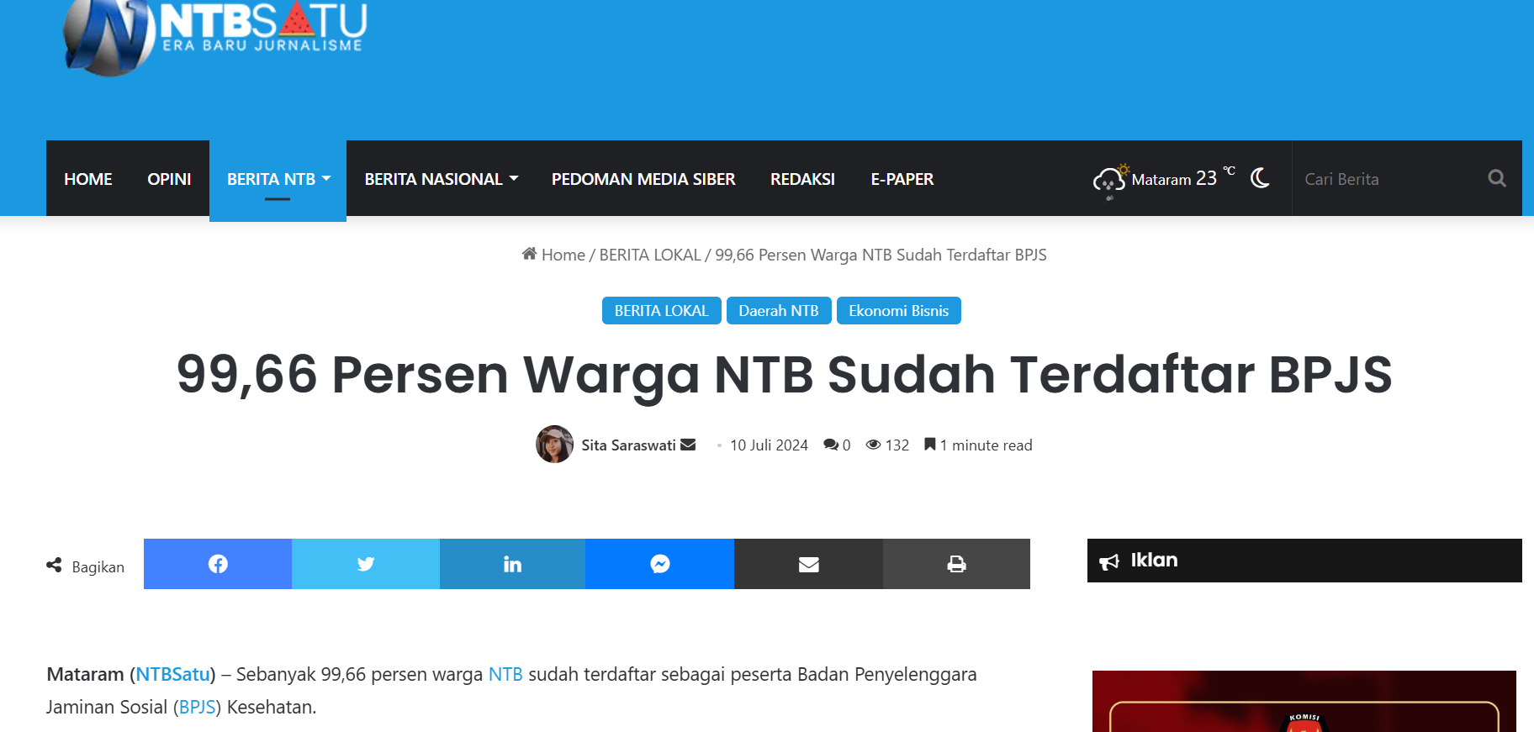
Figure 12. Percentage of NTB BPJS membership
Source : https://ntbsatu.com/2024/07/10/9966-persen-warga-ntb-sudah-terdaftar-bpjs.html#google_vignette

News from NTBSatu about the proportion of the population of West Nusa Tenggara (NTB) registered as participants in the Social Security Administering Body (BPJS) as of July 2024 is depicted in the image. According to the article, as many as 99.66 percent of the population of NTB have registered for the program. According to academics, this data shows how much the community participates in the social security program which is very important for improving social welfare (Marx, 2020). The large number of registrations shows the success of the socialization program and increasing the accessibility of local health services. This can also be a strategic step in achieving sustainable development goals in the health sector and be a benchmark for how well the local government is in guaranteeing the health rights of the community. It is hoped that BPJS will ease the financial burden of public health costs, motivate the community to take more initiative in maintaining their health, and improve their standard of living in general.
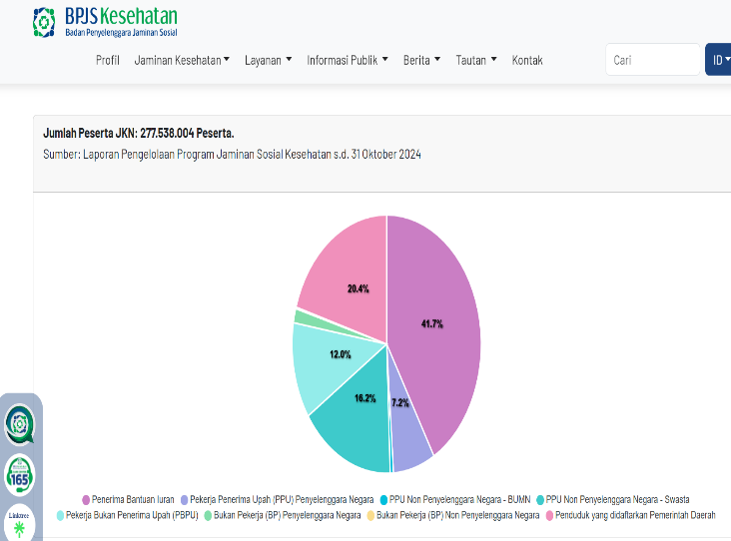
Figure 13. Number of JKN participants
Source : https://faskes.bpjs-kesehatan.go.id/aplicares/#/app/pnama/byname

This figure is a pie chart showing the number of participants in the National Health Insurance (JKN) program registered in the Social Security Administering Agency (BPJS) Health program as of October 31, 2024. This chart groups participants into several categories, such as contribution assistance recipients (PBI), contribution assistance recipients who are not contribution recipients (PBPU), and others. Each category has a unique percentage.

In an academic context, this data highlights the structure of Indonesia's participatory health system, which is critical for analyzing health policy. The percentage of registered participants indicates the effectiveness of social programs in addressing various social problems, where the PBI category highlights government initiatives to protect tenants.

A more comprehensive analysis of population distribution can provide insights into the effectiveness of program socialization and implementation strategies, as well as the accessibility of health services. In addition, this data can be used to assess the impact of health programs on the welfare of the general public and to identify more inclusive and responsive policies related to the health needs of the general public.

Tabel 1. Collaboration to Achieve UHC in Indonesia
No | Isi | Keterangan | Tahun
1. | Social services | Very good | 2024
2. | public health Office | Very good | 2024
3. | BPJS | Very good | 2024
4. | Other Health Facilities | Good | 2024

Based on the table above, there are several agencies to achieve UHC in Indonesia, namely the social service, health service, BPJS, and other fakes. In the social service itself in 2024 it can be categorized as "very good". While in the health service in 2024 it is categorized as "very good", in BPJS it can be categorized as "very good", and finally in other fakes such as hospitals, clinics, health centers, hospitals, etc. are categorized as "good".

Kesimpulan dan Rekomendasi
Based on the author's analysis, it shows that the implementation of health service policies through BPJS Kesehatan in Mataram City has achieved a significant level of success, with a participation rate reaching 99%. This reflects the effectiveness of collaboration between BPJS, health facilities, local governments, and various other stakeholders in providing access to fair and quality health services for the entire community and this can be said to be best practice. Although there are challenges related to service efficiency and capacity, efforts made to improve service quality, such as the development of an electronic claim system and promotive programs, demonstrate BPJS's commitment to meeting the expected health service standards. With strong support from various parties, Mataram City can be used as an example in implementing an inclusive and sustainable national health policy.
Daftar Pustaka

Basith, Z. A., & Prameswari, G. N. (2020). 34957-Article Text-93255-1-10-20200318 (Pemanfaatan Pelayanan Kesehatan di Puskesmas).pdf. 4(1), 52–63.
Fajriansyah, M., Muchsin, S., & Suyeno, S. (2022). Implementasi Pelayanan Badan Penyelenggara Jaminan Sosial (BPJS) Kesehatan (Studi Kasus tentang Pelayanan BPJS Kesehatan di Rumah Sakit Islam Unisma …. Respon Publik, 16(9), 85–92. http://jim.unisma.ac.id/index.php/rpp/article/view/17960
Fatrullibramsah, F., & Dunan, H. (2022). PENGARUH PELAYANAN ADMINISTRASI TERHADAP KEPUASAN PASIEN DI RUMAH SAKIT UMUM. DR HI. ABDUL MOELOEK PROVINSI LAMPUNG. Universitas Bandar Lampung.
Hidayat, R. (2018). PELAYANAN PENGGUNAAN LISTRIK PRABAYAR (LISTRIK ELEKTRIK) PADA PT. PLN (PERSERO) WILAYAH SUMBAWA RAYON ALAS. JISIP (Jurnal Ilmu Sosial Dan Pendidikan), 2.
Hidayat, R. (2023a). GAMBARAN PELAYANAN BIDANG PENANGANAN KEMISKINAN, PERLINDUNGAN DAN JAMINAN SOSIAL. Jurnal Pemerintah Dan Keamanan Publik, 5.
Hidayat, R. (2023b). Pelayanan Publik di Kota Mataram: Program Public Safety Center (PSC) 119 Mataram Emergency Medical Service (MEMS). Jurnal Ilmiah Ilmu Administrasi, 6.
Kesehatan, B. (2024). BPJS Kesehatan Kantor Cabang Mataram. Idalamat. https://idalamat.com/alamat/3536/bpjs-kesehatan-kantor-cabang-mataram
Mariyam, S. (2021). Sistem Jaminan Sosial Nasional melalui BPJS Kesehatan (Persektif Hukum Asuransi). Jurnal Ilmiah UNTAG Semarang, 7(2), 36–42.
Marx, K. (2020). Preface to a contribution to the critique of political economy. Knowledge and Postmodernism in Historical Perspective, 165–167. https://doi.org/10.1057/9780230117457_4
Mustika, R., & Yoki Pradikta, H. (2022). Pelaksanaan Pelayanan Kesehatan Penyandang Disabilitas: Perspektif Fiqih Siyasah. As-Siyasi : Journal of Constitutional Law, 1(2), 14–33. https://doi.org/10.24042/as-siyasi.v1i2.11368
Putra, K. N., & Raymond, A. (2024). Pengaruh Akun Tiktok Pandawara Group Terhadap Kampanye Pengurangan Sampah Plastik Pada Generasi Z. Jurnal Penelitian Ilmu-Ilmu Sosial, 1(8), 101–106. https://doi.org/10.5281/zenodo.10898061
Q.A., D. T., & Sujarwoto. (2024). Jurnal Ilmiah Administrasi Publik (JIAP). Jurnal Ilmiah Administrasi Publik (JIAP), 2(1), 58–67.
Rambet, D. (2020). 28485-58691-1-Sm. VIII(2), 5–15.
Suprapto, S., & Malik, A. A. (2019). IMPLEMENTASI KEBIJAKAN DISKRESI PADA PELAYANAN KESEHATAN BADAN PENYELENGGARA JAMINAN KESEHATAN (BPJS). JURNAL ILMIAH KESEHATAN SANDI HUSADA, 7(1), 1–8. https://doi.org/10.35816/jiskh.v7i1.62
Suryani, A. I., & Suharyanto, A. (2020). Implementasi Program Badan Penyelenggara Jaminan Kesehatan (BPJS) Dalam Meningkatkan Pelayanan Administrasi Kesehatan di Rumah Sakit Umum Sibuhuan Kabupaten Padang Lawas. Jurnal Administrasi Publik, 4(1), 86–99. http://ojs.uma.ac.id/index.php/publikauma/article/view/889
Untari, P. H. (2023). Peserta BPJS Kesehatan Tembus 262 Juta per 1 September 2023. Breaking News. https://finansial.bisnis.com/read/20230904/215/1691331/peserta-bpjs-kesehatan-tembus-262-juta-per-1-september-2023

