LAMPIRAN

Lampiran 1. Surat Permohonan Izin Penelitian
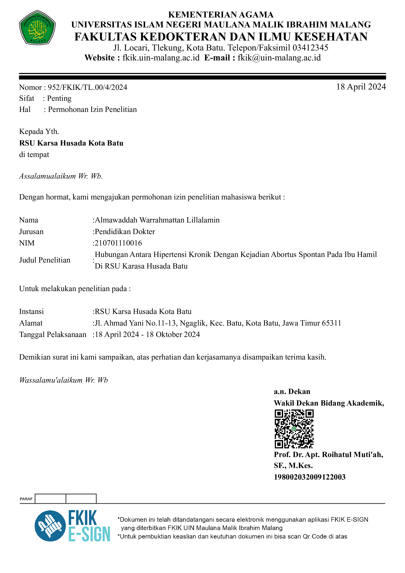

Lampiran 2. Surat Disposisi Rumah Sakit

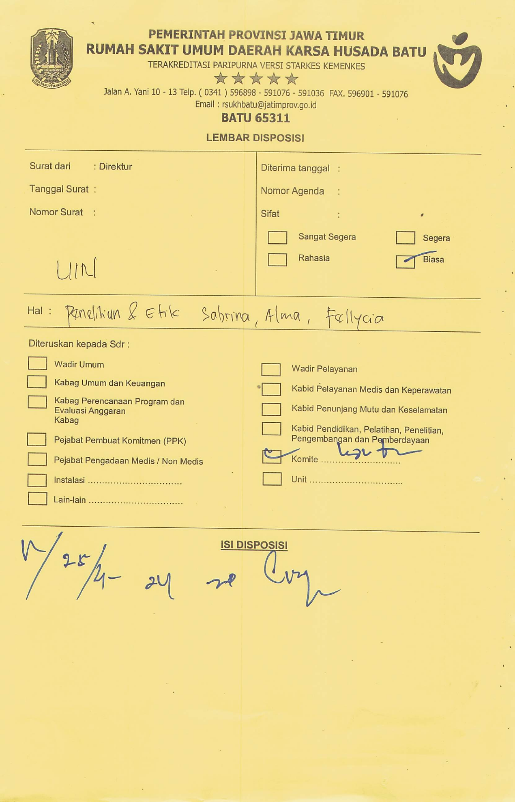

Lampiran 3. Surat Layak Etik

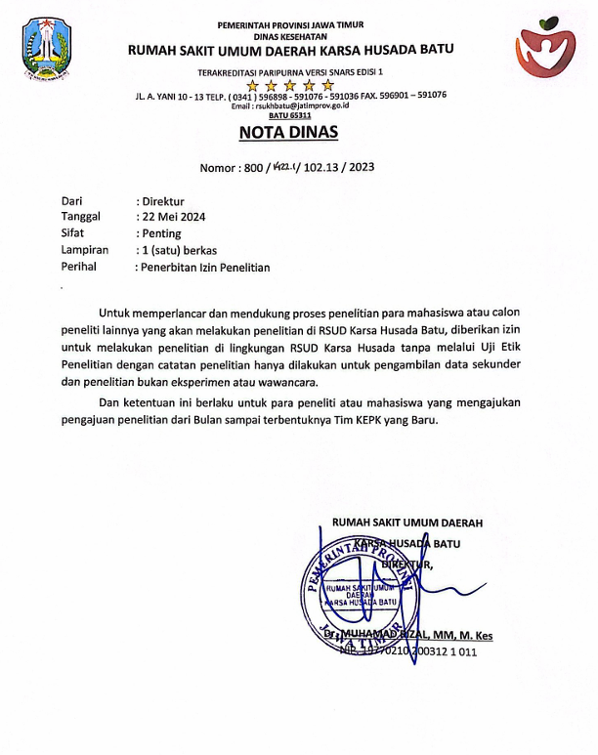

Lampiran 4. Surat Persetujuan Penelitian
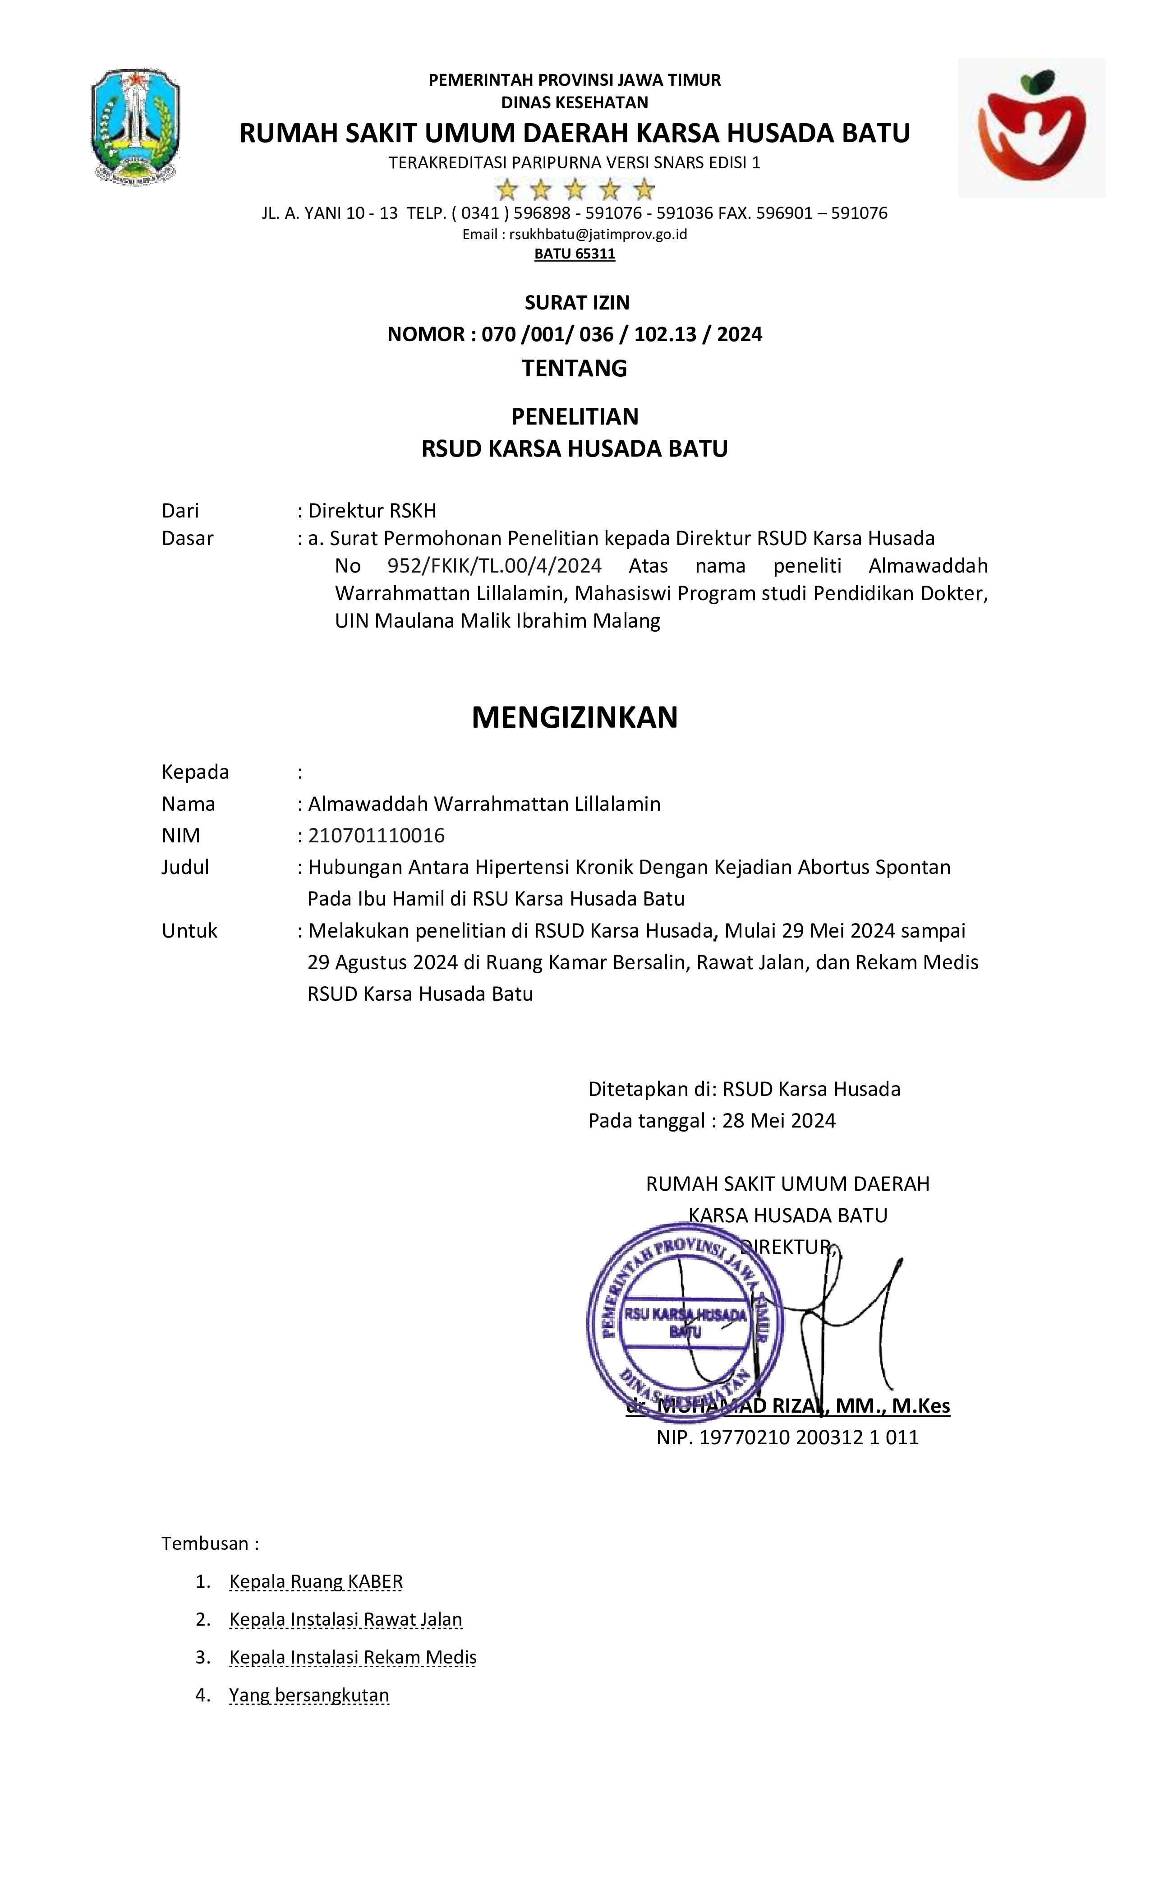

Lampiran 5. Data Penelitian
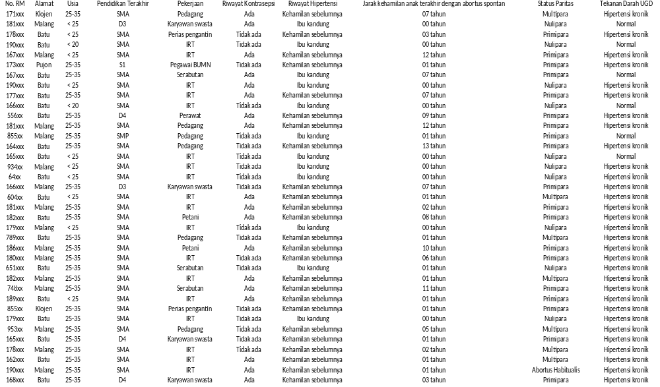

Lampiran 6. Hasil Pengolahan Data

Analisis Univariat

Usia
 |  | Frequency | Percent | Valid Percent | Cumulative Percent
Valid | < 20 | 2 | 5.4 | 5.4 | 5.4
Valid | < 25 | 10 | 27.0 | 27.0 | 32.4
Valid | 25-35 | 25 | 67.6 | 67.6 | 100.0
Valid | Total | 37 | 100.0 | 100.0

Pendidikan
 |  | Frequency | Percent | Valid Percent | Cumulative Percent
Valid | D3 | 2 | 5.4 | 5.4 | 5.4
Valid | D4 | 3 | 8.1 | 8.1 | 13.5
Valid | S1 | 1 | 2.7 | 2.7 | 16.2
Valid | SMA | 30 | 81.1 | 81.1 | 97.3
Valid | SMP | 1 | 2.7 | 2.7 | 100.0
Valid | Total | 37 | 100.0 | 100.0

Pekerjaan
 |  | Frequency | Percent | Valid Percent | Cumulative Percent
Valid | IRT | 18 | 48.6 | 48.6 | 48.6
Valid | Karyawan swasta | 4 | 10.8 | 10.8 | 59.5
Valid | Pedagang | 6 | 16.2 | 16.2 | 75.7
Valid | Pegawai BUMN | 1 | 2.7 | 2.7 | 78.4
Valid | Perawat | 1 | 2.7 | 2.7 | 81.1
Valid | Perias pengantin | 2 | 5.4 | 5.4 | 86.5
Valid | Petani | 2 | 5.4 | 5.4 | 91.9
Valid | Serabutan | 3 | 8.1 | 8.1 | 100.0
Valid | Total | 37 | 100.0 | 100.0

Riwayat_Kontrasepsi
 |  | Frequency | Percent | Valid Percent | Cumulative Percent
Valid | Ada | 18 | 48.6 | 48.6 | 48.6
Valid | Tidak ada | 19 | 51.4 | 51.4 | 100.0
Valid | Total | 37 | 100.0 | 100.0

Riwayat_Hipertensi
 |  | Frequency | Percent | Valid Percent | Cumulative Percent
Valid | Ibu kandung | 12 | 32.4 | 32.4 | 32.4
Valid | Kehamilan sebelumnya | 25 | 67.6 | 67.6 | 100.0
Valid | Total | 37 | 100.0 | 100.0

Jarak_Kehamilan
 |  | Frequency | Percent | Valid Percent | Cumulative Percent
Valid | 00 tahun | 9 | 24.3 | 24.3 | 24.3
Valid | 01 tahun | 11 | 29.7 | 29.7 | 54.1
Valid | 02 tahun | 2 | 5.4 | 5.4 | 59.5
Valid | 03 tahun | 2 | 5.4 | 5.4 | 64.9
Valid | 05 tahun | 1 | 2.7 | 2.7 | 67.6
Valid | 06 tahun | 1 | 2.7 | 2.7 | 70.3
Valid | 07 tahun | 4 | 10.8 | 10.8 | 81.1
Valid | 08 tahun | 1 | 2.7 | 2.7 | 83.8
Valid | 09 tahun | 1 | 2.7 | 2.7 | 86.5
Valid | 10 tahun | 1 | 2.7 | 2.7 | 89.2
Valid | 11 tahun | 1 | 2.7 | 2.7 | 91.9
Valid | 12 tahun | 2 | 5.4 | 5.4 | 97.3
Valid | 13 tahun | 1 | 2.7 | 2.7 | 100.0
Valid | Total | 37 | 100.0 | 100.0

Status_Paritas
 |  | Frequency | Percent | Valid Percent | Cumulative Percent
Valid | Abortus Habitualis | 1 | 2.7 | 2.7 | 2.7
Valid | Multipara | 7 | 18.9 | 18.9 | 21.6
Valid | Nulipara | 10 | 27.0 | 27.0 | 48.6
Valid | Primipara | 19 | 51.4 | 51.4 | 100.0
Valid | Total | 37 | 100.0 | 100.0

Tekanan_Darah
 |  | Frequency | Percent | Valid Percent | Cumulative Percent
Valid | Hipertensi kronik | 31 | 83.8 | 83.8 | 83.8
Valid | Normal | 6 | 16.2 | 16.2 | 100.0
Valid | Total | 37 | 100.0 | 100.0

Analisis Bivariat

Hubungan antara Hipertensi Kronik dengan Kejadian Abortus Spontan

Tekanan Darah
 | Observed N | Expected N | Residual
Hipertensi | 31 | 18.5 | 12.5
Normal | 6 | 18.5 | -12.5
Total | 37

Test Statistics

 | Tekanan Darah
Chi-Square | 16.892ª
df | 1
Asymp. Sig. | .000
a. 0 cells (.0%) have expected frequencies less than 5. The minimum expected cell frequency is 18.5.

Lampiran 7. Dokumentasi Penelitian

