PREJUDICE TOWARD BLACK PEOPLE CHARACTERS IN KATHRYN BIGELOW’S DETROIT FILM
Vicky Farizky, Mardliya Pratiwi Zamruddin, Setya Ariani
English Department, Faculty of Cultural Studies
Mulawarman University
Email: vickyalfarezky@gmail.com
ABSTRACT
This research deals with prejudice in the Detroit film by Kathryn Bigelow. Prejudice is the negative assessment or hostility toward an individual or group resulting in negative treatment. There are so many negative treatments from the prejudice portrayed in the Detroit film. In this research, the researcher analysed the prejudice aspects through the characterization of the characters experiencing negative treatments in the Detroit film. This research was conducted by using a qualitative research design. The data were generated from the speech, thoughts, effect, action, and looks of the characters portrayed in the film. The researcher revealed that the negative treatments in Detroit are committed by the white people police officers and experienced by the black people citizens. In conclusion, four negative treatments experienced by the characters were anti-locution, discrimination, physical attack, and extermination. Therefore, the researcher concluded that the difference between both races such as their skin tone, or the types of their hair is what generated prejudice in Detroit film.
Keywords: prejudice, black people, Detroit

ABSTRAK
Penelitian ini berkaitan dengan prasangka dalam film Detroit oleh Kathryn Bigelow. Prasangka adalah penilaian negatif atau permusuhan terhadap suatu individu atau kelompok yang menghasilkan perlakuan negatif. Ada begitu banyak perlakuan negatif dari prasangka yang digambarkan dalam film Detroit. Di dalam penelitian ini, peneliti menganalisis aspek prasangka melalui penokohan dari tokoh yang mengalami perlakuan negatif dalam film Detroit. Penelitian ini dilakukan dengan menggunakan bentuk penelitian kualitatif. Data dihasilkan dari percakapan, pemikiran, pengaruh, dan penampilan dari karakter-karakter yang digambarkan di dalam film. Peneliti mengungkapkan bahwa perlakuan negatif di dalam Detroit dilakukan oleh petugas-petugas polisi berkulit putih dan dialami oleh warga berkulit hitam. Kesimpulan nya, empat perlakuan negatif dialami oleh karakter-karakter yaitu anti-lokusi, diskriminasi, serangan fisik, and pemusnahan. Oleh karna itu, peneliti menyimpulkan bahwa perbedaan di antara kedua ras seperti warna kulit, atau jenis rambut mereka itulah yang menimbulkan prasangka di film Detroit.
Kata kunci: prasangka, warga kulit hitam, Detroit

- INTRODUCTION
There are so many phenomena that happen in a literary work and so many aspects of the story in a literary work can be analysed. The literature can give education with a different understanding depending on what happens in the story and also what is formed from the perspective of the other readers. The researcher is interested in discussing a literary work that contained the prejudice phenomenon and discussed the negative treatments that are generated from prejudice in the film entitled Detroit.
In this research, the researcher uses the prejudice theory by Gordon Allport from his book entitled “The Nature of Prejudice” to describe the prejudice treatments. Allport states prejudice as “an aversive or hostile attitude toward a person who belongs to a group, simply because he belongs to that group, and is therefore presumed to have the objectionable qualities ascribed to the group” (Allport 7). From the statement, the researcher interprets prejudice as negative assessment or hostility toward an individual or group resulting in negative treatment. In general, negative treatment occurs because of inequity, hatred, or conflict toward an individual or group. In this situation, individuals or groups that receive negative treatment made some resistance that trigger the violence. Another statement from Allport is “thinking ill of others without sufficient warrant” (Allport 6). This definition contains two essential ingredients, which are: 1) unfounded judgment, and 2) a feeling-tone which later is connected to attitude. There are so many kinds of negative treatments such as physical attack and extermination portrayed between individuals or groups in the object of this research, especially toward black people. Based on the definition above, the researcher analysed negative treatments from the prejudice experienced by the characters in the film.
Besides happening in the real world, prejudice toward individuals or groups also appears in literary works as the mirror of society. One of them is represented in Detroit film. The presence of negative treatments from prejudice to individuals or groups has triggered the violence or hostility between the races in some places or cities. Therefore, “Prejudice toward Black People Characters in Kathryn Bigelow's Detroit Film” becomes the title of this research.
- LITERATURE REVIEW
- Literature and Film
- Literature
“Etymologically, the Latin word “litteratura” is derived from “littera” (letter), which is the smallest element of alphabetical writing” (Klarer 14). In his book entitled An Introduction to Literary Studies, Klarer explained that literature refers to the entire written expression, with the restriction that not every written document can be categorized as literature in the more exact sense of the world (Klarer 1). It means that literature is a writing expression by the authors. Not all written text can be called literature. Literature can be said as creative or imaginative writing by the authors which makes literature regarded as an art.
- Film
Film's idiosyncratic modes of presentation-such as camera angle, editing, montage, slow and fast motion-often parallel features of literary texts or can be explained within a textual framework (Klarer 53). The most important of these methodologies coincide with the ones already discussed in connection with literary theory. There are, for example, approaches similar to text-oriented literary criticism which deals with material aspects of the film, such as film stock, montage, editing, and sound.
- Character and Characterization
- Character
The character belongs to people in a story that is created to make the story feel alive. The character has to be suitable with the situation in the story that happens in it, the character also will be changed if there is something, which causes it. In the story, characters are different from one another. “Characters in another definition is individual. Each character or individual has a different role, depending on the reader to see the character because each character in the story has different functions” (Bal 105).
- Characterization
There are two types of characterization which are direct characterization and indirect characterization. Based on the object of the research, the researcher chose to use the indirect characterization.
- Direct characterization
Direct characterization is also known as explicit characterization, it consists of the author telling the audience what a character is like. A narrator may give this information to the audience, or the character in the story may do it. Furthermore, Charters said that the direct characterization can also involve other external detail, such as names or another overt commentary (Charters 58).
- Indirect characterization
Indirect characterization is also known as implicit characterization, this type is consisting of the author showing the audience what kind of person a character is through the character’s thoughts, words, and deeds/action (Burroway 54). In addition, there are five different methods of indirect characterization in literary work, which are: speech, thoughts, effect, action, and looks of the character that portrayed in the object of the research (Indirect Characterization: Definition & Examples).
- Prejudice
Allport said that a prejudiced person does not judge the merits or quality of an individual, but rather judge an individual based on their membership. “An aversive or hostile attitude toward a person who belongs to a group, simply because he belongs to that group, and is therefore presume to have the objectionable qualities ascribed to the group” (Allport 7). These are kinds of prejudice that are happened in Detroit film, like anti-locution, avoidance, discrimination, physical attack, and extermination, as explained below:
- Anti-locution
Anti-locution is the first negative treatment that white people give to the black people in Detroit. Allport explained, anti-locution is an action of most people who have prejudices talk about them. With like-minded friends, occasionally with strangers, they may express their antagonism freely. But the people never go beyond this mild degree of antipathetic action (Allport 14). The example of anti-locution is Bad-mouthing, spiteful gossiping, creating negative myths about people, anti-jokes, verbal abuse, stereotyping, and hate speech.
- Avoidance
Avoidance is the second negative treatment from prejudice. Allport said, this level of prejudice is more intense, it leads the individual to avoid members of the disliked group, even perhaps at the cost of considerable inconvenience (Allport 14). The example of avoidance is Ignoring, excluding, isolating, physical withdrawal, e.g. not patronising businesses.
- Discrimination
Discrimination is the third negative treatment from prejudice, the person who commits this prejudice will deny or disadvantages minority opportunities and access to the services. This prejudice also gives individuals or groups different treatment or detrimental distinctions (Allport 15). The example of discrimination is Denies/disadvantages minority opportunities and access to the services.
- Physical attack
Physical attack is the fourth negative treatment from prejudice. Physical attack is an action under conditions of heightened emotion, this prejudice is also known as a hate crime that leads to acts of violence or semi-violence (Allport 15). The example of physical attack is Assault, rape, criminal damage, and physical harm.
- Extermination
Extermination is the last negative treatment from prejudice and the ultimate form of negative treatment which results from intense prejudice. Allport gives the example of extermination such as lynchings, pogroms, massacres, and the Hitlerian program of genocide; these example mark the ultimate degree of violent expression of prejudice (Allport 15).
- RESEARCH METHOD
- Research Design
Qualitative research is concerned with developing an explanation of social phenomena (Hancock 7). Qualitative research is used to show and help the researcher to see the social phenomenon which is the prejudice; and only focuses on the screenshots of the scenes from the object of this research.
- Data and Data Source
The data for this research is Kathryn Bigelow’s Detroit Film, and the data sources of this research is from the screenshot of the scenes that contained prejudice treatments that are taken from article, website, or any sources from the library and the internet that are related to the prejudice which is supported this research.
- Data Collection
There were three steps applied in data collection in this research. The first step is the researcher watched the film carefully. The second, the researcher captured the scenes from the film by screenshot and noted the data that contained the prejudice. And the last, the researcher sorted and identified the data that related to the research question.
- Data Analysis
In analysing data, the researcher analysed the data using Matthew Miles and Michael Huberman’s (10-12) theory. Three steps were conducted by the researcher to analyze the data. They were data reduction, data display, and conclusion drawing/verification.
- FINDINGS AND DISCUSSION
In this analysis, the researcher analysed the prejudice through the characters’ characterization that portrayed in Detroit. The researcher paid attention to the negative treatments from white people characters to the black people characters that displayed in the film and identified five kinds of the prejudice portrayed in the negative treatments.
The researcher found four forms of the negative treatments as the results of the prejudice, they are anti-locution, discrimination, physical attack, and extermination; that occurred toward the black people characters in the Detroit film. While avoidance, the second kind of negative treatment from prejudice is not found in the object of the research. The data is not found because the Detroit film is directly showed the worse intense prejudice.
- Findings
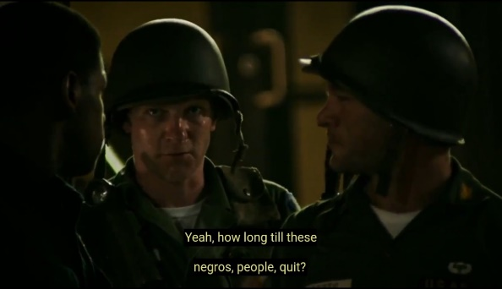
- Anti-locution

Roberts: We actually took sniper fire.
Roberts: Had one, right by here.
Dismukes: Ain’t no snipers here, man.
Dismukes: Just you and me,
Dismukes: and the people partying in that motel.
Roberts: How long do you think this is gonna last?
Matthew: Yeah, how long till these Negros, people, quit?
Dismukes: How the hell am I supposed to know?
This scene is categorized as anti-locution treatment because Matthew’s character expresses his resentment expression which is stereotyping the black people.
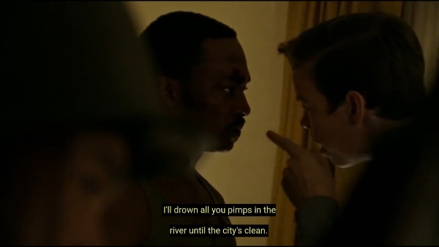
- Discrimination

Julie: You’re on some trip. You think you can come into my city
Flynn: and pimp out a bunch of young girls?
Greene: I said it wasn’t like that
Krauss: I don’t care if you were in the army
Krauss: I’ll drowned all you pimps in the river until this city’s clean
This scene can be categorized as discrimination treatment because Krauss and Flynn give the black man character (Karl Greene) different treatment or detrimental distinction.
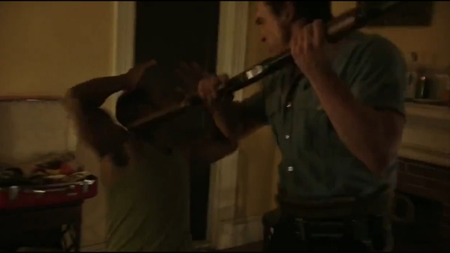
- Physical attack

Flynn: Anybody in there?
Greene: No sir. (Flynn shooting)
Flynn: Get the fu*k up! Get downstairs! Go!
This scene is categorized as physical attack treatment because there is no one behind Greene’s back at that time, but Flynn character still threatens and strikes Karl Greene in the face with the shotgun.
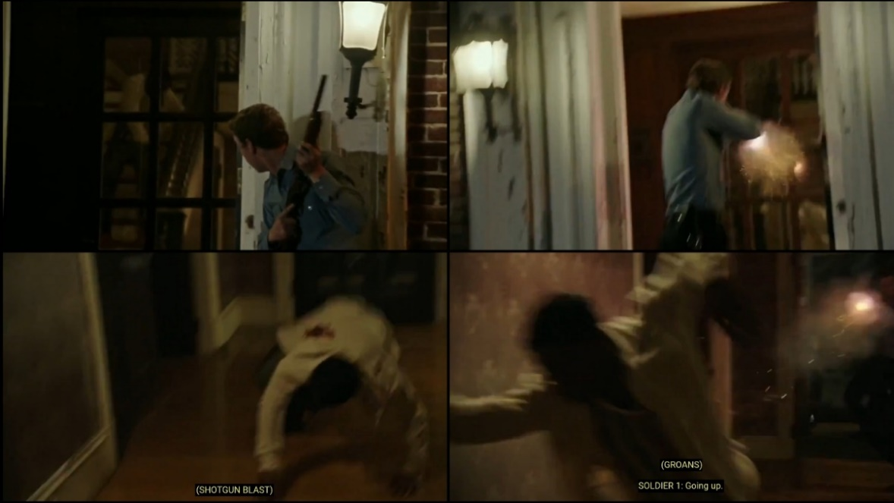
- Extermination

Krauss: GUNSHOT (Phillip Krauss shot Carl Cooper twice).
Dismukes: What happened?
(Melvin Dismukes asked Krauss and Flynn after saw Carl Cooper’s body).
Krauss: Fella here had a knife, tried to go for my gun.
Flynn: Yeah, I heard him shout, “Get off my gun!”
Krauss: Yeah, it happened pretty fast.
Dismukes: I guess you had to defend yourself.
This scene is categorized as extermination treatment. The several characters in this motel are executed by Phillip Krauss and his partner.
- Discussion
Anti-locution treatments in the findings are contained resentment expressions toward black people characters in the film. A person who did anti-locution will lead the opinion to the others and then affect people to have the same negative thoughts about something (Allport 14). Based on the findings, anti-locution appeared in stereotyping the black people, this form happened when Matthew’s character asked a question to the black man security officer, Melvin Dismukes. The question agrees that black people are the cause of the problem, and influenced the other troops to ask the same question that driving their minds to think that black people are the cause of the riots.
Discrimination in the film is portrayed the different treatment or detrimental distinction to the black people characters in the Detroit film. The person who commits this prejudice will deny or disadvantages minority opportunities and access to the services (Allport 15). Discrimination appeared in excluding black man character from a certain type of employment, this form happened when Krauss and Flynn characters did not believe that Karl was an Army, they discriminate against and humiliate Karl Greene in front of his friends (Julie and Karen).
Physical attack is an action under conditions of heightened emotion, this prejudice is also known as hate a crime that leads to acts of violence or semi-violence (Alport 15). Physical attack in the findings has portrayed the action of violence and semi-violence through the black people character based on the Detroit film. Physical attack treatment appeared in physical harm and vandalism, these forms happened when Flynn’s character strikes Greene’s face with his shotgun and destroys a wardrobe behind him.
Extermination in this research intentionally happens toward the black people characters that are planned to be killed and executed by the white people characters during the uprising in Detroit. Extermination is the ultimate form of negative treatment which results from intense prejudice (Allport 15). Therefore, the researcher identifies that the negative treatments from the film are included as extermination. Based on the findings, extermination treatments have appeared in the form of pogroms and massacres that appeared in the film. This negative treatment is displayed when Krauss kills Carl Cooper by shooting him twice in his back when Carl tries to escape from the upstairs. There are total of three black people characters that were killed in this film, and all of them are planned and executed by the same group, which are white people.
In terms of differences, the researcher found the other difference in this research. The researcher found the negative treatments from the prejudice committed by white people characters in the film were not only experienced by black people characters but also experienced by white people characters, namely Julie and Karen.
- CONLUSION
The negative treatments from the prejudice that were committed by white people police officers towards black people citizens and two white people visitors in Detroit city have appeared four kinds in the film. Those are anti-locution, discrimination, physical attack, and extermination. The negative treatments from prejudice are described through the three indirect characterizations. The first is indirect characterization through speech, then indirect characterization through action and the last is indirect characterization through thoughts.
Based on the results of the data analysis above, the researcher concluded the negative treatments from the prejudice are happened because of diversification from individual or group between majority and minority in some places or cities. In this case, the majority are white people and the minority are black people, white people are considered that their race (skin tone) is better than black people, this different opinion is the cause of disagreement. Therefore, this research is concluded that the difference between both races is what generated prejudice in Detroit.
The researcher suggests that the readers should be aware of the kinds of prejudice and also should recognize its various form of negative treatments to put the research in better result. Therefore, the researcher expects this research and the issues that are portrayed in the film can be a reference or an example to the other researcher that also raise the prejudice phenomenon as the object. The last to note, this film also can be analysed using other theories that related to the prejudice issues, such as racism and discrimination.

WORK CITED
Allport, Gordon W. The Nature of Prejudice. United States: Addison-Wesley Publishing Company, 1954.
Bal, Mieke. Introduction to The Theory of Narrative: 4th Ed. London: University of Toronto Press, 2017.
Burroway, Janet. Writing Fiction, Tenth Edition: A Guide to Narrative Craft. United States: The University of Chicago Press, 2019.
Charters, Ann. The Story and Its Written: An Introduction to Short Fiction. New York: Bedford, 2011.
Hancock, Baverley. An Introduction to Qualitative Research. London: Trent Focus Group, 1998.
“Indirect Characterization: Definition & Examples.” study.com, 19 May. 2015, Accessed 27 June. 2021.
Klarer, Mario. An Introduction to Literary Studies. London and New York: Routledge, Taylor and Francis Group, 1999.
Miles, Matthew and Michael Huberman. Qualitative Data Analysis: An Expanded Sourcebook. Thousand Oaks: Sage Publications, 1994.

