BEHAVIORAL PSYCHOLOGY STUDY OF THE MAIN CHARACTER IN ROOM (2015) FILM

Nurhaliza Fajar Wati^{1,*}, Fatimah Muhajir²
^{1,2,} Department of English Literature, Faculty of Cultural Sciences, Mulawarman University
^{1,*} Email: lizazldk@gmail.com
² Email: fatimah@fib.unmul.ac.id

ABSTRAK

Penelitian ini bertujuan untuk menjelaskan perilaku tokoh utama, Jack dalam film Room (2015) dengan menggunakan teori behaviorisme dari John B. Watson dan B.F. Skinner. Penelitian ini menggunakan metode deskriptif kualitatif dengan pendekatan psikologi behavioristik. Data dikumpulkan melalui penayangan film secara berulang, pencatatan, dan identifikasi pola perilaku yang berkaitan dengan stimulus dan respons. Analisis difokuskan pada pengkondisian klasik, pengkondisian operan, dan faktor internal yang mempengaruhi perilaku. Hasil penelitian menunjukkan bahwa perilaku Jack dibentuk oleh berbagai rangsangan eksternal, termasuk respons yang dikondisikan terhadap rutinitas sehari-hari dan interaksi sosial dalam lingkungan yang terbatas. Pengkondisian operan terlihat dari perubahan perilaku Jack sebagai respons terhadap konsekuensi dan hadiah. Selain itu, faktor internal seperti emosi, kesadaran diri, dorongan, serta tujuan dan niat juga memainkan peran penting dalam respons dan adaptasi Jack terhadap lingkungannya. Temuan ini mendukung pandangan behaviorisme bahwa perilaku manusia dibentuk dan dipelajari melalui interaksi dengan lingkungan.

Kata kunci: Pendekatan psikologi, Perilaku, Film room

ABSTRACT

This study aims to explain the behavior of the main character, Jack, in the film Room (2015) using the behaviorist theories of John B. Watson and B.F. Skinner. The research uses a qualitative descriptive method with a behaviorist psychological approach. Data were collected through repeated viewing of the film, note taking, and identification of behavioral patterns related to stimulus and response. The analysis focuses on classical conditioning, operant conditioning, and internal factors that influence behavior. The results of the study indicate that Jack’s behavior is shaped by various external stimuli, including conditioned responses to daily routines and social interactions within his limited environment. Operant conditioning is evident through Jack’s behavioral changes in response to consequences and rewards. Additionally, internal factors such as emotions, self-awareness, drives, and goal and intentions play a significant role in Jack’s responses and adaptation to his environment. These findings support the behaviorist perspective that human behavior is shaped and learned through interactions with the environment.

Keywords: Behavioral, Psychological approach, Room film

A. INTRODUCTION
Human behavior certainly changes throughout life. It is influenced, affected, and shaped by many factors, such as family background, social interactions, friendships, and work environments. According to Patty (1982), behavior is an individual's response to various stimuli, often influenced by their social environment as a result of human relationships. As Watson states in the book Behaviorism (2006) behaviorism is a point of view on how human conduct is affected by external conditions such as fear, which the environment created through authority figures like parents, religious leaders or others. Behaviorism helps explain how the behavior of a character is shaped by the enviromental conditions and how people particular responses to stimuli lead to certain actions (Graham, 2000). To identify the behavior of the main character in the film Room (2015), the behaviorism theory popularized by John B. Watson provides a solid foundation. Watson (1924) argued that human behavior can be fully explained by observing the responses produced by individuals when interacting with specific stimuli from their environment, without involving internal mental processes such as thoughts or emotions.
In the context of Room, Jack’s behavior can be analyzed based on how he responds to stimuli from his environment. In addition, this study also applies B.F. Skinner’s operant conditioning theory, which focuses on how behavior is shaped by reinforcement and punishment. Skinner (1953) emphasized that behavior can be increased or decreased depending on the consequences that follow it. Jack’s behavior is influenced not only by reflexive responses to external stimuli but also by the rewards or consequences he receives after certain actions. This study also considers internal factors such as self-awareness, emotions, drives, and goals and intentions. These internal factors provide a clearer understanding of Jack’s behavior, especially in how he expresses his feelings through spontaneous physical or bodily reactions.
Based on the explanation of the background of the study, the research question is “How is Jack’s behavioral response portrayed in the film Room (2015) based on the external stimuli and internal factors that influence his behavior?” and based on the research question, the purpose of the study is to analyze how Jack’s behavior is influenced by external stimuli and to identify the internal factors that affect his behavior in the film Room (2015).
Room chosen to be the subject of the study. The scope of the study is to describe how external influences and environmental stimuli shape Jack’s behavior and reactions throughout the film based on John B. Watson and B.F Skinner’s behaviorist theory, the researcher decided that this study is limited to the protagonist to maintain a clear focus on Jack.

B. LITERATURE REVIEW
      - Film Literature
Literature uses language to portray characters, while in film, characters are shown through actions and dialogues. Both share intrinsic and extrinsic elements that enhance the experience for readers or viewers (Ramrao, 2016).
      - Character
Klaler (2004) explains that characters who have one dominant trait are called flat characters, while round characters refer to more complex and unique characters.
- According to their role and level of importance, characters can be divided into two categories: first the main characters who are always involved in the story and have an important role in driving the plot, and second the secondary characters, who may only appear occasionally in the story.
- The characters in a story can be categorized into simple characters and complex characters. Simple characters have consistent traits and pose no surprises to the reader, while complex characters are usually the center of attention of the reader because they have more diverse dimensions of life and personality, often exhibiting conflicting traits and are difficult to predict.
      - Characterization
Pickering and Hoeper (1981) categorize characterization into two methods that is direcly and indirectly
      - Direct characterization
This approach presents a character by having the author explicitly reveal their traits. It involves building a character through their own actions, interactions with others, or through the narrator's insights, which the reader can interpret.
      - Indirect characterization
Indirect characterization is a literary technique used by authors to reveal the personality and traits of a character through dialogues and emotions.
      - Psychology of Literature
The psychology of literature involves the study of the author, the creative process, psychological types within literary works, and the effects of literature on readers (Wellek and Warren as cited in Goksen Aras, 2015).
      - Behaviorism
According to Watson (1994) human behavior is entirely learned from the surrounding environment.
- Learning Through Classical Conditioning
In classical conditioning, which Pavlov refers to as respondent behavior, an organism's response is triggered by a specific, familiar stimulus. In this type of conditioning, a particular response is drawn out by a known stimulus, and the stimulus always occurs before the response.
- Learning Through Operant Conditioning
According to Skinner (1986), operant conditioning involves a response that interacts with and alters the environment. This form of conditioning establishes a link between a behavior and its resulting consequences. The critical aspect of operant conditioning is the immediate reinforcement following the behavior (Skinner, 1986).
            - Positive Reinforcement
When positive reinforcement is applied to reward desirable behavior, the unwanted behavior tends to decrease or even disappear over time (Skinner, as cited in Rumfola, 2017).
            - Negative Reinforcement
Negative reinforcement is a behavioral principle in which removing an undesirable stimulus strengthens a behavior, making it more likely to be repeated in the future. It focuses on encouraging the behavior rather than punishing it (Hineline & Rosales 2013).
            - Postive Punishment
Positive punishment is the occurrence of a behavior followed by the presentation of an unpleasant stimulus and makes the unwanted behavior not reoccur in the future (Skinner, as cited in Rumfola, 2017).
            - Negative Punishment
Negative punishment is the occurrence of a behavior that is reinforced by the removal of the stimulus and and makes the unwanted behavior not reappear in the future (Skinner, as cited in Rumfola, 2017).
- Internal Factors
Human behavior, as a series of actions or activities, is greatly influenced by internal factors, both directly and indirectly, which play a significant role in shaping its development. Some of Skinner's opinions about the role of the internal state are:
- Self-awareness
Humans not only have consciousness but are also aware of their consciousness. They are aware not only of their surroundings but also of themselves as part of their environment. Behavior is a function of both the environment and the internal aspects of a person. This internal part of the universe is unique to each individual and thus private. We recognize our own thoughts, emotions, memories, and intentions in a personal way (Skinner, 1974).
- Drives
Drives refer to the likelihood of an organism responding in a certain way. They represent the driving forces behind a person’s behavior, linking specific impulses to particular actions (Skinner, 1974).
- Emotions
Behaviors that result in feelings of pleasure, excitement, or enjoyment are reinforced, making it more likely for the individual to repeat those behaviors in the future, such as when a child receives praise and a sense of accomplishment after completing a difficult puzzle, encouraging them to engage in similar activities again (Skinner, 1974).
- Goals and Intentions
Goals or intentions are physical stimuli experienced by the organism, not mental events that influence behavior. The consequences of operant behavior are not determined by the behavior itself, but by the same consequences that have shaped and reinforced it over time (Skinner, 1974).

C. METHODS
The researcher used descriptive qualitative method because this method matches with purpose of this research. Qualitative research is used to analyze the data in the form of images, words, and sentences, not numbers. According to Creswell and Poth in Dodgson (2017), qualitative research is a method to describe and analyze non-numerical data like language and visual scenes.
The approach used in this research is psychological approach which focused on theory about stimulus and response. It is suitable for analyzing Jack’s behavior in the film Room (2015) which shows how a child learns and adapts to his environment through external experiences and internal factors.
The data in this study were taken from the film Room, directed by Lenny Abrahamson and produced by David Gross and Ed Guiney under Element Pictures in 2015. The film has a duration of 118 minutes. The data are in the form of dialogues, images, scenes, expressions, and behavior of the character Jack that are related to classical conditioning, operant conditioning, and internal factors like emotion and self-awareness.
The data were collected through these steps: 1) Watching the film repeatedly to understand Jack’s behavior. 2) Taking notes on important dialogues and actions that show stimulus and response. 3) Capturing screenshots and writing the transcripts of scenes that are related to behaviorism theory.
The data were analyzed using the method from Huberman (1994) in three steps: 1) Classifying the behavior shown by Jack based on stimulus and response patterns. 2) Analyzing the behavior to match it with types of behaviorism. 3) Reviewing the analysis to ensure it fits the research objectives and gives a clear explanation of Jack’s behavior in the film.

D. FINDINGS AND DISCUSSIONS

      - Findings
        - Classical Conditioning
Classical Conditioning explains that behavior can be formed through repeated associations between initially neutral stimuli and stimuli that become familiar and elicit a specific response.

Data 1:
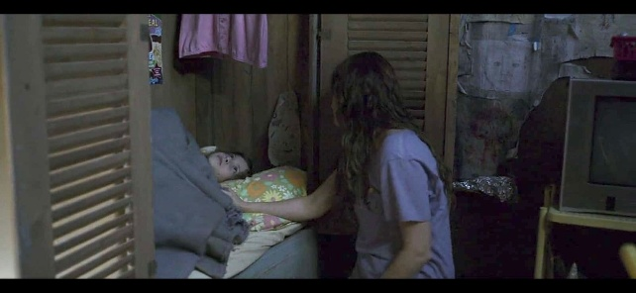
Figure 1. Ma instructs Jack to go to sleep in the wardrobe that already contains bedding such as blankets and pillows that are familiar to him.
Ma : ”Come on, Jack. It's late. Let's go to bed.”
(Room 2015, 00:08:18 - 00:08:25).

One example is Jack's reaction to certain sounds that are part of his daily routine. When Ma tells him that it's time to go to bed, Jack immediately walks toward the wardrobe and gets inside without asking questions or showing confusion, since that is where he sleeps. This behavior happens because Jack is used to hearing that command as a signal that Old Nick, the only person he knows besides Ma is about to arrive. The instruction also tells him that it is bedtime.
Ma's voice has become a stimulus that triggers Jack’s response, such as walking into the wardrobe and preparing to sleep. Jack associates Ma’s voice with both bedtime and Old Nick’s arrival, which leads to this automatic response.

Data 2:
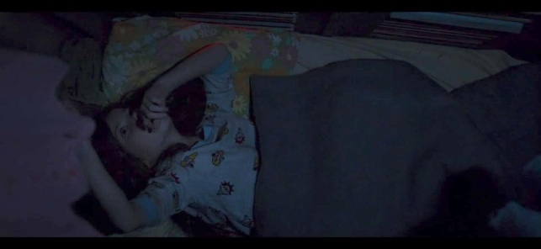
Figure 2. Jack heard Old Nick coming from the sound of the knock on the door and observed Old Nick and Ma's daily conversation from inside the wardrobe.
(Knock on the door)
Old Nick : ”Is it a birthday cake?”
Ma : “Mm.”
Old Nick : “Mm. You should have told me. I'd have got him a present. So, uh, how old is he anyway? Four? Five.”
(Room 2015, 00:09:57 – 00:10:25).

Similarly, the sound of knocking on the door, which Jack heard almost every night, became a familiar situation for him. Although he has never seen the person knocking, he immediately recognized the sound as a sign of Old Nick’s arrival. Jack was used to hearing Old Nick’s voice from inside the wardrobe.
Jack didn’t need to see his face or hear his name. His voice alone was enough for him to recognize who it was. While lying down, Jack would listen to Ma talking with Old Nick about daily needs or simple conversations, such as birthday presents or complaints about work. Jack overheard everything from inside the wardrobe.
These nightly conversations became part of Jack’s bedtime routine. As a result, the knocking sound and the voices that followed became familiar stimuli. Jack associated the knock with Old Nick’s arrival and the start of their routine.

Data 3:
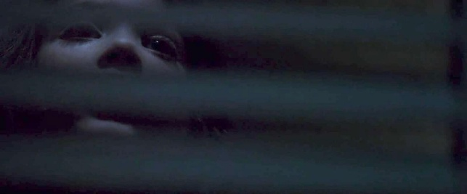
Figure 3. Jack listens to Ma and Old Nick's conversation about him by peeking through the gap in the wardrobe to know what they are talking about more clearly.
Old Nick : ”So how did he like his truck?”
Ma : “Yeah.”
Old Nick : ”I know boys”
Ma : “The vitamins. There’s nothing in them.”
(Room 2015, 00:10:10)

Besides, whenever Jack hears Ma and Old Nick talking about him, he always reacts the same way. He tries to peek through the small gaps in the wardrobe and presses his ear to the wall to hear them more clearly. This behavior shows his curiosity and a habit formed over time. Jack understands that when his name is mentioned, it often means something important, like Ma asking Old Nick to provide for his needs or showing concern for him.
In these nightly talks, Ma often discusses Jack’s needs, such as books, medicine, vitamins, or even birthday presents. Sometimes, they talk about Jack’s growth and development. These conversations become part of his nightly routine. Therefore, Jack associates every conversation about him with care and attention, whether it comes from Ma or Old Nick.

Data 4:
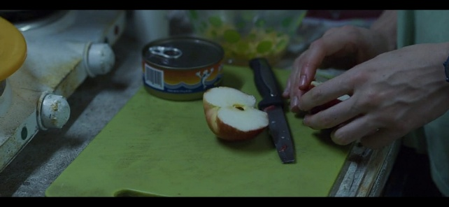
Figure 4. Ma prepares breakfast for Jack from the food Old Nick delivers which has become a familiar routine for them (Room 2015, 00:12:25).
In addition, every time Jack hears the sound of knocking on the door, he immediately understands that Old Nick is about to enter the room. He also starts thinking about what Old Nick might be bringing.
Jack has learned that Old Nick’s visits are usually followed by the arrival of items like food, bread, milk, eggs, fruit as well as gifts, toys, vitamins, medicine, and other household items that Jack would see the next morning which made him familiar. Because of this, Jack automatically pays close attention to the voice outside the wardrobe because the voice has been associated in his mind as a sign of the “delivery” of daily necessities, especially foods.

  - Operant Conditioning
Operant conditioning involves responses that are influenced by the social environment, where a behavior may result in a consequence or a reward depending on the action performed.

Data 5:
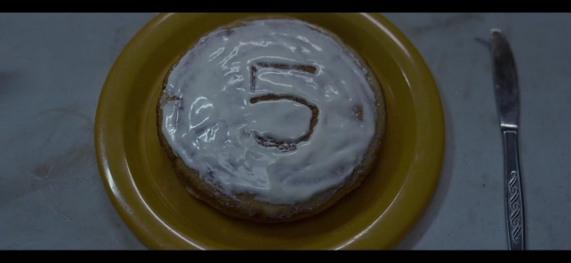
Figure 5. Jack's birthday cake didn’t have any candles, which made Jack argue with Ma because he wanted the candle right away, but the situation didn’t allow Ma to give him one.
Jack : “Now the candles!”
Ma : “We don’t have any candles.”
Jack : “I know. You said a birthday cake, for real. That means candles on fire!”
Ma : “Jack…”
Ma : “I’m sorry. You know, I have to ask for stuff that we really need, stuff that he can get easily.”
Jack : “Next week when I'm six, you'd better ask for real candles.”
Ma : “Next year, you mean.”
(Room 2015, 00:05:53 – 00:06:30)

Operant conditioning in Jack's character appears when he interacts with Ma about his request for birthday candles. Jack wants a candle for his fifth birthday, but Ma cannot provide it due to their limited situation in the room. At first, Jack insists and feels disappointed, but this behavior only leads to Ma’s anger and frustration.
Ma’s anger acts as a punishment for Jack’s demanding attitude. From this, Jack learns that being pushy does not help and only creates tension. Over time, he chooses to stay calm and not force his wishes. This situation makes Jack learns through operant conditioning.
When Jack accepts the situation calmly, Ma responds with gentle words and promises to give candles next year. This positive response serves as reinforcement for his patient behavior. Jack realizes that forcing his wishes is pointless, as they cannot go out to buy candles. This positive reinforcement shapes his behavioral tendency to be more patient and helps him feel better emotionally.

Data 6:
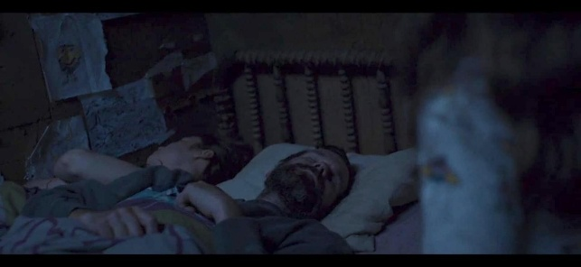
Figure 6. Jack comes out of the wardrobe to look at Old Nick's sleeping face because he is curious about him.
Old Nick : “Oh, hey Sonny.”
Jack : “(Screaming)”
Old Nick : “Quite the noise! Quite the noise. Quite the noise. Fuck!
(Room 2015, 00:23:16 – 00:23:50)

Another example of operant conditioning in Jack’s behavior happens when he steps out of the wardrobe to see Old Nick. Jack is curious and quietly sneaks out while Old Nick is sleeping. But suddenly, Old Nick wakes up, and Jack screams in fear and makes Old Nick angry and he yells at Jack.
This moment is a form of positive punishment. Jack’s scream brings a negative reaction, such as Old Nick’s loud scolding. This unpleasant experience teaches Jack not to make noise or disturb Old Nick. After this, Jack becomes more careful and chooses to stay quiet to avoid being yelled at. This situation makes Jack learn through operant conditioning.
In contrast, when Jack stays silent inside the wardrobe as Ma told him, nothing bad happens. Old Nick doesn't notice him, and there is no punishment. Through this experience, Jack learns that staying quiet and obedient helps him avoid negative consequences. This is how operant conditioning shapes his behavioral tendency to remain obedient and silent in order to avoid being yelled at, thus making him feel better.

Data 7:
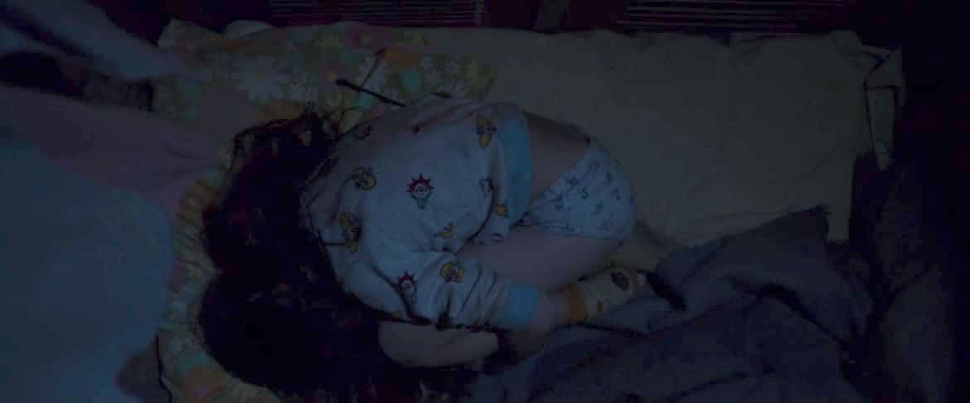
Figure 7. Jack feels scared after being threatened by Old Nick because he screamed, so he runs, covers his ears, and curls up inside the wardrobe.
Old Nick : "Do you want to breathe? Then shut the fuck up!"
(Room 2015, 00:23:40 – 00:23:46)

After previously been yelled at for making a scene, Jack got a more severe punishment. Old Nick immediately grabbed Jack by the neck and started strangling him while threatening that he wouldn't let go unless Jack stopped yelling or started obeying. At first Jack continued to rebel and scream, but he knew that the strangulation would not be released if he continued to scream so he finally chose silence, then the strangulation was released so that he could escape into the wardrobe even though there was still fear that made him cover his ears and cower.
This situation explains negative punishment, where Jack loses his security of being free from the strangulation if he continues to exhibit undesirable behavior. In other words, Jack would not be free from pain until he stopped screaming. This experience teaches Jack that screaming only puts him in a dangerous and painful situation, whereas staying quiet and obedient causes the pain to stop. This situation makes Jack learn through operant conditioning.
On the other hand, when Jack remained calm, obedient and did not fight back, Old Nick treated him more gently. In such situations, Old Nick does not feel bothered or threatened, which leads to a gentler and less harmful response. This is a form of positive reinforcement, where behavior that Old Nick deems “good” is followed by more pleasant consequences. This negative punishment shapes his behavioral tendencies to become a calmer child and makes him feel more secure.

  - Internal Factors
Internal factors include responses when their feelings are expressed through facial expressions or spontaneous movements, which involve self-awareness, drives, emotions, as well as goals or intentions.
Data 8:

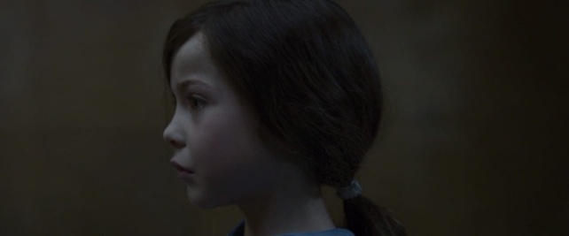
Figure 8. Jack expresses his anger from the look on his face when Ma tells him that Lucky is not real.
Jack : ”It might be my dog, lucky.”
Ma : “Jack, we can't have a dog. There's not enough space with the barking and the scratching.”
Jack : “Lucky won't scratch, he promises.”
Ma : “There is no lucky!”
Jack : “Yes, there is!”
Ma : “No, there's not. You made him up in your head, he's not real.”
(Room 2015, 00:15:30 – 00:15:44).

Jack often sees television shows featuring a dog named Lucky, and due to his confinement in the room, he begins to hope that he will one day meet Lucky. He firmly believes that Lucky is a real dog and imagines that someday he might see or even have Lucky for himself. Jack even hopes that Old Nick will bring him a dog as a gift specifically, a dog like Lucky, whom he frequently sees on television.
However, Jack's emotional response is triggered when his hopes are denied by Ma, who suddenly tells him that Lucky is not real and is merely a fictional dog. This revelation causes Jack to cry loudly, shout, and express anger out of sadness and disappointment. His spontaneous outburst reflects his emotional struggle in dealing with the disillusionment that something he believed to be real turns out to be imaginary. So Jack's reaction spontaneously turned angry and shouted because he wanted to express the disappointment he felt because Lucky did not really exist. This situation is where Jack expresses his emotions as something he feels from his inner feelings.

Data 9:
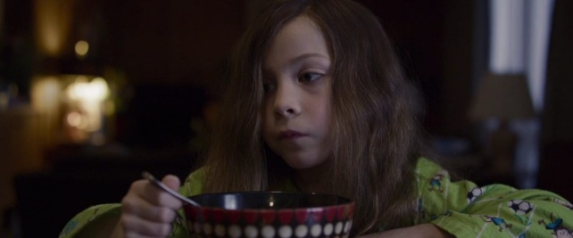
Figure 9. Jack was given food by Leo after expressing his hunger and asking Leo for food.
Jack : “I'm pretty hungry. I want to eat”
Leo : “Oh, I know. I got something in the kitchen, I think.”
(Room 2015, 01:21:27 – 01:21:36)

Another example of internal factors can be seen when Jack shows a response to his hunger. His desire to find food is shown through his physical behavior which spontaneously rushes to the kitchen while holding his hungry stomach as a form of direct response to his internal body condition.
Furthermore, in an attempt to satisfy his hunger, Jack quickly runs towards his grandfather Leo in the hope of getting food. this is a form of Jack's behavior that spontaneously expresses his internal feeling when he feels hungry. This situation is a form of drives that comes from within Jack to immediately relieve hunger by asking Leo for food.

Data 10:

Figure 10. Jack who expressed his amazement from inside the car window spontaneously after seeing the sky, trees, airplanes, people, and tall buildings were as real as what he saw from the television.
Jack : “I've seen pancakes, and a stairs, and birds, and windows, and hundreds of cars. When I was small, I only knew small things, but now I'm five, I know everything.”
(Room 2015, 01:09:21 – 01:09:35).

Another example of Jack's internal factors is seen in the response of his self-awareness that comes along with his growth and new experiences outdoors. Jack shows his feelings when he is in the car and stares out the window with a spontaneous feeling of amazement and sparkling eyes when looking at the outside world from the car window by looking at the trees, tall buildings, streets and people on the move when he is heading to his grandmother's house. He compares his condition in the past when he was still in a confined space, with the current situation where he feels he knows more because he has experienced a wider world. This shows that Jack has reached the early stages of self-awareness which develops with age and life experience.

Data 11:
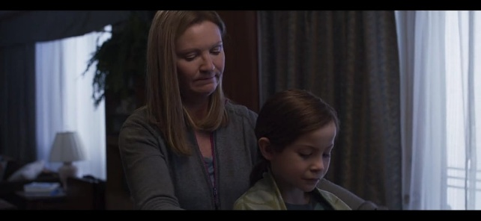
Figure 11. Jack has the intention to support Ma who is in a mental hospital by cutting her hair so that she feels supported and can recover quickly.
Jack : ”I want to send it to Ma. She needs my strong more than me, so I want to send it to her.”
(Room 2015, 01:41:35 – 01:41:50).

Another example of internal factors influencing Jack's character can be seen when he shows a sincere intention to cut his hair as a form of moral support to Ma who is being hospitalized. After hearing a story from his grandmother about Ma's childhood that was often cut by Grandma, Jack spontaneously looked for scissors and cut his own hair, with the intention of giving it to Ma. This action is driven by his desire for Ma to recover soon and be able to return home. This behavior reflects that Jack has goals and intentions that arise from within himself, namely the desire to help and show affection to Ma, so she can recover quickly.

- Discussion
Jack shares a very close bond with Ma. He relies entirely on her for food, bathing, changing clothes, and learning essential skills. Ma teaches him basic things such as how to speak, hold a spoon and eat, read books, write, and she often tells him stories about the world outside Room including her past, what her old house looked like, and descriptions of Jack’s grandparents. Jack often asks questions about how the world works, like whether aliens exist or whether cars, trees, and the sky are real. He is also curious about Old Nick. Although he never sees him directly, Jack becomes aware of his presence through the sound of knocking on the door.
Based on the analysis of the film Room (2015), the behavior of the main character, Jack, can be understood through the behavioral psychology approach developed by John B. Watson’s classical conditioning, B.F. Skinner’s operant conditioning, and internal factors. Jack’s behavior is shaped through his interactions with the environment, which influence how he reacts to situations and forms habits over time.
Jack's behavior is formed through the relationship between social environmental stimuli and the responses they produce, either reflexively or through reinforcement and punishment. In addition, Jack's behavior is also influenced by internal factors within himself, which are expressed through facial expressions, spontaneous movements, and are based on self-awareness, emotions, drives, goals, and intentions.
In the context of classical conditioning developed by Watson, Jack displays various emotional responses formed through the repeated association of stimuli. For example, when Ma tells him to go to sleep, Jack immediately walks into the wardrobe without hesitation or questioning. This happens because he has repeatedly heard the command to sleep, which is often associated with the arrival of Old Nick. In this case, the phrase “time for bed” becomes a familiar stimulus, while Jack’s immediate response going into the wardrobe is a behavior that occurs automatically due to the repeated association. Therefore, this can be categorized as classical conditioning.
Another example is when Jack hears a knocking sound at the door, which signals that Old Nick is about to enter. At first, the knocking sound was just a neutral stimulus, but after being repeatedly linked with Old Nick’s arrival, the sound becomes a stimulus that triggers certain responses from Jack. This is also a form of classical conditioning because Jack has automatically associated the sound with Old Nick’s arrival.
Jack also associates Old Nick’s arrival with the “delivery” of daily necessities such as food, toys, vitamins, or other household items. This shows that Jack has formed an association between Old Nick’s presence and the expectation of receiving goods the next morning. This process is also part of classical conditioning, as Jack’s response arises automatically based on repeated experiences.
Meanwhile, through operant conditioning, Jack demonstrates behavior shaped by reinforcement and punishment. For instance, when Jack receives praise or positive attention from Ma for being patient on his birthday, it acts as positive reinforcement that strengthens his calm behavior. On the other hand, when he acts demanding or angry, Jack receives a negative response from Ma, which functions as positive punishment to reduce that behavior.
In his interactions with Old Nick, Jack learns that behaviors such as resisting or yelling result in painful consequences like being threatened, which leads him to avoid such behavior in the future. This is a clear form of positive punishment, where an unpleasant consequence is added following an undesired behavior, thereby decreasing the likelihood of that behavior occurring again. This situation illustrates a learning process based on fear and threat, which is a key principle of operant conditioning, where behavior is shaped by consequences.
Conversely, when Jack behaves obediently, he tends to be treated more gently, which acts as negative reinforcement, the removal of an unpleasant stimulus, such as threats or anger from Old Nick when Jack shows expected behavior. This encourages Jack to continue behaving quietly and obediently. Because the consequence of his obedience is the absence of a negative experience, this reinforces the behavior, demonstrating another aspect of operant conditioning.
Equally important, internal factors also play a significant role in shaping Jack’s behavior. First, the internal factor of emotion is clearly shown when Jack expresses anger after Ma tells him that the dog named Lucky, which he often sees on TV, is not real. Jack spontaneously screams and gets upset, refusing to accept that truth. This emotional reaction happens because Jack feels disappointed and shocked. His emotions explode as he feels like he is losing something he believed was real. This shows that Jack’s behavior is influenced by what he feels inside, making it part of the internal factor of emotion.
Second, the internal factor of drives appears when Jack feels hungry and spontaneously goes to the kitchen to ask Leo for help in finding food. This action is driven by the hunger that comes from inside his body, a basic physical need. His behavior happens naturally as a way to meet that need. Therefore, this is considered an internal drive because it comes from a biological urge that directly influences his action.
Third, Jack shows growth in his self-awareness when he leaves his limited room and starts to realize that the world is much bigger than he ever imagined. Before, Jack believed the world only consisted of room and what he saw on TV. But after stepping outside, he begins to understand that there is a real, wide world beyond his limited room. This shows an increase in his awareness and understanding of himself and his surroundings, which makes it part of the internal factor of self-awareness.
Lastly, the internal factor of goals and intentions is shown when Jack cuts his hair and gives it to Ma as a way to support her and help her feel better. This action doesn’t come from any outside pressure but from Jack’s own sincere intention to encourage and care for Ma. It shows that Jack has his own thoughts and emotional goals that guide his actions. This is included as an internal factor goals and intentions because it comes from within and shows Jack’s personal desire to do something meaningful.
All of these responses show that Jack's behavior is not only shaped by external social environments but also driven by internal factors. Thus, the findings of this study support the behaviorist view that human behavior can be learned through the stimulus and response, while also involving personal experiences that enrich the meaning of each action.

E. CONCLUSION
It can be concluded that Jack’s behavior in the film Room (2015) is shaped by both external stimuli and internal psychological factors. This research shows that Jack’s responses are formed through the process of classical and operant conditioning. External factors like his environment, daily routines, and interactions with Ma play a strong role in shaping how Jack behaves.
In addition, internal factors such as self-awareness, emotions, drives, and goals also influence his actions. Even though Jack grows up in a limited space, he shows emotional growth, intention to help, and awareness of himself. These findings support the behaviorist analysis that human behavior is a result of learned experiences through interaction with environment.

DAFTAR PUSTAKA
Aras, G. (2015). Personality and Individual Differences: Literature in Psychology-Psychology in Literature. Procedia-Social and Behavioral Sciences, 185, 250-257.
Breur, T. (2011). Data Analysis Across Various Media: Data Fusion, Direct Marketing, Clickstream Data and Social Media. Journal of Direct, Data and Digital Marketing Practice, 13, 95-105.
Clark, K. R. (2018). Learning Theories: Behaviorism. Radiologic Technology, 90(2), 172-175.
Cohen, T. R., Panter, A. T., Turan, N., Morse, L., & Kim, Y. (2014). Moral character in the workplace. Journal of Personality and Social Psychology, 107(5), 943—963. https://doi.org/10.1037/a0037245.
Dodgson, J. E. (2017). About research: Qualitative Methodologies. Journal of Human Lactation, 33(2), 355-358.
Hineline, P. N., & Rosales-Ruiz, J. (2013). Behavior in Relation to Aversive Events: Punishment and Negative Reinforcement.
Indick, W. (2013). Psycho thrillers: Cinematic Explorations of the Mysteries of the Mind. McFarland.
Klarer, Mario. (2004). An Introduction to Literary Studies Second Edition. London : Routledge
Miles, M. B., & Huberman, A. M. (1984). Drawing Valid Meaning from Qualitative Data: Toward a Shared Craft. Educational Researcher, 13(5), 20-30.
Pickering, J. H., & Hoeper, J. D. (1981). Concise Companion to Literature. Macmillan Publishing Co., Inc.
Rana, A. M., Desai, K. R., & Jauhari, S. (2013). Synthesis, Characterization, and Pharmacological Evaluation of 1-[2-(6-nitro-4-oxo-2-phenyl-4 H-quinazolin-3-yl)-ethyl]-3-phenyl ureas. Medicinal Chemistry Research, 22, 225-233.
Rumfola, L. (2017). Positive Reinforcement Positively Helps Students in the Classroom. Education and Human Development, 5, 786.
Skinner, B. F. (1986). Is it behaviorism?. Behavioral and Brain Sciences, 9(4), 716-716.
Skinner, B. E (1975). TheSsteep and Thorny Way to a Science of Behavior. American Psychologist, 30, 42-49.
Watson, J. B. (1994). Psychology as the Behaviorist Views it. Psychological Review, 101(2), 248.

